National Offshore Petroleum Titles Administrator
2014–15 Annual Report of Activities
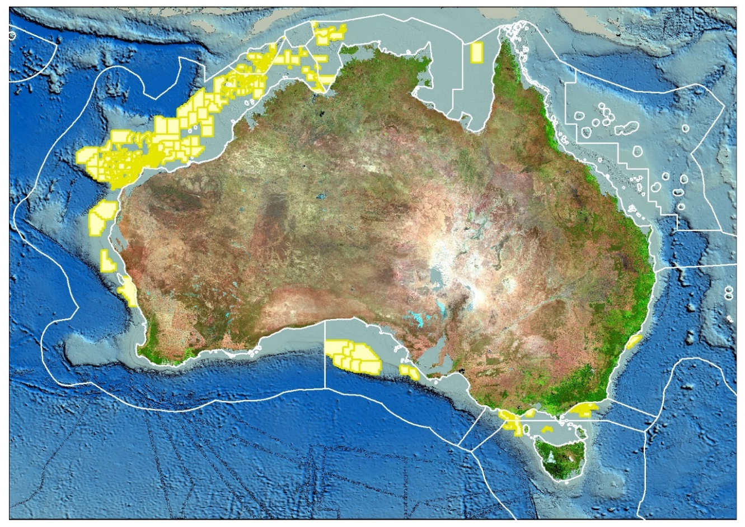

Our Vision:
Enabling productivity and growth for Australia’s offshore oil and gas industry


Atwood Osprey Semisubmersible—image courtesy of Atwood Oceanics

National Offshore

Petroleum Titles Administrator
2014–15 Annual Report of Activities

© Commonwealth of Australia 2015
This work is copyright. Apart from any use as permitted under the Copyright Act 1968, no part may be reproduced by any process without prior written permission from the Commonwealth. Requests and inquiries concerning reproduction and rights should be addressed to the Department of Industry, Innovation and Science, GPO Box 9839, Canberra ACT 2601.
ISSN: 2205-8230 (print version)
ISSN: 2205-8249 (online)
Designed by: Raivans

For more information about this report please contact:
Business Manager
National Offshore Petroleum Titles Administrator Department of Industry, Innovation and Science GPO Box 7871
Perth WA 6850
Telephone: (08) 6424 5300
Email: corporate @nopta.gov.au
Web: www.nopta.gov.au

Cover image: Map produced by NOPTA showing Australian offshore titles in force at 30 June 2015


Seismic vessel in Bight Basin—image courtesy of TGS and Dolphin Geophysical

Contents
Titles Administrator’s Review 4
Overview 5
Key Achievements 2014–15 6
Cost Effectiveness 7
Organisational Structure 8
Figure 1: NOPTA’s organisational structure at 30 June 2015 8
Key Outputs 9
Figure 2: 2014–15 Submitted applications 9
Decisions of the Joint Authority and the Titles Administrator 10
Figure 3: 2014–15 Decisions of the Joint Authority and the Titles Administrator 10
Cost recovery 11
Table 1: Annual Titles Administration Levy 2014–15 11
Table 2: Application Fees 2014–15 12
NOPTA’s Financial Result 13
Figure 4: NOPTA Finances $M 13
Corporate Plan 14
Key Work Areas Summary of Activities 16
Titles 16
Data Management 17
Figure 5: Submission items received 2014 to July 2015 17
Figure 6: Outstanding submission items 2014 to July 2015 18
Compliance and Operations Support 20
Geoscience and Engineering 22
Information Technology 23
Strategic Coordination & Support 24
Outlook for 2015–16 25

Titles Administrator’s Review

It is my great pleasure to present the inaugural report on NOPTA’s activities for the 2014–15 financial year. We intend to publish such a report annually.

Much has been achieved since NOPTA commenced operations in January 2012, particularly when considering the very short timeframe from NOPTA’s creation to its commencement. We have completed the transition from former regulatory regimes, have established the National Offshore Petroleum Data and Core Repository, and developed the National Electronic Approvals Tracking System (NEATS)—all achieved through full cost recovery. The dedication and professionalism of our staff has been recognised by our stakeholders who, in a recent survey, provided very positive feedback and expressed a high level of satisfaction with NOPTA’s performance of its role and function.
NOPTA is committed to continuous improvement, with a culture that embraces innovation, efficiency and stakeholder engagement.
In particular we strive to identify and then relieve any unnecessary regulatory burdens. Specifically we are working on expanding the functionality of the NEATS portal, including our web-based forms and our website, a key mechanism to simplify industry’s compliance obligations. We also continue to enhance our competent capacity—with particular emphasis in the areas of geology, reserve/petroleum engineering, and geophysics—to assist in improving the management of Australia’s offshore hydrocarbon resources, both discovered and undiscovered.
In relation to our activities in 2014–15, NOPTA celebrated several firsts, including independent survey of key stakeholders, implementation of a 3–year Corporate Plan on a page, and being awarded the 2015 National Archives Award for Digital Excellence in the small agency category. In addition, the Department engaged an independent third party to audit NOPTA’s legislative compliance that concluded NOPTA has in place comprehensive assurance arrangements for managing compliance with respect to applicable elements of the Offshore Petroleum and Greenhouse Gas Storage Act 2006. A statutory Ministerial Review of NOPTA’s first three years of operations also commenced in 2015 (2015 Operational Review).
The 2015 Operational Review report to the former Minister for Industry and Science was tabled in Parliament on 16th September 2015. The review’s overall finding was that NOPTA is contributing to the efficiency of decision making by the Joint Authority, and concluded that NOPTA’s establishment and subsequent operations have—to a large extent—met the Australian Government’s response to the 2009 Productivity Commission Review. It also found that, as a cost recovery agency, NOPTA provides its functions at a reasonable cost, its fee structure is appropriate, and that it does not represent a barrier to the offshore petroleum industry entering, operating in, or exiting Australia.
I trust you will find our first report to be a good read and we welcome your feedback.
Graeme A Waters
National Offshore Petroleum Titles Administrator

Overview
The purpose of this inaugural report is to provide key stakeholders with information specific to the activities of the National Offshore Petroleum Titles Administrator (NOPTA), headed by a statutory position of Titles Administrator.
The report is also intended to complement the statutory 2014–15 Annual Report of the Department of Industry and Science (the Department), which includes a paragraph on the Department’s obligation to address special legislative requirements relating to NOPTA under section 695N of the Offshore Petroleum and Greenhouse Gas Storage Act 2006.
NOPTA was established as a branch of the Resources Division of the Department on 1 January 2012, to be the national offshore petroleum regulator responsible for providing advice and information to the responsible Commonwealth Minister and the relevant State and Northern Territory Ministers, collectively named the Joint Authority (JA). NOPTA’s advice is independent to the decisions of the JA.
The Titles Administrator is also separately responsible for making decisions relating to offshore petroleum titles, and administering titles and related well and survey digital reports and data.
NOPTA’s vision is to enable productivity and growth for Australia’s offshore oil and gas industry. It undertakes a range of regulatory functions with a focus on timeliness, accuracy, transparency and consistency. NOPTA’s Corporate Plan 2015–2017 provides information on how NOPTA delivers its objectives and its indicators of success. The Corporate Plan is available on NOPTA’s website at www.nopta.gov.au and is included in this report on page 14.
An important aspect of NOPTA’s operation is to consult stakeholders to continue to simplify and streamline processes for industry. As part of its obligations under the Australian Government’s Regulator Performance Framework, NOPTA engaged KPMG to undertake a survey of key stakeholders during 2014–15, to provide an assessment of NOPTA’s performance, level of stakeholder satisfaction and identify areas for improvement.
The key findings of the survey as reported by KPMG were as follows:
“Overall, this survey indicated a high level of satisfaction with NOPTA’s performance, role and function. Stakeholders engage with staff frequently, and consider them to be competent and professional. Its information is seen as useful, accessible and timely, and the organisation is considered to be collaborative and demonstrate commitment to continuous improvement. Stakeholders strongly consider that the creation of NOPTA, and the way it operates, have improved the offshore petroleum regulatory framework and reduced unnecessary burden on the industry to a large extent, and almost all stakeholders consider that the introduction of NOPTA has reduced duplication of effort between agencies administering the offshore petroleum regulatory framework.”
The KPMG Stakeholder Survey Report is available on NOPTA’s website.

Key Achievements 2014–15
The following achievements were published in the Department’s 2014–15 Annual Report.
“In the past 12 months NOPTA:
- was awarded the 2015 National Archives Award for Digital Excellence in the small agency category—these awards recognise and promote excellence and innovation in the management, use and reuse of digital information by Australian Government agencies;
- received very positive feedback from key stakeholders, as part of a stakeholder survey independently conducted by KPMG—overall, the survey indicated a high level of satisfaction with NOPTA’s performance, role and function;
- implemented the Regulatory Performance Framework;
- implemented the new Corporate Plan 2015–2017;
- implemented a new cost-recovery implementation statement in compliance with the Australian Government’s revised cost-recovery guidelines;
- continued to build competent capacity in resource management;
- developed the National Offshore Petroleum Information Management System with Geoscience Australia;
- continued to enhance its relationship with NOPSEMA to simplify and streamline processes for industry.”
In addition, the Minister approved NOPTA’s contribution of $1.2 million as a joint Commonwealth and State ($1.3 million) initiative to expand the Western Australian Geological Survey Core Library in Carlisle. The expansion will create extra viewing space for geologists to examine drill core, a conference room, and extend the area housing a sophisticated rapid spectroscopic logging and imaging system known as a HyLogger core scanner. Construction is expected to commence in late 2015 and be finished by the end of 2016.
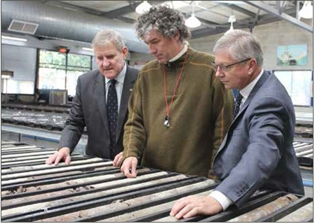
Figure 1: (left to right) former Commonwealth Minister the Hon Ian Macfarlane MP; Ian Copp, consultant geologist to Buru Energy; and WA State Minister the Hon W R (Bill) Marmion BE MBA MLA at the launch of the core store redevelopment at the Geological Survey Core Library in Carlisle.
Photo copyright Department of Mines and Petroleum, Western Australia.

Cost Effectiveness
Since its establishment NOPTA has maintained a low cost delivery of its legislated functions to the industry. A recent assessment of NOPTA’s structure, resources and skills found that NOPTA’s staffing level was significantly below that of previous arrangements by 44%. A comparison between NOPTA and similar overseas bodies including the Norwegian Petroleum Directorate, the United Kingdom’s Department of Energy & Climate Change and the Canada-Newfoundland and Labrador Offshore Petroleum Board, also found that NOPTA is the smallest in terms of establishment. NOPTA is committed to maintain a low cost delivery through continuous process and systems improvement in consultation with industry.
NOPTA has a small support team based at its Perth office, to undertake administrative and executive tasks. The cost of this team represents 3% of NOPTA’s total operating expenditure, and less than 10% of total staff numbers. This represents value for money to titleholders and compares very favourably with other like organisations where corporate activity levels of 32% is considered reasonable.
The Department provides NOPTA with the necessary corporate governance structure under the Public Governance, Performance and Accountability Act 2014, that includes Accountable Authority Instructions, financial policies and delegations, as well as other organisation-wide services. To date, there has been no overhead costs allocated to NOPTA by the Department.
Another indicator of cost effectiveness is the level of administrative and regulatory burden imposed on industry, and hence unnecessary additional costs of doing business with the Government. There are strong indications that the introduction of NOPTA and its leadership in the implementation of titles administration and ongoing operations have had a very positive impact in improving efficiency in this regard. In its Stakeholder Survey Report, KPMG stated:
“Ultimately, NOPTA was set up to reduce duplication and overlap in the offshore petroleum regulatory framework, which was found to be imposing unnecessary burden on the industry and impacting on the value of the industry to Australia. This survey indicates that stakeholders—titleholders and non-titleholders alike—overwhelmingly consider that:
- the current framework is more streamlined, and has reduced duplication of effort between agencies administering the offshore petroleum regulatory framework;
- the introduction of NOPTA has simplified titleholder interactions with the regulatory framework;
- the time and effort spent on compliance is reasonable given the regulatory risk; and
- NOPTA makes a valuable contribution to the process of managing Australia’s resources.
As such, the results of this stakeholder satisfaction survey indicate that stakeholders strongly consider that the creation of NOPTA and the way it operates have improved the administration of the offshore petroleum regulation regulatory framework and reduced unnecessary burden on the industry.”

Organisational Structure
During the year, NOPTA engaged an external consultant, Protiviti, to assist in maintaining a competent organisational capacity. Protiviti addressed the adequacy of the number and skills of staff and the structure for deploying those resources within NOPTA. In particular, Protiviti noted the high level of vacancy since NOPTA’s establishment. This was attributed to the specialist nature of the work, the difficult employment market for technical skills and the overlay of Government requirements for recruitment. Protiviti recommended that these positions together with other positions occupied by contractors be filled as soon as practicable. A net increase of 6 positions was recommended, in particular with technical skills such as financial, commercial, compliance and reservoir engineering.
NOPTA was successful in gaining approval from the Department to recruit eleven vacant positions.
The approved staffing level, including contractors, increased from 39 at the beginning of the financial year to 47 at 30 June 2015.
Figure 1: NOPTA’s organisational structure at 30 June 2015
Chief Geoscientist
Geoff O’Brien
General Manager
Graeme Waters
Executive Assistant
Paula Blair
Deputy General Manager
Melbourne Office Manager
Terry McKinley
Strategic Coordination & Support Team
Fiona Pekin, Manager
Titles Team
Jo Bell, Manager
Compliance & Operations Support Team
Steven Taylor, Manager
Data Management
Mark Ducksbury,
Manager
Geoscience Engineering Team Jenny-Lee Maher,
Manager
HR & Coordination Leader
Finance Officer
Asst Manager, Titles (4)
Senior Titles Administration Officer (4)
Titles Administration Officer (2)
Technical Specialists (5)
Data Specialists (5)
Geo Spatial Systems (2)
Legal Compliance (4)
Commercial & Analytics (4)
Information, Communications & Technology Stephen Power, Manager
Information Manager, Database Manager, & NEATS (4)
Asst Manager, Data Management (1)

Key Outputs
NOPTA undertakes various assessments and compliance activities relating to the following key outputs:
- Acreage Release (Petroleum Exploration Permit): Annual release (three rounds per release) of petroleum exploration acreage through a competitive bidding/tender process.
- Petroleum Exploration Permit: Applications for grant, renewal, credits, surrenders, expiries and cancellations.
- Suspension and Extension; Variation; Exemption: Applications for suspension, suspension and extension, variation, and exemption relating to conditions of a permit, lease or licence (including work program conditions).
- Declaration of a Location: Applications to declare a location following the discovery of petroleum and nominate a block or blocks as a location.
- Retention Lease: Applications for grant or renewal.
- Production Licence: Applications for grant, renewal, field development plans, rate of recovery, and equipment and procedures.
- Infrastructure Licence: Applications for grant, including proposed location of infrastructure.
- Pipeline Licence: Applications for grant and variation, including proposed location of the pipeline.
- Special Prospecting Authority and Access Authority: Applications for grant and variation. Applications for scientific investigation consents.
- Transfers and Dealings: Applications for the registration of transfers of, and dealings in, petroleum titles.
- Greenhouse Gas Storage Applications: Applications for assessment permits; variation, suspension, extension and surrender of assessment permits; renewal of assessment permits; declaration of a formation; holding leases; injection licences; search authorities; special authorities; and research consents.
NOPTA received 625 applications in 2014–15 (2013–14: 596), as outlined in figure 2 below.
Figure 2: 2014–15 Submitted applications

Application type | Jul | Aug | Sep | Oct | Nov | Dec | Jan | Feb | Mar | Apr | May | Jun
Cancellations/Expiries | 2 |  |  | 2 |  | 1
Dealing/Transfer | 24 | 12 | 17 | 7 | 19 | 93 | 4 | 18 | 5 | 8 | 17 | 57
Field Development |  |  |  | 1 |  | 5 | 5 | 1 |  | 1 | 2 | 5
Grants/Renewals/ Locations | 7 | 2 | 11 | 25 | 14 | 1 | 3 | 15 | 6 | 15 | 11 | 13
Other |  | 2 | 1 | 3 | 2 | 5 |  | 2 | 3 | 4 | 6 | 16
S/S&E/Variation | 9 | 8 | 11 | 4 | 6 | 16 | 5 | 16 | 14 | 15 | 12 | 22
Surrender | 1 | 2 | 1 | 1 | 2 | 1 |  |  | 2 |  |  | 4
Monthly Total | 43 | 26 | 41 | 43 | 43 | 122 | 17 | 52 | 30 | 43 | 48 | 117
Cumulative | 43 | 69 | 110 | 153 | 196 | 318 | 335 | 387 | 417 | 460 | 508 | 625

Decisions of the Joint Authority and the Titles Administrator
In 2014–15 there were 573 decisions (2013–14: 525) made with regard to applications for offshore petroleum titles. NOPTA provided advice to the Joint Authority for decisions on 230 applications and the Titles Administrator made 343 decisions. The following illustrates the decisions made by the responsible authority and by jurisdiction.
Figure 3: 2014–15 Decisions of the Joint Authority and the Titles Administrator

 | Jurisdiction
Decision Maker | WA | SA | NT | Vic | AC* | NSW | QLD | Tas*
Joint Authority | 186 | 6 | 7 | 11 | 16 | 2 | 1 | 1
Titles Administrator | 243 | 11 | 4 | 47 | 18 | 0 | 1 | 19
Totals | 429 | 17 | 11 | 58 | 34 | 2 | 2 | 20
*AC = Ashmore Cartier. JA comprises only the Commonwealth Minister, Tasmania has opted out of JA arrangements and the Commonwealth Minister is the decision maker

Cost recovery
NOPTA recovers its operating costs by charging the holders of offshore petroleum and greenhouse gas titles a fixed annual Titles Administration Levy, while variable fees are payable upon the submission of various applications.
An Annual Titles Administration Levy (Levy) is imposed on holders of titles (permits, leases and licences). The Levy is payable in accordance with the Offshore Petroleum and Greenhouse Gas Storage (Regulatory Levies) Regulations 2004 upon the grant of a title and annually thereafter within 30 days of the anniversary of the title. Where a title is in force for less than twelve months, the Levy is calculated for the remaining period of the title.
The annual Levy makes up the majority of NOPTA’s source of revenue, approximately 83% in 2014–15, providing a stable revenue stream that is based on the current number and type of titles in force. It is used to fund activities where it is not possible or practical to attribute their costs to a specific entity (e.g. industry wide monitoring, compliance and enforcement). This means there is a degree of cross-subsidy between titleholders as the Levy does not necessarily reflect the effort associated with regulatory activities for individual titleholders. As part of an initial transition to reduce that cross-subsidy and smooth out the impact to industry, NOPTA recalibrated its levy structure in consultation with industry in November 2013 and introduced new application fees. It is anticipated that a further recalibration will take place in July 2016.
There were 416 titles in force during 2014–15 that attracted the annual Levy of $8.5 million, as shown in the table below.
Table 1: Annual Titles Administration Levy 2014–15
Title type | No. of Titles | No. of blocks | Length Km | Levy Rate | Levy Amount
Exploration Permit | 193 | NA | NA | $9,781/title | $1,887,733
Infrastructure Licence | 3 | NA | NA | $22,500/title | $67,500
Pipeline Licence | 72 | NA | 3,977 | $52/km | $206,804
Production Licence | 93 | 308 | NA | $15,500/block | $4,774,000
Retention Lease | 55 | 207 | NA | $7,755/block | $1,605,285
Annual Levy | 416 |  |  |  | $8,541,322
The Levy is calculated at a statutory rate per title for an exploration permit and an infrastructure licence. For a production licence and a retention lease, the Levy is based on the number of blocks whereas for a pipeline licence it is based on the length of the pipeline. Technical assessments of field development plans are more closely aligned to the number of blocks, whereas for pipeline licences the complexity of assessments varies depending on the length of the pipeline.

Application fees are payable in accordance with schedule 6 the Offshore Petroleum and Greenhouse Gas Storage (Resource Management and Administration) Regulations 2011 at the time that an application is submitted for approval to enable titleholders to undertake certain regulated activities. Revenue from fees fluctuates from year to year, as they are dependent on the timing, type and number of applications lodged by titleholders.
NOPTA received 625 applications in 2014–15, of which 378 applications attracted a statutory fee and generated revenue of $1.8 million, or approximately 17% of NOPTA’s total income, as shown in the table below.
Table 2: Application Fees 2014–15
Application type | No. of Applications | Fee | Fee Amount
Work-bid petroleum exploration permit | 26 | $8,183 | $212,758
Renewal of petroleum exploration permit | 6 | $2,090 | $12,540
Petroleum retention lease | 19 | $2,090 | $39,710
Renewal of petroleum retention lease | 5 | $2,090 | $10,450
Petroleum production licence | 2 | $2,090 | $4,180
Renewal of petroleum production licence | 1 | $2,090 | $2,090
Variation of pipeline licence | 2 | $1,050 | $2,100
Petroleum special prospecting authority; Access authority | 39 | $5,580 | $217,620
Suspension and extension; variation; exemption (per title) | 106 | $5,340 | $566,040
Declaration of location | 6 | $7,596 | $45,576
Transfer | 37 | $7,180 | $265,660
Dealing | 129 | $2,950 | $380,550
Application Fees | 378 |  | $1,759,274
Fees were last reviewed in September 2013 as part of an initial transition towards reducing the level of cross-subsidy with levies. As a result some new application fees were introduced (Suspension and extension; variation; exemption; declaration of a location; access authority; transfers; and dealings) in November 2013.
It was recognised that a further adjustment would be required at a later time in order to complete the transition. A comprehensive review of activities and rates is scheduled for 2015–16.

NOPTA’s Financial Result
Over the three and a half years since its establishment, NOPTA has been able to recover most of its costs, with a small accumulated deficit of $121,000 (0.35% under recovery, after depreciation and amortisation of $2.8 million) over total operating expenditure of $34.5 million.
NOPTA aims to retain a cash reserve of 10–20 per cent of its annual budget as a financially responsible measure. Excluding the remaining funds provided by Government to finalise NOPTA’s establishment and contractual commitments, NOPTA had an operational cash balance of $1.7 million available at 30 June 2015 (17% of the published 2015–16 budget). This will enable NOPTA to continue to meet its ongoing monthly expenses, asset replacements and potential unplanned expenditure.
Figure 4 illustrates NOPTA’s financial performance since its establishment.
Figure 4: NOPTA Finances $M

Corporate Plan

Our Vision
Enabling productivity and growth for Australia’s offshore oil and gas industry.

Our Purpose
The effective stewardship of Australia’s offshore oil and gas resources to ensure the optimum long-term recovery of hydrocarbons.

Our Culture
In NOPTA, our commitment to each other is based on mutual respect, openness and inclusiveness. We invite participation. We work together and lead with enthusiasm and purpose to make a difference.

Key Performance Indicators (Regulator Performance Framework)
KPI 1 NOPTA does not unnecessarily impede the efficient operation of titleholders. KPI 2 Communication with titleholders is clear, targeted and effective. KPI 3 Actions undertaken by NOPTA are proportionate to the regulatory risk being managed. KPI 4 Compliance and monitoring approaches are streamlined and coordinated. KPI 5 NOPTA is open and transparent in its dealings with titleholders. KPI 6 NOPTA actively contributes to the continuous improvement of regulatory frameworks.

Our Key Achievements 2012–2014
- Completed transition from former regulatory regimes.
- Established the National Offshore Petroleum Data and Core repository (NOPDCR).
- Developed the National Electronic Approvals Tracking System (NEATS).
- Achieved full cost recovery for the establishment of NOPTA, NOPDCR and NEATS.
- Implemented ICT network (NOPTANet).
- Developed fact sheets for titleholders.
- Developed electronic document and records management system.
- Established resource management project.
- Established new cost recovery arrangements.

Our Key Risks
- Recruitment and retention of experienced professionals up to our approved staffing level, in a competitive environment.
- Maintaining financial capacity within NOPTA to effectively respond to changes in work priorities.
- Maintenance of adequate information management systems that support streamlined, efficient workflows.
- Maintaining high profile delivery of legislated functions to titleholders whilst operating within a large, multi-faceted Department.

Our Functions | Our objectives | How we will deliver | Our indicators of success
Assist and Advise the Joint Authority and the Responsible Commonwealth Minister  Incorporating  Titles Administrator’s Delegated and Statutory Decisions and Authorisations | - Contribute to the efficient decision making of the Joint Authority (JA) and responsible Commonwealth Minister.  - Deliver efficient, consistent and timely Titles Administrator decisions.  - Promote stakeholder engagement.  - Reduce regulatory burden. | - Provide reliable advice and recommendations to the JA and responsible Commonwealth Minister.  - Conduct robust reviews and assessments including analysing development options, economic modelling and barriers to commercialisation.  - Maintain open and transparent relationship with titleholders.  - Maintain timely authorisations to release well, survey and petroleum mining sample data.  - Participate at national and international regulatory forums.  - Implement compliance program.  - Review guidelines and other public material (factsheets) through appropriate internal and external consultation. | - Improved management of hydrocarbon resources in offshore Australia.  - Advice to the JAs and the Responsible Commonwealth Minister is timely, accurate and consistent.  - Assessment timeframes set by the JA protocol are met.  - Decisions and authorisations are timely, consistent, defensible and readily accessible.  - Positive feedback from JAs, industry and other stakeholders (Annual NOPTA survey).  - Clear, targeted and effective stakeholder engagement.  - Enhanced recognition of NOPTA as an effective regulator.  - Risk-based compliance program documented.  - Reduction of overall non-compliance.  - Industry feedback is incorporated into guidance material.  - Guidance information provided to industry is accurate, complete and readily accessible including information on the NOPTA website.
Keeping Register of Titles | - Maintain a publicly available titles register and approvals tracking system for applications. | - Maintain and improve the National Electronic Approvals Tracking System (NEATS).  - Upload historical title registers in NEATS for all active titles.  - Establish a tracking process and system for key regulatory submissions. | - The titles register is publicly available, and up to date. » Tracking system for regulatory submissions implemented.
Data and Information Management | - Improve data quality and data integration.  - Complete consolidation of offshore data collection.  - Implement resources and reserves reporting standards.  - Streamline data submissions and access processes.  - Facilitate ease of access to open file data. | - Manage the National Offshore Petroleum Data and Core repository (NOPDCR).  - Coordinate with Geoscience Australia and States and Territory representatives to finalise data integration and quality control processes.  - Develop reporting standards in consultation with stakeholders.  - Maintain central point for company contacts.  - Implement systems for enhanced delivery of data. | - Data consolidation and integration program implemented.  - Reporting standards for resources and reserves and other data submissions implemented and monitored.  - National Offshore Petroleum Information Management System (NOPIMS) implemented.
Cooperate with NOPSEMA and other Agencies | - Enhance relationship with NOSPEMA, other agencies and the Department’s Offshore Resources Branch.  - Streamline and reduce regulatory burden.  - Contribute to improvements in the timely exploitation of Australia’s offshore hydrocarbon resources. | - Work with NOPSEMA to simplify and streamline processes for industry.  - Provide input and technical support to various Departmental and interdepartmental committees/taskforces and related agencies.  - Provide input and technical support to the policy area of the Offshore Resources Branch.  - Participate in intra and interdepartmental forums and quarterly meetings with NOPSEMA and the Offshore Resources Branch.  - Provide high quality input for resource management projects.  - Undertake comprehensive assessments of the hydrocarbon resource systems (and attendant infrastructure). | - Geographic Information System (GIS) services delivered to NOPSEMA.  - Opportunities to streamline and share services and information with NOPSEMA identified and put into action.  - Co-operative approach to proposed legislative amendments.  - Positive feedback from agencies, industry and other stakeholders (Annual NOPTA survey).  - NOPTA advice on all aspects of hydrocarbon resources is accurate, timely and valued by stakeholders.
Provide Corporate Support to Facilitate Delivery of Legislated Functions | - Maintain a competent capacity.  - Maintain a strong financial management and risk management culture.  - Maintain secure, reliable and responsive information technology systems. | - Recruit and retain skilled professionals.  - Encourage individuals’ professional development.  - Facilitate annual NOPTA planning and training workshop.  - Maintain and improve staff work-life balance.  - Provide a safe and supportive workplace with flexible work options.  - Implement automated workflows, information management and integrated communications systems.  - Implement a quality management system. | - NOPTA is fully cost recovered.  - Staff performance rated as effective or above.  - Risk management integrated into financial and corporate decision making processes.  - Flexible working arrangements implemented.  - Unplanned leave events are reduced.  - Increased efficiency through the use of collaborative work platforms.

Key Work Areas Summary of Activities

Titles
The Titles Team has three core functions:
- To provide guidance to industry on matters pertaining to compliance with the offshore petroleum and greenhouse gas storage regulatory framework.
- To act as the point of contact between industry and the Joint Authority and/or Titles Administrator on offshore petroleum and greenhouse gas storage titles applications.
- To undertake day to day administration of offshore petroleum and greenhouse gas storage titles in accordance with the Act and Regulations.
These functions involve:
- maintaining a publicly available register of offshore petroleum and greenhouse gas titles;
- working with the other teams within NOPTA to provide information, application assessments, analysis, reports and advice to the Joint Authority and/or the Titles Administrator; and
- implementing offshore petroleum and greenhouse gas title related decisions.
During 2014–15, the Titles Team undertook a review of the team structure and established four key operational areas within the team, being: Exploration, Acreage Release, Development, and Projects. These key areas now have dedicated resources and defined roles and responsibilities. This process was supported by a recruitment exercise, to ensure the team is appropriately resourced to deal with the increasing breadth and depth of work undertaken within the team.
The team has a strong commitment to continuous improvement, and in this regard completed or commenced a number of improvement activities around website content, application forms, application assessment templates and application checklists. The team has also been actively involved in establishing electronic work flows, and establishing new statistical reporting mechanisms for its application processing work.
During 2014–15, the team provided substantial resources for the revision of the Offshore Petroleum Exploration Guidelines (released in May 2015), and for the implementation of the new arrangements for exploration permits with combined primary work programs. The team also contributed to the development of the Greenhouse Gas Requirements and Assessment Guidelines (released in August 2014). Other guidelines the team has been working on include: a re-write of the Declaration of Location Guideline; review of the Special Prospecting Authority Guideline; review of the Retention Lease Guideline; the development of the Greenhouse Gas Declaration of a Formation Guidelines. The team was also the primary group within NOPTA involved in implementing the Australian Government’s new cash bidding exploration permitting system, and the first cash bidding auction.
Furthermore to the petroleum application work, the team was involved in the establishment of new greenhouse gas storage guidelines, application forms, assessment templates and checklists. The team (in conjunction with other areas in NOPTA) is providing continuing support to the Department in this regard.

Data Management
The Data Management Team is responsible for managing the submission and release of offshore petroleum data in compliance with the Resource Management Administration (RMA) Regulations.
Key aspects of this role include:
- managing the submission of data made under the OPPGSA (RMA) Regulations;
- developing systems and business processes to improve consistency and usability of offshore petroleum data;
- managing the National Offshore Petroleum Data and Core Repository (NOPDCR) relationship;
- developing reporting standards for data submissions, including activity reports;
- recommending the release of well, survey and petroleum mining sample data; and
- improving the level of integration and quality of the Commonwealth data collection.

Data submission and release
Technological change is having a profound influence on data management activities, with the volume of data being submitted growing exponentially and advancements in the way that data is discovered and delivered. Appropriate access to data is of vital importance to attracting investment in exploration, development and production of Australia’s offshore oil and gas resources.
In 2014–15 NOPTA recorded an overall reduction in new seismic surveys, although the size of these surveys in area and data volumes is generally increasing. In terms of new offshore wells drilled, the focus has clearly shifted to development as a percentage of new wells drilled. The complexity of data submitted however continues to increase and there is an ongoing need for flexibility in managing the different data types and submission media.
Figure 5: Submission items received 2014 to July 2015
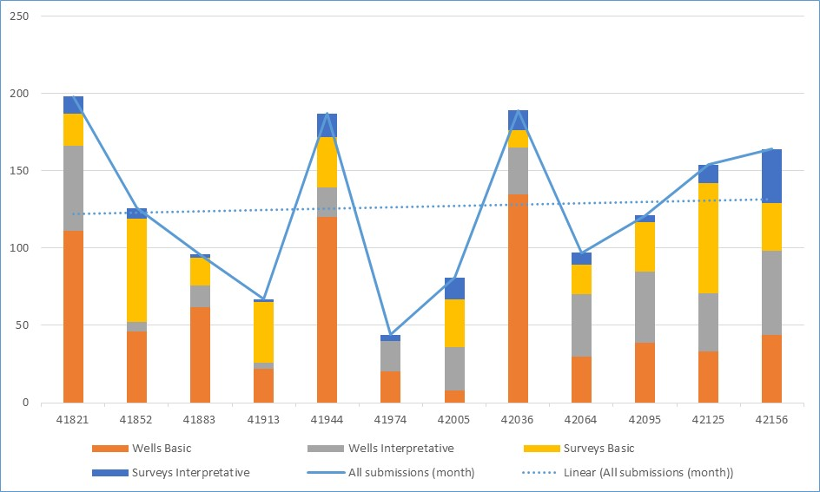

Despite a decrease in new well and survey activity in 2014–15 there has been an increase in the number of submissions (reports and datasets for completed activities) received and processed by NOPTA. There are several reasons for this, including the time lag apparent between activity completion and submission due dates; the emphasis within NOPTA on compliance activity to ensure a greater level of submission completeness; and a high degree of cooperation on the part of industry to assist in filling these gaps.
Throughout 2014–15, NOPTA undertook a communication program with titleholders aimed at providing agreed expectations around data submission and release. This has resulted in a significant reduction in outstanding items and reduced compliance backlogs to consistently low levels. In general terms data is now submitted by industry on time, which supports NOPTA’s continuing efforts to improve the comprehensiveness and quality of information available for future exploration and research purposes.
NOPTA has continued to enhance its data submission and compliance regime to ensure that data is submitted appropriately, is complete at the time of submission and meets relevant usability criteria on release—that is, it is fit for the purpose intended.
In terms of release of data on the expiration of the specified confidentiality periods, new reports and data are quality checked and made available each week. Lists of impending releases are provided through the NOPTA website several months in advance and the actual activities released each month are also published.
Figure 6: Outstanding submission items 2014 to July 2015
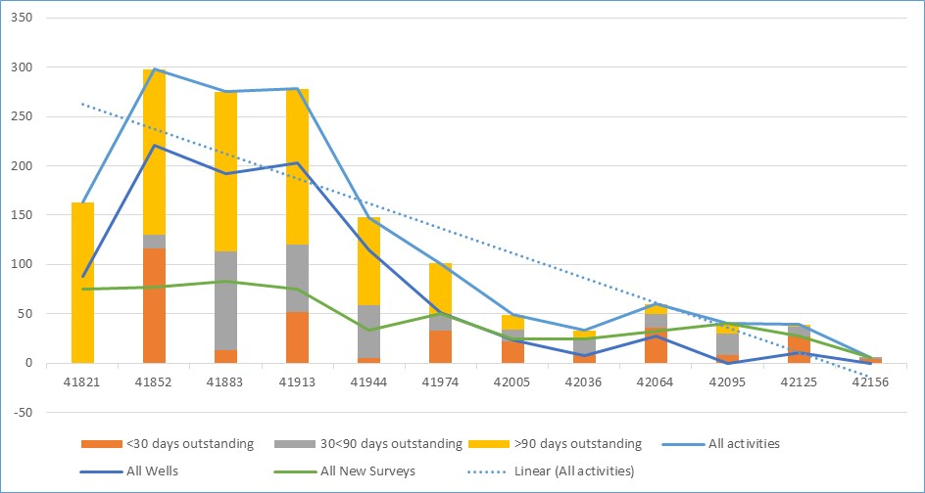

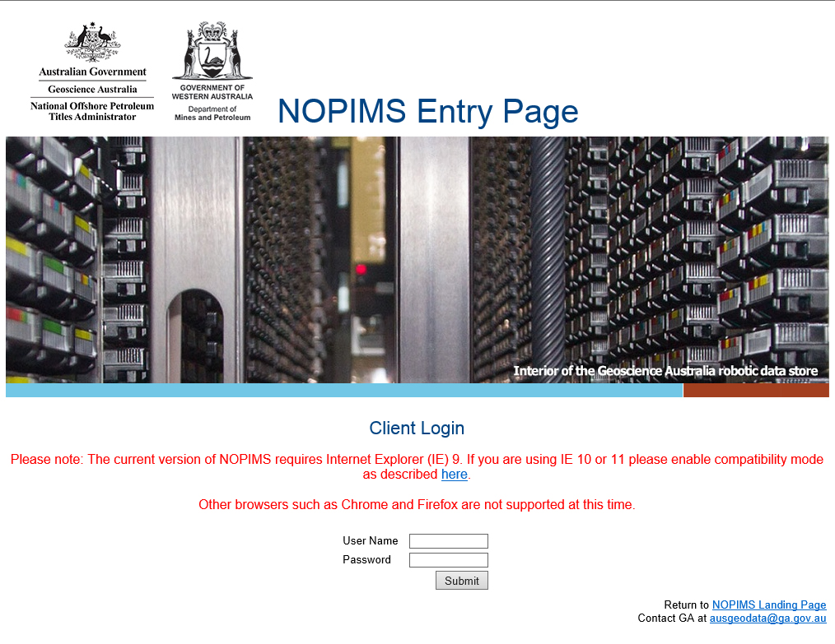
National Offshore Petroleum Data and Core Repository
Since its inception in 2012, NOPTA has established the National Offshore Petroleum Core and Data Repository (NOPDCR) in conjunction with Geoscience Australia (GA) and the Geological Survey of Western Australia (GSWA).
One of the significant improvements NOPTA has implemented has been in the handling and storage of data and core. To support these endeavours, NOPTA and GA undertook the development of a National Offshore Petroleum Information Management System (NOPIMS) throughout 2014–15. Once implemented, the NOPIMS will significantly improve the management of petroleum data during confidentiality period(s), and availability and access to the data for industry after open-file release.
Quality gaps in the legacy data will take additional focus and further time and resources to resolve. NOPTA and GA are addressing this with the intent to ensure a greater level of completeness and improved quality, and to and make that data available through the NOPIMS within a three year period.
The vast majority of the post 1 January 2012 data has been checked, uploaded into NOPIMS, and is becoming progressively available when authorised by NOPTA for release. There remains, however, an issue with the quality of legacy data (submitted prior to 2012) due to the differing compliance standards across jurisdictions at the time the data was collected.
All offshore petroleum mining samples from throughout Australia have been relocated from state custodianship and samples are now available to be viewed at either the Perth or Canberra repositories. Hard copy records have also been relocated and consolidated on a single site in Canberra. Through the NOPDCR relationship NOPTA is now working on full integration of these items to improve the comprehensiveness of the Commonwealth offshore data collection.

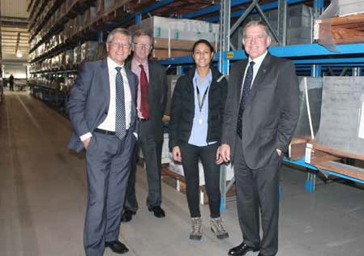
Figure 7: (left to right) WA State Minister the Hon W R (Bill) Marmion BE MBA MLA, Simon Bennison, CEO Association of Mining and Exploration Companies, Charmaine Thomas, Senior Petroleum Geologist GSWA Department of Mines and Petroleum, and former Commonwealth Minister the Hon Ian Macfarlane MP at the launch of the core store redevelopment at the Geological Survey Core Library in Carlisle.

Photo copyright Department of Mines and Petroleum, Western Australia.

Compliance and Operations Support
The Compliance and Operations Support Team (COPS) has four core functions:
- Compliance Policy and Enforcement
Compliance activities within NOPTA are devolved across all teams with responsibility for administering titles and the activities undertaken by titleholders. The COPS team is responsible for establishing and implementing a compliance policy across the organisation that ensures a consistent approach to the escalation and resolution of issues of non-compliance as they are identified.
In 2014–15 a compliance program has been developed using a risk based approach and analysis of historic data to identify potential areas of concern. Areas that are being considered as part of this program include the quality and completeness of information provided through the Annual Title Assessment Report, the measurement and level of compliance with Field Development Plans, work program compliance in Exploration Permits and reporting requirements relating to non-standard title conditions.
- Regulatory Advice & Deregulation
The COPS team provides regulatory support across NOPTA. This area also manages NOPTA’s relationship with the wider department in relation to policy, legislative and deregulation matters and acts as a central contact point.
In 2014–15 COPS has focused on preparing, and contributing to, internal and external guidance for staff and other stakeholders. This has taken the form of factsheets, guidelines, information on website pages and internal guidance notes. COPS has also been involved in amendments to the legislation and providing NOPTA’s input in relation to the government’s deregulation agenda. COPS continues to identify areas of improvement, balancing reducing regulatory burden with the effective management of oil and gas resources, around NOPTA processes and across the legislation.

- Commercial assessments
The COPS team provides input to economic and financial assessments required as part of the title administration and application processes. In particular they undertake assessments of commercial viability in relation to Retention Leases, input into the assessment of optimal recovery of petroleum, and assessment of the financial capacity of applicants when becoming titleholders or applying for new acreage.
This area has developed considerably over the past 12 months with new staffing resources being recruited and a significant increase in work load over earlier years. The commercial group within COPS is looking to develop and compile a database of information on the projects currently operating and being proposed as a reference point for future assessments and insight into the future pathways to commercialisation of known resources.
- Geospatial Services
The Geospatial Services group currently provides support to all teams within NOPTA as part of the titles administration and application process. That includes the production of maps for NOPTA’s title instruments, and advice to the Joint Authority, as well as providing access to an internal spatial viewing platform to assist with the decision making processes. Support is also provided to NOPSEMA with their spatial requirements.
Geospatial Services maintains the corporate spatial datasets to reflect the ongoing activities undertaken by the titleholders. Publicly releasable spatial data have been made available for external parties to download from the NOPTA website, this includes the petroleum titles and well locations.
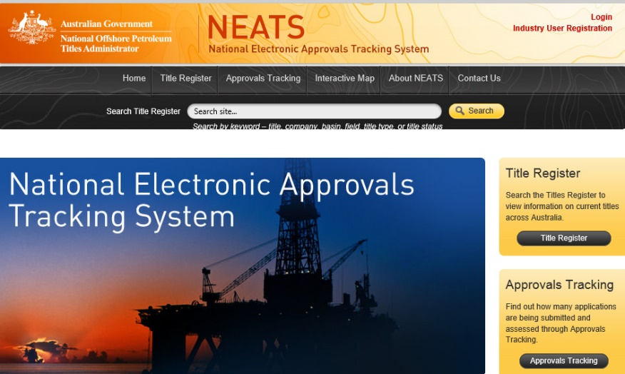
- NEATS
The COPS team has also been responsible for the oversight of the NEATS portal and the development of internal workflow systems. Significant work has been done internally to develop electronic workflows to improve the consistency of internal procedures and overall efficiency. The system incorporates electronic document management and integration with the NEATS administration portal and will enable NOPTA to provide more detailed application tracking to industry and internal management reporting on overall performance against benchmarks.
That development work is now reaching completion and is in the process of being deployed. We expect industry to see the benefit of this work over the coming year and opportunities exist for greater integration between NOPTA and industry through the NEATS portal. Responsibility for this work is currently being transitioned from the COPS team to an expanded ICT team within NOPTA.

Geoscience and Engineering
The Geoscience and Engineering Team (GET) facilitates the exploration and development of Australia’s offshore petroleum resources through the provision of high quality geoscience and engineering advice in relation to titles administration, acreage release and resource management.
GET contributed across three core functions throughout 2014–15:
- Titles Administration
Support for the titles administration process continued to involve the majority of GET’s available staffing resources. GET provided geoscience assessments and advice across the full gamut of petroleum titles in offshore Australia, from the assessment of the acreage release bids through to the evaluation of Field Development Plans. Progressive improvements in efficiency were made in these assessments, as staff became more experienced and new, streamlined approaches to the assessments were adopted.
- Resource Stewardship
Resource Stewardship was an area of increased focus throughout 2014–15, although the extent of the work has been limited by the lack of staff.
Work commenced on upgrading the accuracy and flexibility of the databases on the hydrocarbon reserves and resources of offshore Australia. This was an important step in developing a consolidated, consistent and agreed “point-of-truth” for understanding the nation’s current and likely future hydrocarbon inventory. The programme, which is ongoing, has updated the known resources and reserves in the Commonwealth’s exploration permits, retention leases and production licences.
A key undertaking was the instigation of a systematic approach to the characterisation and grouping of the Commonwealth’s producing and non-producing fields offshore. The goal is to provide the semi-regional to regional context for the individual development projects lying within a region, via the identification of the coherent production systems that lay within that area. A driver for that approach is the need to develop a “portfolio” understanding in the regulation of the offshore fields and pools, to complement the existing title-by-title approach which forms the primary basis for regulation. That will allow a better understanding of all of the aspects—including infrastructure, pool size and distribution, gas type and quality, water depth etc.—that contribute to the timing and types of developments employed offshore.
Another key activity in Resource Stewardship has been an increased effort on evaluating the production performance and efficiency of Australia’s offshore fields. Monitoring of the technical compliance between the production rates and approaches outlined in the approved development plan and those being achieved from these fields forms the first plank of technical compliance. In other words, the key question is whether the production from any field is consistent with the principles of good oil-field practice and achieving the optimal long-term recovery of hydrocarbons? In addition, there has been a focused investigation of a number of fields which, due to proximity and/or reservoir type, have the potential to interact significantly, and negatively, with each other on production timeframes. This work is ongoing.

- Special Projects
GET has provided significant input to the revised Offshore Petroleum Exploration Guidelines, released in May, the Offshore Petroleum Retention Lease Guidelines, currently out for industry consultation and the Greenhouse Gas Requirements and Assessment Guidelines, released in August 2014. Work on the Greenhouse Gas Declaration of a Formation Guidelines, Declaration of Location Guidelines and Petroleum Field Development Guidelines is progressing.
GET made a key contribution throughout 2014–15 to the Offshore Petroleum Resource Management Review, which was undertaken by the Department. GET provided technical input to the Review, the goal of which was to achieve the administrative and regulatory efficiencies in the management of the offshore petroleum industry.
In addition, GET’s involvement in the technical aspects of Browse Apportionment negotiations between the Commonwealth and Western Australia in regard to offshore boundary changes with respect to the Browse LNG Project (Torosa Field) was significant.

Information Technology
The Information and Communications Technology team (ICT) has three core functions:
- implementing NOPTA’s ICT strategy
- managing ICT contracts and services provided by external providers
- facilitating the development and administration of NOPTA’s business tools.
In 2014–15 ICT focused its attention on cross team discovery of data structures and connectivity between data sources to identify, plan and begin construction of an enterprise data model and centralised data repository.
In addition to this work, ICT also facilitated workflow processing of titles applications and core business systems. The service named “NOPTAnet” provides NOPTA staff with a collaborative workspace environment that tracks titles applications, compliance, data submissions, geotechnical reporting and corporate services in a centralised portal service. Staff interact with documents, data and information through quality scripted workflows to ensure consistency and accuracy in the decision making process.
Mapped closely to the Department’s ICT Strategy for 2014–18, the primary outcomes of these processes are:
- a reduction in red tape, access and collaboration of data used in decision making processes
- greater efficiency in information processing, increased productivity and data integrity and accuracy
- leveraging information and data from a “single source of truth”
- empowering staff with the tools, data and information needed to deliver highly collaborative decision making processes.
A major part of ICT delivery for 2014–15 has been the implementation of NOPTA’s electronic documents and records management system (EDRMS). NOPTA was awarded the 2015 National Archives Award for Digital Excellence in the small agency category—these awards recognise and promote excellence and innovation in the management, use and reuse of digital information by Australian Government agencies.

Strategic Coordination & Support
The strategic coordination and support team undertakes the necessary administrative and executive functions to enable NOPTA to meet its statutory obligations under the Public Governance, Performance & Accountability Act (PGPA) and to facilitate a safe and supportive workplace.
During 2014–15, the Corporate Support Team facilitated the implementation of a new 3–year NOPTA Corporate Plan, the Regulator Performance Framework, updated NOPTA’s Risk Register, and acted as a conduit for the statutory Ministerial Review of NOPTA operations, the Department’s internal audit of legislative compliance and the inaugural NOPTA survey of key stakeholders.
The Corporate Support Team also provided input into various procurement activities undertaken by NOPTA, including the tender for ongoing Sharepoint support and maintenance, and the renegotiation of the outsourced ICT managed services.
NOPTA’s Cost Recovery Implementation Statement was updated to meet the requirements of the revised Australian Government Cost Recovery Guidelines released in July 2014.
A minor reconfiguration of the Melbourne office was undertaken in liaison with the Department’s Property team.
NOPTA’s annual planning day was held in November 2014 and included a workshop on strategic management of regulatory and law enforcement agencies presented by the internationally acclaimed Professor Malcolm Sparrow from Harvard University, JFK School of Government.
Following Departmental approval, recruitment was also a key focus area for NOPTA with 11 positions advertised and the process was well advanced at 30 June 2015, with 8 new starters scheduled to start in July and August 2015.
There was high staff engagement in learning and development, with 100% of staff participating in ongoing learning activities that included technical courses, sponsored university study, conferences, targeted in-house workshops and international training and visits.
There were no staff resignations or redundancies recorded in 2014–15.

Outlook for 2015–16
NOPTA’s key work areas for 2015–16 include:
- implement improvement opportunities identified from the 2015 stakeholder survey report;
- work with other stakeholders as required to implement actions from the Resource Management review;
- enhance its competent capacity by seeking to recruit 5–8 specialists in the areas of geology, reserve/petroleum engineering, and geophysics to enable improved resource management and stewardship, reflecting the significant development projects in offshore Australia;
- commitment of $3.5 million over a 3–year period to migrate legacy data and make it available through the National Offshore Petroleum Information Management System in collaboration with Geoscience Australia;
- review and update NOPTA’s cost recovery implementation statement;
- enhancements of NEATS to meet industry calls for transparency of application tracking, greater automation, industry and Joint Authority portals, and facilitate payment by industry;
- ICT change management to reflect development in NEATS, workflows and increased business requirements;
- establish legislative compliance and deregulation unit to ensure continued compliance with and meet obligations under the Regulator Performance Framework; and
- implement recommendations of the Ministerial review.

Australian Offshore Petroleum Well Activity: 2012 to 30 June 2015 Australian Offshore Petroleum Survey Activity: 2012 to 30 June 2015
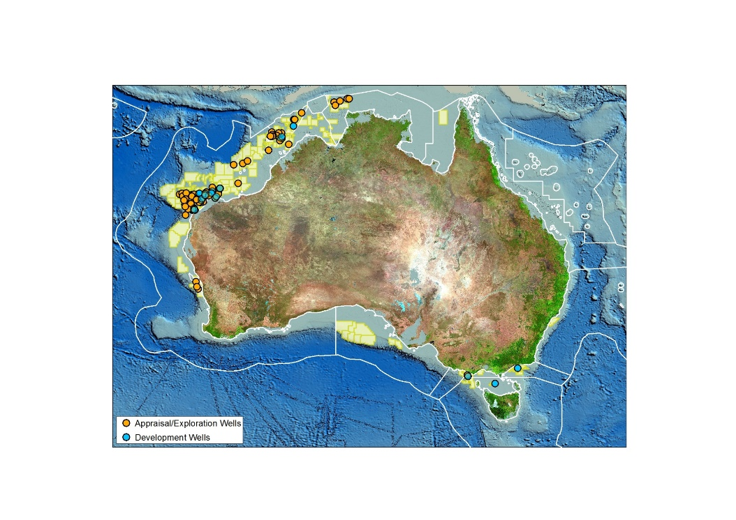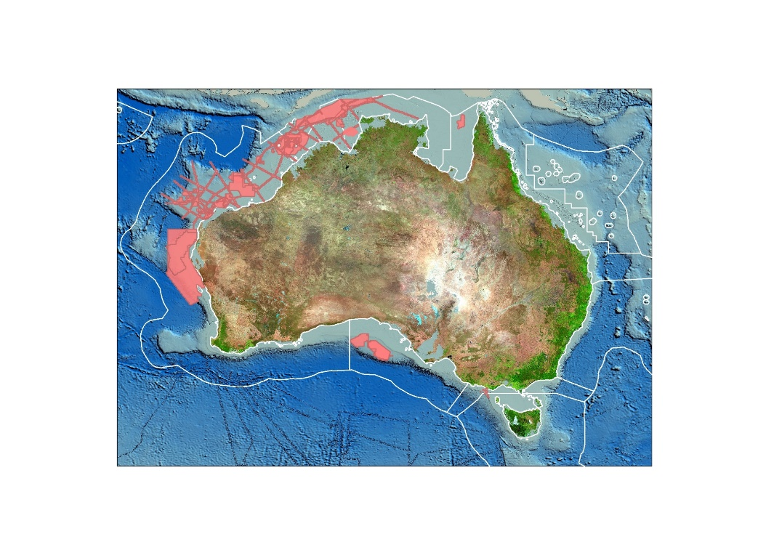

Now known as the Department of Industry, Innovation and Science
Offshore Petroleum and Greenhouse Gas Storage Act 2006
NOPTA’s Corporate Plan 2015–2017
Regulator Performance Framework
KPMG Stakeholder Survey Report 29 May 2015
National Offshore Petroleum Safety and Environmental Management Authority Financial Report on cost effectiveness NOPSEMA Operations Financial Year 2012–13
KPMG Stakeholder Survey Report 29 May 2015 pp. 8–9
Offshore Petroleum and Greenhouse Gas Storage (Regulatory Levies) Regulations 2004
Cost Recovery Impact Statement National Offshore Petroleum Titles Administrator 1 November 2013–30 June 2016 pp.15–16
Offshore Petroleum and Greenhouse Gas Storage (Resource Management and Administration) Regulations 2011

