



National Offshore Petroleum Data and Core Repository—

Commonwealth Offshore Petroleum and Greenhouse Gas

Sample Submission Standards


National Offshore Petroleum Titles Administrator, Department of Industry, Science, and Resources (DISR)

Geoscience Australia, Department of Industry, Science, and Resources (DISR)

Geological Survey of Western Australia, Department of Mines, Petroleum and Exploration

Document Control Information
Document owner: National Offshore Petroleum Titles Administrator
Endorsement body: National Offshore Petroleum Data and Core Repository
Publication dates: July 2015, March 2026
[Cover photo source: picturespider.com]

Further details of this publication:
National Offshore Petroleum Titles Administrator
Level 10, 58 Mounts Bay Road
GPO Box 7871
Perth WA 6850
data@nopta.gov.au

Contents
About offshore sample management 5
Best practices for processing drill core into trays 6
Common mistakes to avoid when processing drillcore into trays 7
Ditch cuttings 11
Sidewall core 12
Gaseous hydrocarbons and fluid samples 13
Thin sections 14
Samples submission addresses 15
How to apply for submission variations 15
Returned samples 16
Transporting samples 16
Labelling 17
Attachment A. NOPDCR—thin section transmittal 18
Attachment B. NOPDCR samples—transmittal 19

Figures
Figure 1 Correct core direction and layout in metal core trays 7
Figure 2 Correct core direction and layout in corrugated plastic trays 7
Figure 3 Well/tray information on both tray and lid 7
Figure 4 Core breaking away from main slab due to no end cap 7
Figure 5 Tight fitting plastic end caps with cap cut to fit core barrel 7
Figure 6 Rubber end caps 7
Figure 7 Heavy three-row four-inch and five-inch two-third core 8
Figure 8 Two-row four-inch and five-inch two-third core 8
Figure 9 No finger space 8
Figure 10 With good finger space 8
Figure 11 Core markers 9
Figure 12 Section inserts 9
Figure 13 Undersize core for tray sections 10
Figure 14 Oversize core for tray sections 10
Figure 15 Core sitting too low in tray 10
Figure 16 Correctly labelled ditch cuttings sample bags 11
Figure 17 Correctly labelled smaller sample boxes and larger transport boxes 11
Figure 18 Side wall core in aluminium foil 12
Figure 19 Correctly labelled side wall core jars with lids 12
Figure 20 Gas cylinder: 150cc internal volume 13
Figure 21 ¼" inline swage lock valve 13
Figure 22 1 litre screw-top Pyrex/Schott glass bottles 14
Figure 23 Example of unacceptable sample containers 14
Figure 24 Thin section case with slide dividers and index sheet 14
Figure 25 Pallet for transport with strapping, heat shrink wrap and labels 17

Attachments
Attachment A. NOPDCR—thin section transmittal 18
Attachment B. NOPDCR samples—transmittal 19

About offshore sample management
From 1 January 2012, the National Offshore Petroleum Titles Administrator (NOPTA) assumed responsibility for a range of regulatory and administrative functions for Commonwealth waters that had previously been the responsibility of the ‘Designated Authorities’.
In early 2012, NOPTA conducted a review of offshore physical data management to identify the most cost effective and efficient option for receiving, storing and providing access to offshore samples (cores, cuttings, slides etc). The review was conducted in collaboration with Geoscience Australia (GA) and in consultation with state/NT data managers, the Australian Energy Produces (AEP) and petroleum titleholders.
From this review the National Offshore Petroleum Data and Core Repository (NOPDCR) was established – operated in collaboration between NOPTA, GA and the WA Department of Mines, Petroleum and Exploration (DMPE).
The NOPDCR ensures that GA's Canberra Core Store continues to be the storage location for the 1/3 conventional core, one set of cuttings collected, and all fluid or gas samples required to be submitted under the Offshore Petroleum and Greenhouse Gas Storage (Resource Management Administration) Regulations (the regulations).
DMPE's Carlisle Core Store in Perth is the storage and sampling location for the 2/3 conventional core, one set of cuttings and side wall cores for the offshore Commonwealth jurisdiction.
Palynological, paleontological and petrological slides and residues are currently managed by the DMPE and also archived at Carlisle Core Store in Perth.
This document aims to outline a standard process that will assist those involved in the submission of samples, to help titleholders meet submission requirements under current and previous offshore regulations and to ensure samples are archived in the best way for future generations.

Best practices for processing drill core into trays

Under the regulations, section 136(4) and 184(4), the one-third core slab must be submitted to GA, before the end of the day, the day 12 months after the rig release date.
The two-third core slab must be submitted to the DMPE, before the end of the day, the day 18 months after the rig release date.
When processing drillcore into trays, consider the following as best practice, illustrated in Figure 1 below:
- All core trays –
  - core gets deeper from top of tray to bottom of tray.
  - core gets deeper from right to left in tray sequence.
  - all tray numbers are in sequence from right to left.
  - a new core number starts in a new tray (tray numbering sequence continues).
  - write well name, total tray depth range, core number, tray and total tray numbers.
  - core depths are written on the top and bottom of each core tray section.
  - a directional arrow is drawn at the start (highest) end of each tray.
  - all information must be written clearly in black indelible ink (permanent markers).
- For corrugated plastic trays –
  - well/ tray information is written on both tray and lid (see Figs 2 and 3).
  - repeat each tray’s last section depth (see Fig. 2).

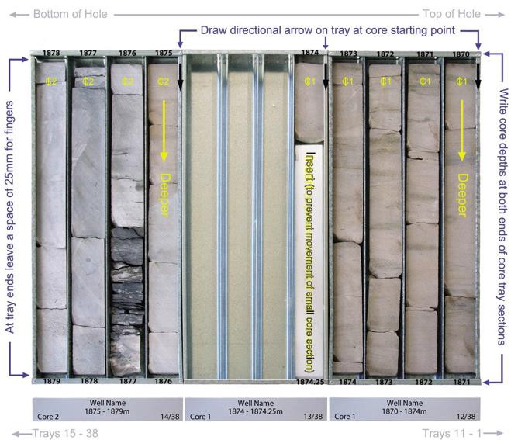
Figure 1 Correct core direction and layout in metal core trays

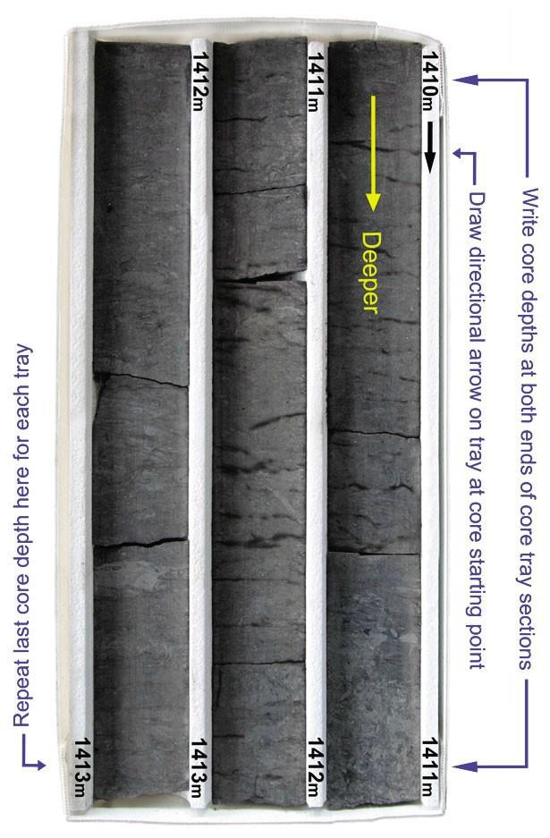
Figure 2 Correct core direction and layout in corrugated plastic trays
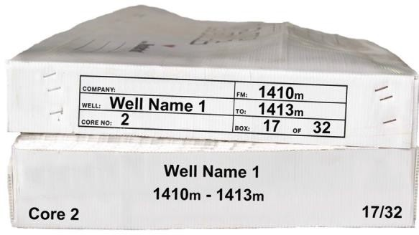
Figure 3 Well/tray information on both tray and lid

Common mistakes to avoid when processing drillcore into trays
Some common mistakes include:
- not using drillcore end caps,
- extra heavy trays,
- not leaving finger space, for lifting metal trays,
- not marking preserved, missing and sampled core sections,
- poor matching of core and tray sizes,
- core sitting too low in core trays.

Use of drillcore end caps
If the core is slabbed in its barrel, plastic or rubber end caps should be secured at both ends to prevent core loss. The cap should be cut as the core is slabbed and should sit ﬂush with the slabbed core surface.

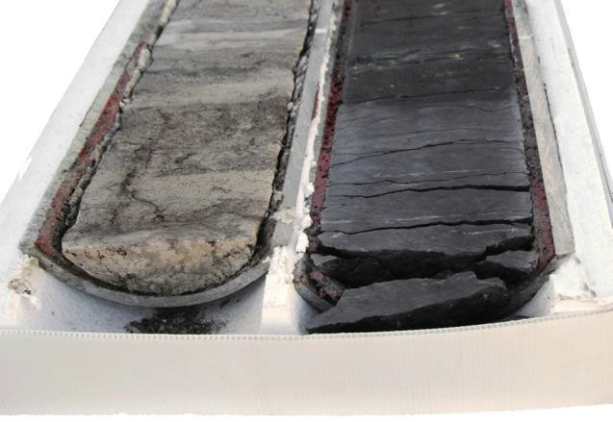
Figure 4 Core breaking away from main slab due to no end cap
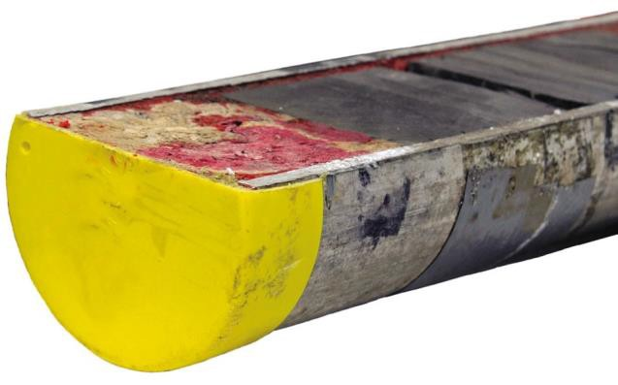
ü
ü
Figure 5 Tight fitting plastic end caps with cap cut to fit core barrel
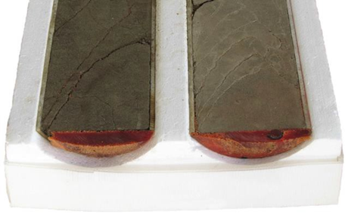
Figure 6 Rubber end caps

Avoid heavy trays
Two-third cores of four-inch and ﬁve-inch core diameters should be processed in two-row trays to help reduce manual handing issues. Individual core tray weights should not exceed 45 kilograms where practical. Where two-row trays will be above this weight, core should be processed in single-row trays.
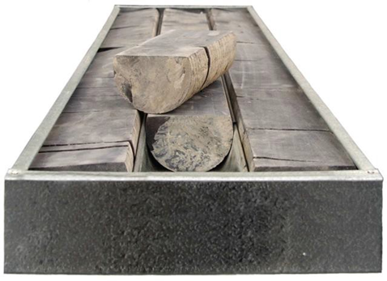
Figure 7 Heavy three-row four-inch and five-inch two-third core
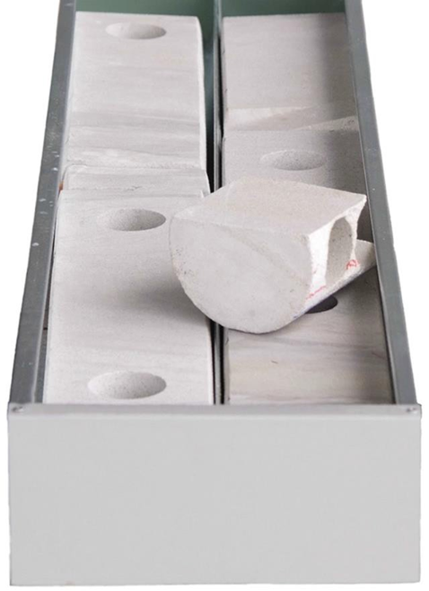
ü
Figure 8 Two-row four-inch and five-inch two-third core

Allow space for ﬁngers in metal trays
For metal trays where the core height is close to the tray lip, a 25 mm space should be left at each section end of core to allow for ﬁnger room when lifting trays.
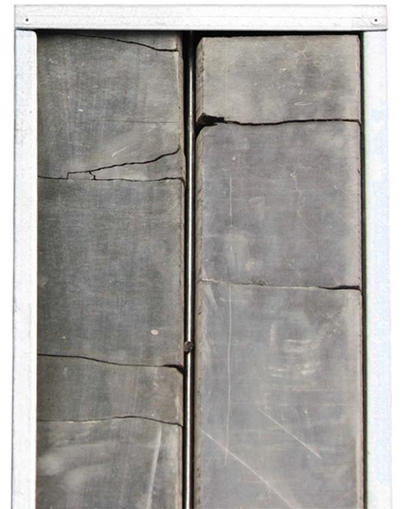
Figure 9 No finger space
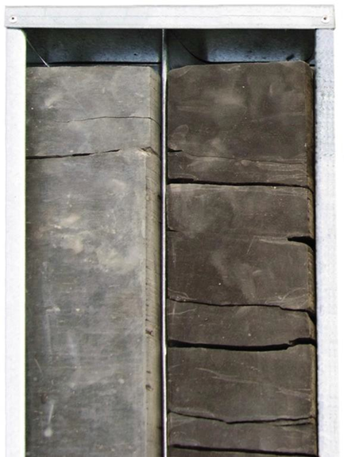
ü
Figure 10 With good finger space

Mark preserved, missing, and sampled core sections
Under sections 136(3) and 184(3) titleholders must apply to NOPTA for a submission variation prior to the submission due date and before undertaking core preservation. Requests to vary core submissions are assessed individually and where granted submission conditions may apply. Further information on the process of applying for a submission variation is provided on page 15.
Any preserved, sampled, or missing core must have markers in place at the location of the missing core. The marker must note the core as preserved, sampled, or missing, as well as including the depth ranges for that core as demonstrated in figure 11 below.
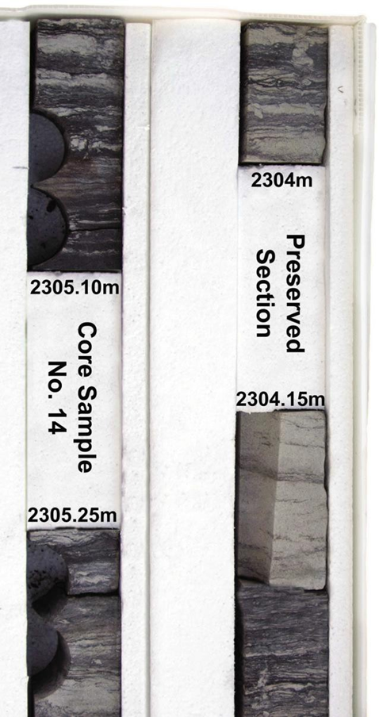
ü

Figure 11 Core markers

Use section inserts in trays
The use of section inserts in trays is recommended to prevent the movement of smaller lengths of core within the tray sections when handling and during the transport of core.
Styrofoam inserts are preferred, but if not available, bubble wrap or rolled newspaper can be used to stop the movement of smaller core sections.
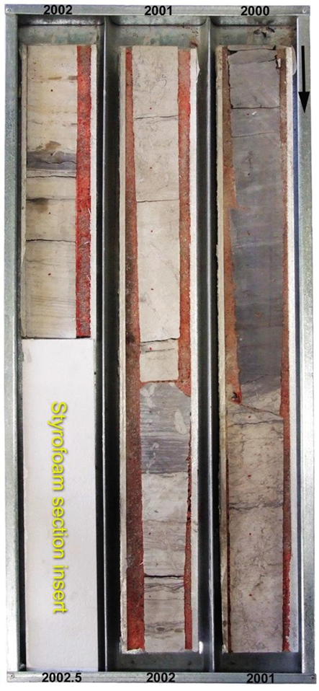
ü
Figure 12 Section inserts

Match the core and tray sizes
Metal and corrugated plastic core trays must be the correct dimensions to house the core. The core and barrel (if applicable) must sit securely within each individual tray section/divider. The slabbed surface of core must be clearly visible; it should not sit too low in the tray (Fig. 15) or have areas of core obscured by tray edges or lips. The core height must not be above the lip of the tray top, nor be able to rock from side to side excessively in tray sections.
The core height in the tray ideally should be close to the level of the tray lip.
When the sides of the metal tray are considerably higher than the core height, viewing is made difﬁcult.
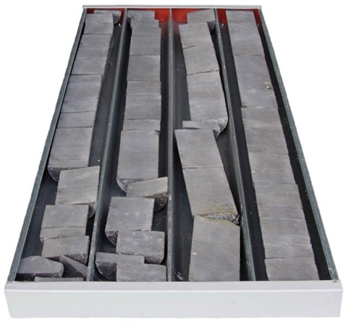
Figure 13 Undersize core for tray sections
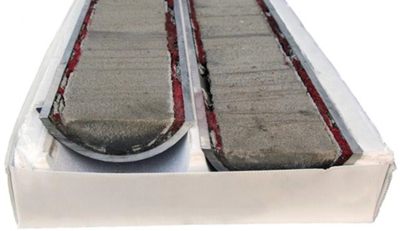
Figure 14 Oversize core for tray sections
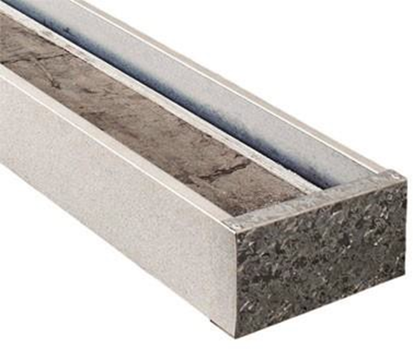
Figure 15 Core sitting too low in tray
Cardboard boxes
The NOPDCR discourages the use of cardboard boxes for processing because:
- long term storage of cardboard is susceptible to damage from oil and insects.
- cardboard boxes are more susceptible to crushing when stacked.
- regular handling of boxes leads to box deterioration, written well information on a cardboard box is more likely to be lost with regular handling.
- cardboard boxes are not made to fit the core; often the core is either packed too tightly or too loosely.
- viewing core in cardboard boxes can be difficult for geologists, often the core has to be removed from the box, which can lead to increased core damage.

Ditch cuttings
Under the regulations, sections 136(4) and 184(4), ditch cuttings are due for submission before the end of the day, the day 12 months after the rig release date.
Two sets of washed and dried cuttings sample at 200 grams dry weight, per sample interval are required for submission: one set to be submitted to both the GA (Canberra) and DMPE (Carlisle) NOPDCR repositories.
Samples should be packaged in metal plastic or plastic zip-locked bags and presented in the following format:
- Bags must be marked with indelible ink displaying the operators (company) name, a full non abbreviated well name, set number and from and to depth range in metres. Note that single depths on bags can cause confusion of the sample interval contained within.
- For metal plastic bags, staple an aluminium tag firmly impressed with a ball point pen displaying the submitting operators (company) name, a full non abbreviated well name, set number and depth range in meters.
- For plastic zip-locked bags, place inside an aluminium tag firmly impressed with a ball point pen displaying the submitting operators (company) name, a full non abbreviated well name, set number and depth range in meters.
ü
ü
Figure 16 Correctly labelled ditch cuttings sample bags
Sample bags should be contained in cardboard boxes with samples vertically positioned in the box. For archiving purposes, the preferred sample box dimensions should be 90x135x380cm or approximate.
The front of sample boxes should be clearly labelled with the submitting operators (company) name, a full non-abbreviated well name, set number and depth range in meters.
Each sample box should display a box number and maximum box number in the submission, i.e. box 9/10.
Sample boxes are best transported in larger securely packaged cardboard boxes, displaying the submitting operators (company) name, a full non abbreviated well name, set number and depth range in meters.
Each transport box should also display a box number and maximum box number in the submission, i.e. box 1/2.
Figure 17 Correctly labelled smaller sample boxes and larger transport boxes
A sampling summary must be provided with the sample shipment and detail the following:
- The depth range of samples and intervals of sample collection.
- All non-recovered and missing sample ranges must be noted with a reason for sample omission, e.g. high ROP, loss of circulation.
- A breakdown of the number of large transport boxes and sample boxes and the depth ranges contained within.

Sidewall core
Under the regulations, sections 136(4) and 184(4), sidewall core must be submitted to the DMPE Carlisle repository before the end of the day, the day 18 months after rig release date.
As specified under the regulations, all sidewall core material collected is to be submitted.
Where it is known that all material collected cannot be submitted, Titleholders are to apply for a submission variation from NOPTA (prior to the submission due date). Further information on the process of applying for a submission variation is provided on page 15.
Samples should be packaged and presented in the following format:
- Sidewall core material should be wrapped in aluminium foil and contained in glass jars sealed with a lid.
- Jars should be labelled with indelible ink displaying the operators (company) name, a full non-abbreviated well name, a sidewall core number and depth in metres.
ü
ü
Figure 18 Side wall core in aluminium foil
Figure 19 Correctly labelled side wall core jars with lids
- Foam packing should be inserted in boxes to secure bottles from movement during transport.
A sampling summary must be provided with the sample shipment and detail the following:
- The depth and depth range of samples collected and the corresponding sidewall core numbers.
- Any missed or non-recovered/lost samples.
- A breakdown of the number of large transport boxes and sample boxes and the depths contained within.

Gaseous hydrocarbons and fluid samples
Under the regulations, sections 136(4) and 184(4), for fluids collected during the drilling of a well, sample submission is due before the end of the day, the day 18 months after the rig release date.
If the fluid sample is collected during a test on a completed well, submissions are due before the end of the day, the day 18 months after collection of the sample.
Gas samples are due before the end of the day, the day 18 months after the rig release date.
Crude oil, condensate and natural gasses recovered are to be submitted to the NOPDCR, GA repository (ACT). Only samples acquired from wireline, drill stem, production tests or separator and stock tanks are required for submission. Manifold and well head samples, such as IsoTubes and IsoJars are currently not required for submission (unless specifically requested).
Gas and fluid samples must be representative of the reservoir and not the remaining fraction left in the cylinder after tests (PVT or other) have been performed.
Gas samples must be stored in appropriate stainless steel gas cylinders that are new, clean and evacuated prior to filling. Cylinders must be equipped with at least one on/off valve.
A total sample volume of 300 cc must be submitted as either one cylinder of 300 cc internal volume or two cylinders of 150 cc internal volume.

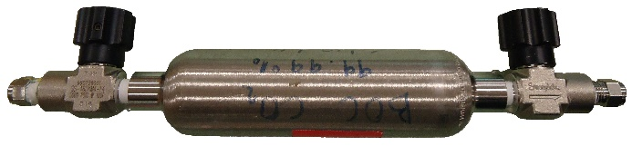
ü
ü
Figure 20 Gas cylinder: 150cc internal volume
Cylinders must be labelled with indelible ink and display:
- the operator (company) name,
- a non-abbreviated well name,
- sample number,
- temperature, date and time of sample capture and
- the pressure in PSI and volume of sample contained.
Samples obtained through wireline should be submitted at reservoir pressure where possible. Drill stem and pressure test surface samples should be submitted at sampling pressure.
Note: GA gas cylinders typically use a female ¼” NPT inline swage lock gas tight fitting, therefore a male ¼” NPT swage lock gas tight adaptor is used to connect to the parent cylinder.
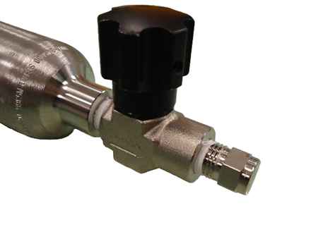
Figure 21 ¼" inline swage lock valve
The GA Laboratory typically uses cylinders rated to 1800 and 5000 psi, these can have 3000 psi valves, or 5000 psi valves attached (according to requirement). This means that they would be able to hold a gas sample of about 1800psi, 3000 psi and 5000 psi or whichever is the lowest working pressure rated component; cylinder or valve.
A sampling summary must be provided with the sample shipment and detail the following:
- The depth range of samples and intervals of sample collection.
- Sample number, temperature, date and time of sample capture and
- the pressure in PSI and volume of sample contained.
Liquid hydrocarbons recovered from a drill stem test or production test must be submitted at atmospheric pressure in a 1 litre screw top Pyrex/Schott glass bottle. 1 litre of liquid hydrocarbons is required.
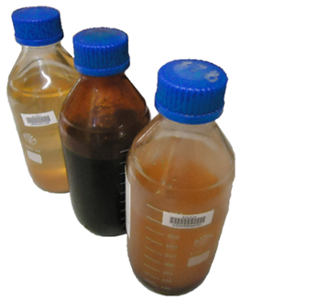
ü
ü
Figure 22 1 litre screw-top Pyrex/Schott glass bottles

Slides and Residues
Under the regulations, sections 136(4) and 184(4), all palynological slides and residues, paleontological material and petrological slides are due before the end of the day, the day 18 months after rig release date.
Slides should be submitted in cardboard or plastic hard cases (fig. 24) with slide slots and an index sheet within the box specifying a slide number, depth and description.
All slides are to be positioned in holding slots. Bubble wrap should be placed on top of slides with tape applied to secure slides in place and eliminate movement during transport. Adhesive tapes should not be applied directly to the slides.
Slide boxes and residues are to be wrapped with bubble wrap or foam packing material and securely sealed in cardboard boxes or cartons. Boxes are to be clearly labelled with a well name and a description of what is being submitted. To preserve slides, fragile stickers or appropriate labelling should be attached to transport boxes.
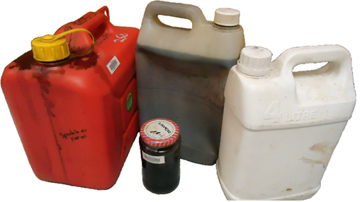
Figure 23 Example of unacceptable sample containers
Transport boxes are to be accompanied by a transmittal and manifest of the submission details.
Attachment A. Thin section transmittal should be completed and accompany the submission of thin sections and residues.
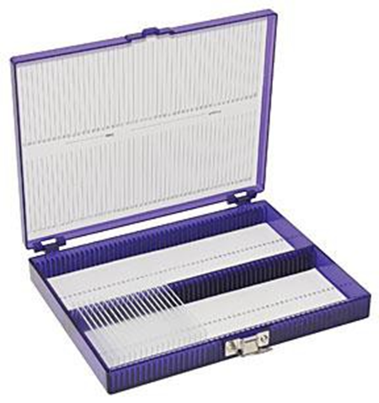
Figure 24 Thin section case with slide dividers and index sheet

Samples submission addresses
Sample type  Sample type | Submission address | Additional information
1/3rd conventional core, ditch cuttings, hydrocarbon samples (fluids and gases) | Manager  National Offshore Petroleum Data & Core Repository  Geoscience Australia  Cnr Jerrabomberra Ave and Hindmarsh DrSYMONSTON ACT 2609 | Advise ausgeodata@ga.gov.au prior to submission and CC data@nopta.gov.au.
2/3rd conventional core, ditch cuttings, side wall core | Manager  National Offshore Petroleum Data & Core Repository  Perth Core Library, 37 Harris Street  CARLISLE WA 6101 | Advise corelibrary.submissions@dmpe.wa.gov.au prior to submission and CC data@nopta.gov.au.
Thin sections, slides and residues | Geoscience Information Officer  Energy Exploration Information Geological Survey Department of Mines, Petroleum and Exploration  100 Plain Street  EAST PERTH WA 6004 | Advise petdata@dmpe.wa.gov.au, ausgeodata@ga.gov.au and data@nopta.gov.au.
Table 1 Outline of sample distribution to the NOPDCR

How to apply for submission variations

A variation to the submission requirements for offshore
petroleum and greenhouse gas samples may be
authorised by the Titles Administrator under sections
136 and 184 of the regulations.

Variations that may be considered include:

- extended submission timing,
- non-standard submissions,
non-standard sample size or quantity.

A request to vary submission requirements should be directed to data@nopta.gov.au prior to the sample submission due date and include the following information:

- title number(s),
- activity details, such as well name,
- the relevant regulation under which the request is being made (i.e., which submission requirement),
- the relevant submission type, such as 1/3 core or drill cuttings,
- the reason for this request,
- requested alternative, for example new submission date or quantity,
- any foreseeable impact the request may have on the availability of the sample for public release.
Where an approval to vary the submission is granted, the submission variation approval number should be quoted on all related correspondence and the relevant data submission transmittal(s).
Transmittals
All sample submissions must be accompanied with a transmittal.
Transmittals should list details of well names from which the sample has been acquired.
Careful attention should be paid to ensure well names are spelt correctly and depth ranges are accurately representative of the samples submitted.
The transmittal should include the following details as a minimum:
- The title under which the well was drilled under and the name of the company operating the title.
- A description of the samples being submitted e.g. conventional core, sidewall core, ditch cuttings etc.
- For conventional core the depths ranges, tray and core numbers, listing missing, preserved samples and core slab volume e.g. 1/3rd or 2/3rd.
Attachment B. NOPDCR transmittal template should be completed and accompany the submission of conventional core, sidewall core, ditch cuttings, hydrocarbon samples, returned samples and any “other” sample.

Returned samples
Under the regulations, section 165, samples sent for overseas analysis must be returned to Australia. Samples are to be returned 12 months after the day that the titleholder notified NOPTA of export, or, if the Titles Administrator agrees to another period – that other period.
Samples used in analysis and not consumed are to be returned to the repository from which the sample was acquired. If the sample was exported from contractor storage prior to government submission, samples should be forwarded to the DMPE Carlisle NOPDCR repository.
Any samples contaminated by analysis should be marked appropriately by the laboratory conducting the test. E.g. MICP.
Where used samples are not a good representation of the original sample, i.e. after selective rock typing/extraction, written advice should be provided with the returned sample.
A transmittal and manifest should accompany returned samples and detail the type of analysis conducted and details regarding the possibility of contamination.

Transporting samples
NOPDCR managers may refuse to accept delivery of samples that arrive without an appropriate transmittal or are incorrectly packaged or labelled. Such refusal will not remove from the titleholder the obligation of submitting samples in compliance with the regulations or these guidelines.
Pallet stacking and strapping
When transporting samples, please adhere to the following recommendations:
- Use good quality pallets with no loose boards or nails.
- Position trays and boxes centrally within pallet dimensions – no trays or boxes overhanging the pallet.
- To maintain tray stability do not stack trays or boxes too high on pallets.
- Lids must be fitted to top trays.
- A minimum of four well-tensioned straps are to be used to secure trays to pallets with straps around both front and sides of pallets.
- All pallets containing samples should be wrapped tightly with plastic pallet wrap or covered by purpose-designed LDPE heat shrink bags.
Where the use of heat shrink bags is not possible, hand-stretch wrap should be used to cover pallets to contain and protect boxes and trays.

Labelling
To assist with receiving samples, please ensure the consignment is labelled as follows:
- ‘To’ and ‘From’ address must be affixed to the front and rear of pallets.
- Pallet weight should be noted, if known.
- Pallet number should be displayed on each pallet e.g. 1/3, 2/3, 3/3.
- Pallets must not be double stacked.
- Pallets should always be loaded as a single layer on truck beds.
- If applicable, consignment barcodes are to be securely attached to pallets.

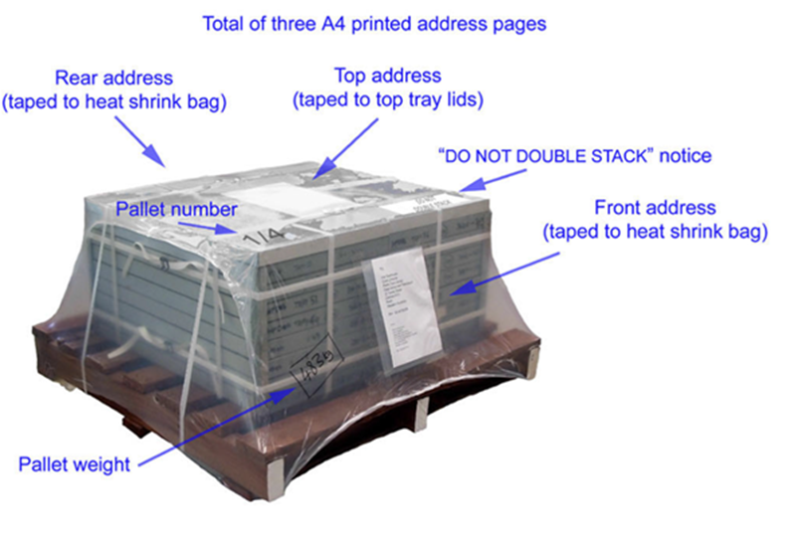
Figure 25 Pallet for transport with strapping, heat shrink wrap and labels

Version history
Version | Date | Comments
3.0 | July 2025 | Update department names and references and content in accordance with new RMA Regulations 2025
2.0 | February 2020 | Update the departments name
1.0 | July 2015 | Guidance document of submission standards

Attachment A. NOPDCR—thin section transmittal
Download the Physical samples transmittal on our How to submit page at https://www.nopta.gov.au/reporting-and-data-submissions/how-to-submit.html.

Attachment B. NOPDCR petroleum mining samples—transmittal
Download the Slides, residues and thin sections transmittal on our How to submit page at https://www.nopta.gov.au/reporting-and-data-submissions/how-to-submit.html.

