

Offshore Petroleum: Declaration of a Location Guideline

In relation to the *Offshore Petroleum and Greenhouse Gas Storage Act 2006*

Effective May 2019

This document has been developed as a general guide only. It is subject to, and does not replace or amend the requirements of the [*Offshore Petroleum and Greenhouse Gas Storage Act 2006*](https://www.legislation.gov.au/Series/C2006A00014) and associated Regulations, which should be read in conjunction with this guideline.

This guideline is made available by the Australian Government for information only. Before relying on this material, users should carefully evaluate the accuracy, currency, completeness and relevance of the information and obtain independent, legal or other professional advice relevant to their particular circumstances.

This document has been prepared by the [Australian Government Department of Industry, Science and Resources](http://www.industry.gov.au/Pages/default.aspx) . It will be reviewed and updated as required.

This document is available online at [www.nopta.gov.au](http://www.nopta.gov.au/)

**Contents**

1. Overview 3

2. Effect of a declared location on exploration permits 3

3. Process for declaring a location 4

4. Assessment of a declaration of a location nomination 5

5. Variation of a declared location 7

6. Revocation of a declared location 8

Attachment A – Locations flowchart…………………………………………………………………...………10

Attachment B – Suggested information to support a nomination to declare a location 11

# Overview

This Guideline provides information regarding the processes to declare, vary and revoke a location under Division 6 of Part 2.2 of the *Offshore Petroleum and Greenhouse Gas Storage Act* *2006 (*the Act). The Guideline also explains how declared locations impact on exploration permits and applications for retention leases and production licences (Parts 2.3 and 2.4 of the Act refer).

* A location provides the mechanism for the transition from an exploration permit to a retention lease or production licence following the discovery of petroleum. It is not a title; rather, it is a means of setting aside and identifying the graticular block or blocks within the permit necessary to cover the discovery from which the permittee may select the block or blocks to form a retention lease or production licence area.
* Retention lease and production licence applications may only be made over a block or blocks comprising a declared location. If two or more blocks are declared as a location, an application for a retention lease or a production licence may be made over some or all of the blocks.
* If the permittee has discovered petroleum through the drilling of a well, they must notify NOPTA of the discovery within 30 days after the completion of the well. There is no ability to extend this deadline (s. 284).
* For **information** about the obligations for notifying and reporting the discovery of petroleum, such as discovery notification and discovery assessment reports, please refer to Part 2 of the [*Offshore Petroleum and Greenhouse Gas Storage (Resource Management and Administration) Regulations 2011*](https://www.legislation.gov.au/Series/F2011L00647) (RMA Regulations) and the [*Petroleum Discoveries* fact sheet](https://www.nopta.gov.au/factsheets/petroleum-discoveries.html) on the NOPTA website.
* See **Attachment A** for a flow chart illustrating the applications that can be made by a permittee for either a retention lease or production licence over a block or blocks covered by a declared location.

# Effect of a declared location on exploration permits

* 1. A block or blocks comprising a declared location remain part of the exploration permit and are subject to the permit conditions, including the minimum work program requirements. Ongoing exploration within the block or blocks declared in the location is therefore expected. A block or blocks not subject to the declared location (including blocks removed from the declared location by variation or revocation—see sections 5 and 6 of this guideline) also remain in force within the exploration permit and subject to the permit conditions.
  2. A block or blocks declared as a location receive preferential status (s. 123(5)) under the halving rules in s. 123 and 124 of the Act with the result that they may be retained in the renewed exploration permit.
  3. A block or blocks that are no longer within a declared location, as a result of either revocation of the entire location (s. 132) or variation resulting in deletion of a block from the location (s. 133(1)(b)), will lose the benefit of preferential treatment under the halving rules in s. 123(5).
  4. For further information about renewing an exploration permit, and the application of the halving rules, please refer to the [*Offshore Petroleum Exploration Guideline*](https://www.nopta.gov.au/_documents/guidelines/Offshore-Petroleum-Exploration-Guideline-Work-bid-2019.pdf) and the [*Renewal of Work-Bid Exploration Permits-Standard Halving Rules*](https://www.nopta.gov.au/factsheets/renewal-of-work-bid-exploration-permits-standard-halving-rules.html) fact sheet on NOPTA’s website.

# Process for declaring a location

* 1. A block or blocks can be nominated as a location by the permittee (s. 129) or the Joint Authority can require the permittee to nominate blocks (s. 130).
  2. Nominations under s. 129 of the Act are submitted to NOPTA for decision by the Joint Authority.

## Timing – Joint Authority requires permittee to nominate blocks as a location

* 1. The Joint Authority can require a permittee to nominate a block or blocks as a location if it forms the opinion that a permittee is entitled to nominate the block or blocks (see section 3.1 of this guideline) but the permittee has not done so (s. 130).
  2. If the Joint Authority requires a permittee to nominate a block or blocks as a location, the Joint Authority will issue a notice to the permittee (via NOPTA) giving 90 days to make the nomination. Permittees can apply for an extension of up to another 90 days to make the nomination.
  3. If the permittee does not apply to declare a location over the identified block or blocks within the 90 day period (or 180 days if an extension is granted), the Joint Authority can nominate the blocks itself (s.130).

## Timing – nomination of blocks by permittee

* 1. Applicants should allow at least two months for the Joint Authority to make a decision on the declaration of a location application once all relevant material (including any response to a request for further information) is submitted to NOPTA.
  2. The nomination of blocks for the declaration of a location does not extend the term of an exploration permit.
  3. It is the permittee’s responsibility to maintain tenure of the underlying permit and to ensure the nomination is lodged in sufficient time to facilitate a decision to declare the location before the expiry of the exploration permit.

## Submission of a Nomination (Application)

* 1. Please refer to the application form for details and submission information, <http://www.nopta.gov.au/forms/forms.html>.
  2. The application fee for this application can be found at <https://www.nopta.gov.au/cost-recovery-and-fees.html> .
  3. Nominations should include the information specified in **Attachment B**.
  4. Nominations are assessed by NOPTA, who then provides advice to the Joint Authority.
  5. NOPTA may clarify any aspect of the nomination submission through a written request for further information to the permittee.

# Assessment of a declaration of a location nomination

* 1. The Joint Authority will declare a block or blocks as a location if it is satisfied that:
* the permittee is entitled to apply, and
* a petroleum pool(s) has been identified in an exploration permit, and
* petroleum has been recovered (see 4.2 below) from that pool(s), and
* the identified petroleum pool(s) is within the nominated block or blocks, generally based on a mid-case probability level of confidence.

**Attachment B** provides suggested supporting information to be included in the application.

* 1. The recovery of petroleum may be from within the permit area or from an area outside the permit into which the petroleum pool(s) extends. The petroleum can be recovered by the permittee or by another person (s. 129(1)).
  2. If two or more laterally distinct petroleum pools are identified in an exploration permit, one nomination may be lodged over all of the blocks to which the petroleum pools extend. However, the blocks being nominated must immediately adjoin each other (i.e. have a side in common) or be joined at one point (s. 129(3)). Please refer to the diagrams at Figure 1.

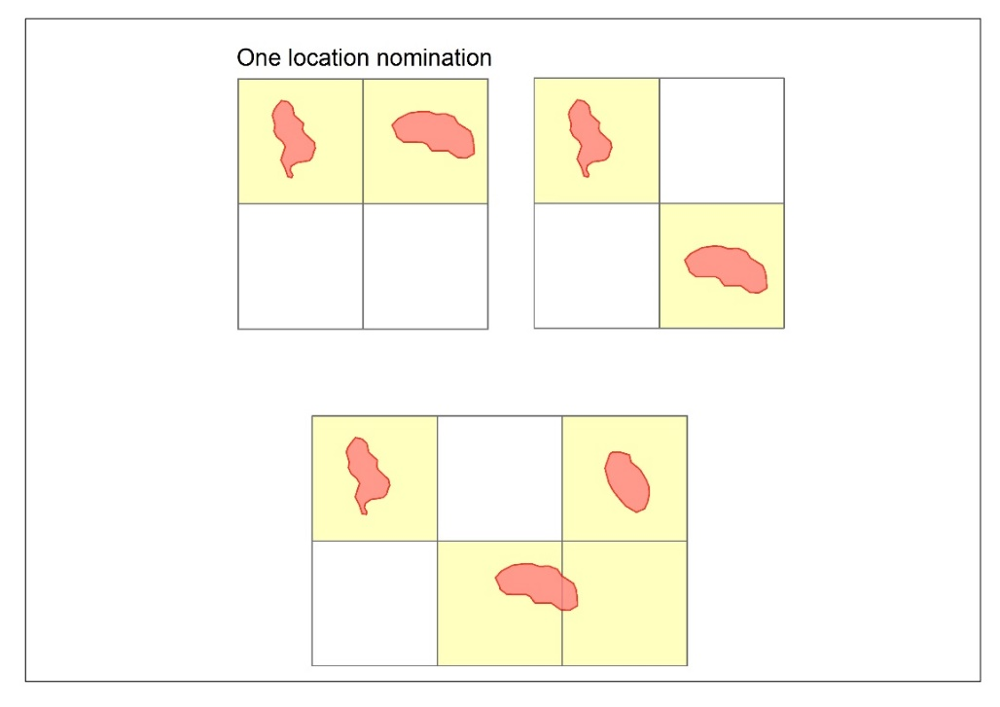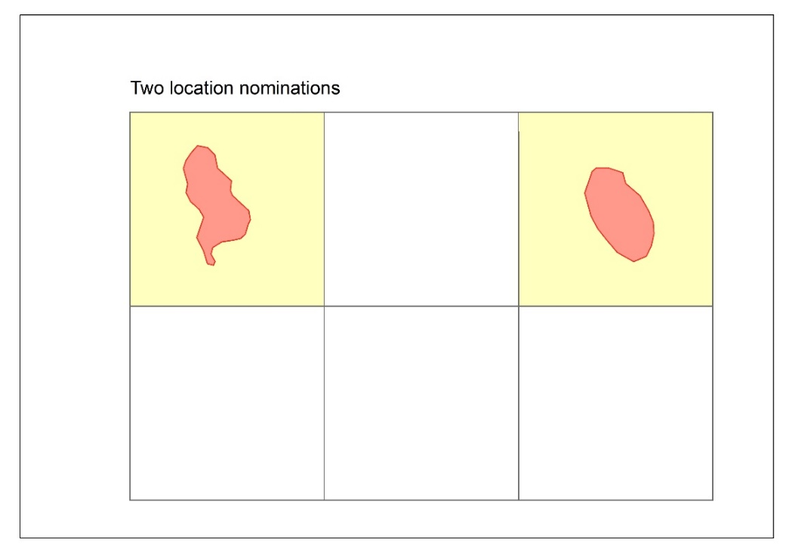  
***Figure 1:*** *laterally distinct petroleum pools (red polygons) may be the subject of one location nomination where the blocks within which the pools are located (yellow shaded areas) adjoin each other. This diagram illustrates three examples where a single nomination may be lodged; and one example where two separate nominations will be required. Examples are not exhaustive.*

* 1. In making its decision, the Joint Authority may have regard to any information, whether provided by the permittee or not (s. 131(3)).
  2. The Joint Authority will only declare a location over a block or blocks that it is satisfied that the pool(s) extends into, generally based on a mid-case probability level of confidence.
  3. The Joint Authority may decide that it is satisfied that the identified pool(s) extends to some, but not all, of the nominated blocks.
  4. If the Joint Authority is not satisfied that a petroleum pool has been identified within any nominated block or blocks, the nomination of that/those particular block or blocks will not be accepted by the Joint Authority (s. 131).
  5. If the Joint Authority decides that the permittee is entitled to nominate the block or blocks under s. 129, an instrument of declaration will be issued to the permittee and a copy of the declaration will be published in the *Australian Government Gazette* (s. 131(2)).

## Application period

* 1. A declared location comes into force for a two year period from the date on which it is declared, during which time the permittee may apply for a retention lease or a production licence in relation to the declared location (or to vary or revoke the location—see sections 5 and 6 of this guideline). This is called the ‘application period’.
  2. The two year application period may be extended for up to a further two years at the discretion of the Titles Administrator, if a written application for an extension is made by the permittee within two years from the date on which the location is declared (s. 141(3)(b) – retention leases and s 169(1)(b) – production licences).
  3. An application to extend the application period should be made at least 30 days before the end of the initial two year period after declaration of the location and include reasons for the application. (For example, the applicant should explain why it is not ready to apply for a retention lease or production licence; and provide details of its forward work plans to progress the location block or blocks towards either a retention lease or production licence).
  4. If an exploration permittee **takes no action** in relation to a block or blocks in a declared location before the expiration of the application period (i.e. does not apply for a retention lease or production licence, or has not applied for and received notice that the Joint Authority has revoked the declaration of location), the block or blocks will revert to vacant acreage[1] and no longer form part of the exploration permit area (s. 188).

# Variation of a declared location

* 1. A declared location may be varied to either add or remove a block (before the end of the ‘application period’ described above) if the relevant criteria are met (s. 133). For example, an application of this type may be made when new geoscientific information reveals that the petroleum pool(s) is within fewer blocks, or extends to an extra block, within the existing exploration permit.
  2. A variation of a declared location can be made be at the permittee’s request, or required by the Joint Authority (s. 133(3)).
  3. A declared location can only be varied to add or remove a single block, per variation application submission. Separate applications (per block) are required to add or remove additional blocks.
  4. A variation of a declared location does not extend the original application period in which the permittee must apply for either a retention lease or production licence.
  5. If a declared location has been varied so that it is over one less block, the block that has been removed remains part of the exploration permit and continues to be subject to the permit conditions.
  6. Applications to vary a declared location should be made in writing at least six months before to the end of the application period. An application form is available at <http://www.nopta.gov.au/forms/forms.html>.
  7. The assessment criteria used by the Joint Authority for a decision to vary a declared location require similar information to that required for an initial declaration of a location, and the application should include the information specified in **Attachment B**.

# Revocation of a declared location

* 1. The permittee can request that the declared location be revoked before the end of the ‘application period’ (s. 132) (see sections 4.9 – 4.12 of this guideline for definition of the ‘application period’).
  2. A revocation can only be made for the entire declared location (s. 132). If a titleholder wishes to remove only a single block from the declared location, the titleholder should consider applying to vary the location (see section 5 of this guideline).
  3. The revocation of a declared location will result in the block or blocks remaining part of the exploration permit and continuing to be subject to the permit conditions.
  4. A request to revoke a declared location should be made at least three months before the end of the ‘application period’. The permittee should include reasons for the request and demonstrate that there are sufficient grounds for the revocation. An application form is at available at <http://www.nopta.gov.au/forms/forms.html>.
  5. A request to revoke a location will generally not be approved if the purpose of the revocation is to reapply for the declaration of a location over the same accumulation.

## Blocks no longer part of an exploration permit, retention lease or production licence

* 1. The Joint Authority must revoke a declared location if an exploration permit is no longer in force over a block or blocks that form part of the declared location (s. 132(3)).
  2. This ensures that a block or blocks that have reverted to vacant acreage (e.g. following expiry of a permit) do not remain covered by a location if a new exploration permit is awarded through a subsequent acreage release process.
  3. A declared location will not be revoked on the grounds of expiration of the exploration permit while an application for a retention lease or production licence is under consideration by the Joint Authority (s. 132(4) and (5)).
  4. If a permittee applies for a retention lease or production licence in respect of some or all of the blocks in a declared location, and the Joint Authority refuses to grant a retention lease or production licence over any of the blocks that were applied for, because it is not satisfied that:

1. the block or blocks contain petroleum; or
2. recovery of petroleum from the block or blocks is likely to become commercially viable within 15 years;

the Joint Authority must revoke a declared location in relation to the block or blocks that was/were refused (s. 132(7), (7A), (8) and (9)). If the underlying exploration permit remains in force, the revoked declared location block or blocks remain part of the exploration permit and continue to be subject to the permit conditions. If the permittee wants to later apply for a production licence or reapply for a retention lease over the block or blocks, the permittee must re‑nominate the block or blocks as a location before making the application.

**Table of revisions**

| Date | Version | Purpose | Jurisdiction |
| --- | --- | --- | --- |
| July 2022 | 4 | Update department name | Commonwealth |
| February 2020 | 3 | Update department name | Commonwealth |
| May 2019 | 2 | Clarification on application process | Commonwealth |
| July 2017 | 1 | To establish a Guideline for the Declaration of a Location. | Commonwealth |



# Attachment B – Suggested information to support a nomination to declare a location

Suggested information for inclusion in a nomination to declare a location, as applicable to the individual circumstances of each nomination.

## Supporting Documentation

The supporting documentation should include a discussion of the regional exploration completed to date. It should also include a detailed discussion of the geological setting of the identified petroleum pool(s), especially within the exploration permit where it is located.

## Exploration Context of Permit and Pool(s) under Consideration

* Title Summary (short summary of the title ownership and exploration work program)
* Exploration and discovery history
  + Wells drilled
  + Well results
  + Adjacent fields
* Geological Setting
  + Play types
  + Petroleum systems
    - Trap types
    - Reservoirs, seals
    - Source rocks
    - Stratigraphy
* Petroleum pool(s)
  + Trapping mechanism(s)
  + Reservoirs, seals
  + Estimated hydrocarbon volumes in place and estimate of recoverable hydrocarbons

## Petroleum Pool(s)

* Recoveries and types of petroleum recovered
  + Nature of testing; volumes recovered
  + Formation(s) from which petroleum was recovered
  + Depths of hydrocarbon recoveries and pressure tests
  + Validity of tests and recoveries
* Nature of hydrocarbons recovered; analyses and compositions of hydrocarbons recovered
* Pressure system(s) present
  + All available pressure data including any identified or interpreted fluid contacts, such as hydrocarbon-water contacts
* Evidence for compartmentalisation in pool and aquifer; potential effects of faulting?

## Lateral and Vertical Extents of Pool(s)

* Evidence for the distribution of the pool(s) in the reservoir(s) within the exploration permit and block or blocks at Low, Mid and High (or 3C-2C-1C or P10-P50-P90) confidence levels
* Discussion of the uncertainties associated with seismic data interpretation, including (but not limited to) depth conversion (and mapping) and amplitude mapping

## Digital Data

* Application document should be submitted in both editable PDF and Microsoft Word formats
* Correctly geo-referenced image files of reservoir structure and other maps

## Figures to Be Provided

The following figures[2] should be included:

* Regional map showing the location of the exploration permit and petroleum pool(s)
* Detailed map, at the permit scale, showing key wells, hydrocarbon pool(s) and field(s) and petroleum infrastructure[3]
* Geological map of pool(s) under application, including wells, significant faults, etc.3
* Reservoir two-way-travel time (TWT) and depth structure maps, as well as distribution of pools at the Low, Mid and High (or 3C-2C-1C or P10-P50-P90) confidence levels to be shown in relation to relevant graticular blocks and the exploration permit. Locations of any seismic or cross-sections used to create the supporting documentation should be annotated3
* Relevant stratigraphic column
* Well log and stratigraphic correlations
* Pressure versus depth data plots for any wells essential to defining the pool(s). These should clearly shows all valid data points and interpreted fluid gradients; a lithological “strip” log of the well should appear on the depth axis of the plot.
* A composite pressure data versus depth plot of all pressure data and fluid gradients from all relevant wells for which data is available. Relevant wells may include wells that demonstrate the extent of the pool(s), support the regional aquifer interpretation or demonstrate the relationship, or lack of relationship, with other near-by accumulations.
* Dip and strike TWT seismic lines across the pool(s), showing well locations within the exploration permit, relevant graticular block or blocks and title boundaries, as well as the positions and extent of the pool(s). Any seismic lines that are available in Depth should be provided also.
* If seismic data extractions are to be submitted, the following should be noted:
  + Amplitude extractions are preferred. Extractions from any other seismic products should be accompanied by comparable amplitude extractions.
  + If angle stack extractions are provided, the full range of angle groupings should be provided such as full, near, mid and far. The definition of each grouping expressed as an angle range should be included.
  + Any seismic data extraction should be unambiguously labelled as to the type of seismic data product used, and a description of the criteria of extraction included.

1. ‘Vacant acreage’ is the term generally used to refer to an area not subject to an existing petroleum exploration permit, retention lease or production licence)
2. Should be provided within the text and also as separate files in a ‘Figures’ appendix (>300 dpi eps and jpg formats)
3. * Should be provided in appropriate geo-referenced file formats in a ‘Spatial Data’ appendix