Change in Control of a Registered Titleholder
All information should be read in conjunction with the Offshore Petroleum and Greenhouse Gas Storage Act 2006 (the OPGGS Act), associated regulations, relevant guidelines and policies (available on NOPTA’s website).

The purpose of this document is to provide additional information about what constitutes ‘control’ of and ‘a change in control’ of a company who is a registered holder of a title (or registered titleholder), as set out in Part 5A of the OPGGS Act. It also provides examples to illustrate how some of the other change in control provisions work, as outlined in the Guideline: Transfers, Dealings, Change in Control and Other Titleholder Transactions.

Please note: this document is intended as a guide only and should not be relied on as legal advice or regarded as a substitute for legal advice in individual cases.

Overview

Chapter 5A of the OPGGS Act sets out the legislative provisions relating to a change in control (or ownership) of a registered holder of a pipeline or infrastructure licence; a petroleum exploration permit, retention lease or production licence; or a greenhouse gas (GHG) assessment permit; holding lease or injection licence.

A change in control under Chapter 5A of the OPGGS Act is a commercial transaction or agreement that is not captured by the transfer of title or the dealing provisions in Parts 4.3, 4.6, 5.3 and 5.6 of the OPGGS Act.

Definition of ‘control’
A person ‘controls’ the registered titleholder where the person either (s 566B(1)):
    - holds the power to exercise, or control the exercise of, 20 per cent or more of the voting rights in the registered holder; or
    - holds, or holds an interest in, 20 per cent or more of the issued securities in the registered holder.

Acting jointly or alone
This includes where the person is either acting alone or jointly with one or more other person(s). A person ‘acts jointly’ with another person(s) where the person acts or is accustomed to acting in agreement with, or in accordance with the wishes of, the other person(s) (s 566B(2)).
For example, two or more related bodies corporate or joint venture partners that collectively acquire or dispose of voting rights or issued securities in a titleholder may acquire control of—and consequently trigger the definition of a change in control of—the registered titleholder, even if each body or partner will individually hold a percentage of voting rights or issued securities that is less than 20 per cent.

Voting rights & issued securities
The terms ‘voting rights’ and ‘issued securities’ are not defined in the OPGGS Act and therefore their ordinary meanings apply.

Definition of ‘change in control’
A ‘change in control’ occurs where (s 566B(4)):
    - one or more other persons, alone or acting jointly, begin to control the registered titleholder by acquiring voting rights or issued securities in the titleholder so that the person(s) holds at least 20 per cent of the voting rights or issued securities; or
    - one or more other persons, alone or acting jointly, who currently controls the registered titleholder ceases to control the registered titleholder by disposing voting rights or issued securities in the titleholder so that the person(s) cease to hold at least 20 per cent of the voting rights or issued securities.

Control versus ownership
‘Control’ of a registered titleholder captures both ‘control’ and ‘ownership’. A ‘change in control’ of a titleholder therefore applies both to persons who propose to:
    - be in a position to exercise control or influence over the titleholder (control); and
    - hold a substantial interest in the titleholder but may not be able to exercise such control or influence (ownership).
For example, a person may acquire 20 per cent of the shares in a titleholder and thereby become a significant source of the financial resources available to the titleholder. However, the person may be unable to exercise control or influence over the titleholder because of the nature of those shares (for example, the shares do not confer voting rights).

Examples of a change in control
The following are examples of transactions that effect a change in control of a registered titleholder, involving persons either beginning or ceasing to control the titleholder or both:
    - Entity A holds 100 per cent of the shares in a titleholder but transfers all its shares to Entity B. Entity A ceases to control the titleholder and Entity B begins to control the titleholder.
    - Entity A holds 100 per cent of the shares in a titleholder and transfers 20 per cent of its shares to Entity B. Entity A neither begins nor ceases to control the titleholder (Entity A retains control), but Entity B begins to control the titleholder.
    - Entity A and Entity B each hold 50 per cent of the shares in a titleholder. Entity A transfers all of its shares to Entity B. Entity A ceases to control the titleholder, but Entity B neither begins nor ceases to control the titleholder (Entity B retains control).
    - Entity A and Entity B each hold 50 per cent of the shares in a titleholder. Entity A transfers 40 per cent of its shares to Entity C. Entity A ceases to control the titleholder, Entity B neither begins nor ceases to control the titleholder (Entity B retains control) and Entity C begins to control the titleholder (see Appendix 1).
Note: If a person currently controls a titleholder (for example, the person holds 20 per cent of the shares in the titleholder) and proposes to increase its shareholding, the person is not required to apply for approval because the person already controls the titleholder—there is no change in control.
Similarly, a person who controls a titleholder may dispose of its shares in the titleholder without approval, provided that the person does not cease to control the titleholder by decreasing its shareholding to less than 20 per cent.

Applications required
Separate applications must be made with respect to each registered titleholder company that will be subject to a change in control, rather than with respect to each title.

Therefore:
    - if a company is the registered holder of more than one title, only one application is required to be made for approval of the change in control in respect of the registered titleholder company (see example 1 below).
    - If a single transaction involves a change in control of more than one company who is a registered titleholder, separate applications for approval of change in control must be made in respect of each registered titleholder company (see example 2 below).

Example 1: change in control in respect of one company which is a registered holder of multiple titles
Entity A holds 100 per cent of the shares in Entity B which is the registered holder of three production licences. Entity A enters into an agreement to sell its controlling interest in Entity B to Entity C. When the agreement comes into effect, Entity A will cease to control the registered titleholder (Entity B) and Entity C will begin to control the registered titleholder.
One application is required because the proposed change in control only relates to one company which is a registered titleholder – Entity B. Separate applications are not required in respect of each production licence held by Entity B. (Note, both Entity A and Entity C are eligible to submit the application as both are either beginning or ceasing to control Entity B.)

Example 2: change in control in respect of multiple companies who are registered holders
Entity A holds 100 per cent of the shares in Entity B and Entity C, which are jointly the registered holders of three production licences. Entity A enters into an agreement to sell its controlling interest in Entities B and C to Entity D. When the agreement comes into effect, Entity A will cease to control the registered titleholders (Entities B and C) and Entity D will begin to control the registered titleholders.
Separate applications are required to be submitted in respect of Entity B and Entity C who are both companies who are registered titleholders, however separate applications are not required in respect of each production licence held by those registered titleholders. Therefore, a total of two applications will be required.

Operation of the tracing provision (s566Z)
Section 566Z enables a change in control of a registered holder of a title to be traced to a change in control of the companies, trusts or partnerships that control the titleholder.
The tracing provisions operate to extend the group of persons deemed to control a registered holder of a title such that a person so deemed can be traced all the way though the chain of ownership

Questions
If you have any questions about this factsheet, please contact NOPTA via titles@nopta.gov.au.

Version history
Version | Date | Comment
1.0 | February 2022 | Creation of factsheet

Appendix 1
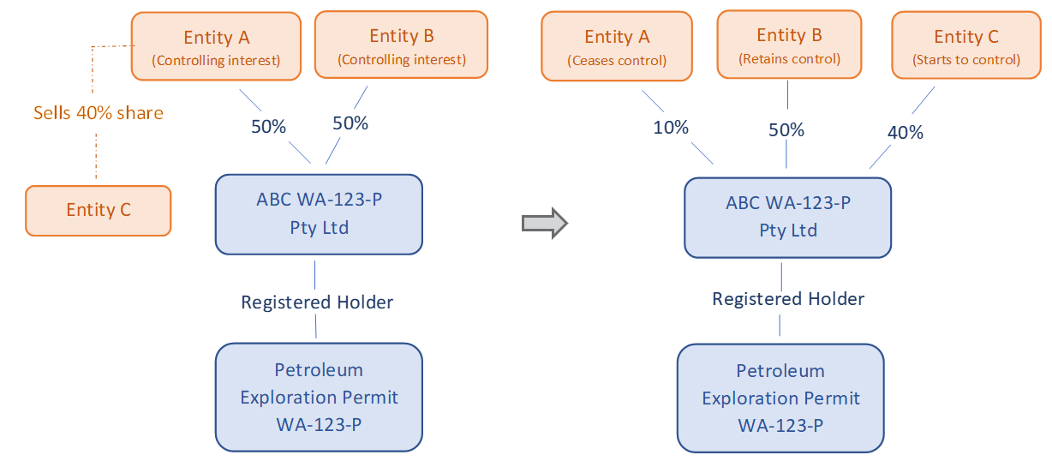

In this example, Entity A and Entity B each hold 50 per cent of the shares in company ABC WA-123-P Pty Ltd, who is the registered holder of Petroleum Exploration Permit WA-123-P. Entity A transfers 40 per cent of its shares in company ABC WA-123-P Pty Ltd to Entity C, reducing its shareholding to 10 per cent. Entity A ceases to control the titleholder (<20 per cent shareholding), Entity B neither begins nor ceases to control the titleholder (Entity B retains a 50 per cent shareholding) and Entity C begins to control the titleholder (by acquiring a 40 per cent shareholding).

Appendix 2
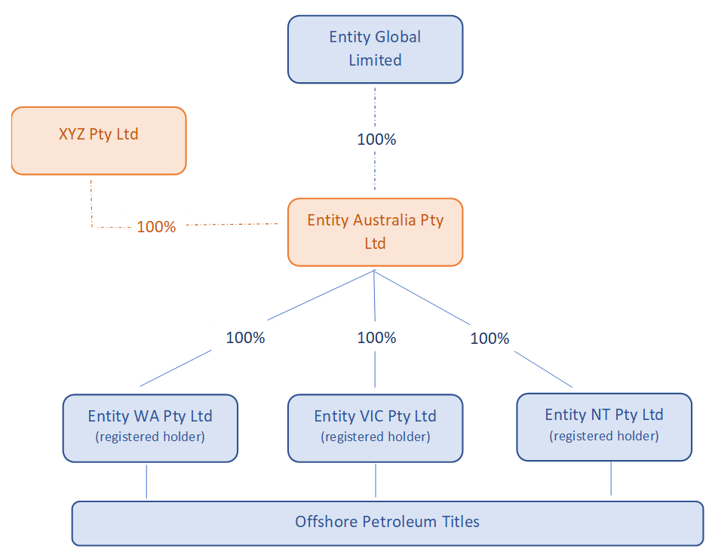

In this example, Entity Global Limited (EGL) holds 100 per cent of shares in Entity Australia Pty Ltd (EA) which in turn holds 100 per cent of shares in three subsidiaries each of whom hold offshore petroleum titles.
The s 566Z tracing provision operates so that effective control of the three companies, which are registered holders of offshore petroleum titles, can be traced up through the chain of companies to EGL.
If EGL wishes to sell 100 per cent of its shares in EA to XYZ Pty Ltd, EGL would cease to control, and XYZ Pty Ltd would begin to control, the companies who are registered holders of offshore petroleum titles.
This transaction would therefore be subject to the change in control provisions and require the Titles Administrator’s approval. XYZ Pty and EGL are both eligible to apply for approval of the proposed change in control (s 566C) because XYZ Pty Ltd is proposing to begin controlling the titleholders and EGL is proposing to cease controlling the titleholders. EA is not eligible to apply as it is neither beginning or ceasing to control a registered holder of a title – it is the subject of the transaction in question.

