Field Development Plan – Content Requirements and Assessment
All fact sheets should be read in conjunction with the Offshore Petroleum and Greenhouse Gas Storage Act 2006 (the OPGGS Act), associated regulations, relevant guidelines and policies (available on NOPTA’s website).

This Fact Sheet provides information on the content requirements for Field Development Plans (FDPs) set out in the Offshore Petroleum and Greenhouse Gas Storage (Resource Management and Administration) Regulations 2025 (Cth) (the Regulations). All section references in this fact sheet pertain to the Regulations unless otherwise stated.
Field development planning is one phase of a typical lifecycle of a petroleum resource. An FDP is one of the Joint Authority (JA) approvals required to develop petroleum resources in offshore areas (for more information please see the Fact Sheet – Developing a Petroleum Resource).
The key objectives of an FDP are to document and communicate the subsurface development strategy and management plan, including wells and the associated sub-sea and surface facilities and activities.
The Titles Administrator, as technical advisor to the JA, assesses FDP applications and provides advice to the JA.
For more information about the field development planning process and the regulatory submission requirements for an FDP, refer to the FDP Regulatory Submission Requirements Fact Sheet

What should an FDP Contain?

Introduction
The appropriate content is critical to fulfilling the criteria for acceptance of an FDP under section 44 of the Regulations.
Subsection 45(1) of the OPGGS Act specifies the minimum mandatory content requirements of FDPs and describes the types of information required rather than the precise information and data to be included. This is consistent with the principles of objective-based regulation and provides flexibility for different development projects and concepts.
The key objectives of an FDP are to document and communicate the subsurface development strategy, including a description of project phasing, schedules and facilities requirements (i.e. wells and associated subsea and surface infrastructure to support production, injection, processing, storage and export operations).
The FDP must demonstrate that pool management in the field will be conducted in a manner consistent with good oilfield practice and optimum long-term recovery of the petroleum. For further information refer to the Assessment section below.
Undertaking early engagement activities with the Titles Administrator, including submission of a pFDP, will help ensure clarity of requirements, assessment processes, timeframes and expectations (see also the the FDP Regulatory Submission Requirements Fact Sheet).

Content
FDPs are underpinned by extensive geoscientific and engineering datasets, reflecting complex, detailed, and extensive activities and studies. The FDP should contain sufficient detail of these activities and studies for the JA to make informed decisions.
Applicants should include in the FDP submission a summary of key licence, field and development data as per the table shown in Appendix A.
Appendix B provides an example of an FDP contents page, which may be used as a guide to address the regulatory requirements and support the Titles Administrator’s assessment of the FDP. The following is a general summary of the expected content:
- An executive summary, with an overview of the field and development pathways.
- Background information on the licence location, regional context, and details of current and potential future developments.
- A reservoir description, which describes all aspects of the subsurface environment including the characteristics of associated fields and petroleum pools.
- A description of reservoir development studies and plans for resource recovery, volumetric estimates, and production and injection forecasts.
- The development concept screening and demonstration that the selected development concept supports optimum long-term recovery of petroleum from the petroleum pools.
- A project and facilities overview, including anticipated schedule.
- Final cost estimates and expenditure phasing for a commercial development and annual cash flow forecast.
- An operational overview, including field and resource recovery management (including project governance arrangements for keeping records).

Supporting data
Field development planning is usually founded on extensive data sets. These data sets must be examined and tested to ensure that they are representative of the range of possible technical, operational and economic outcomes. Demonstrated confidence in the quality of the data sets and understanding of the associated uncertainties is fundamental to the success of the project (refer below). The acquisition and validity of data should be discussed.
The FDP should discuss the most important components of the data, set in a quality-assured, processed and interpreted format. The presentation of raw datasets is usually not necessary.
Titleholders should submit resource estimates, production forecasts and economic data using the templates provided in Appendices C and D. Copies of these spreadsheets can be found on the Titles Administrator’s website at https://www.nopta.gov.au/forms-and-templates/reporting-templates.html.

Uncertainty management and reporting
Uncertainties relevant to the efficient recovery of petroleum and the economic success of the project, including those in the broader geographic area, should be clearly presented.
The description of key uncertainties should be accompanied by information on how they will be managed. For example, explaining how specific outcomes can be mitigated, managed or minimised by the proposed development concept.
Each titleholder will have their own process for assessing, managing and reporting uncertainty. The table below is a suggested minimum of what should be included:
Uncertainty type | Minimum representation
Initially in-place volumes | Low/P90, Mid/P50, and High/P10 by product
Recoverable volumes | 1P, 2P and 3P reserves by product
Contingent resources | 1C, 2C and 3C estimates by product
CAPEX/OPEX | Low, Mid and High estimates
Structural mapping of top reservoir | Low, Mid and High realisations
Fluid contacts | Low, Mid and High realisations
Reservoir stratigraphy and geology | Low, Mid and High realisations
Initial field plateau production rates | Low, Mid and High realisations

How are FDPs Assessed?

Introduction
Section 44 of the OPGGS Act sets out the criteria for the acceptance of an FDP by the JA. It requires that the plan includes the matters listed in section 45 of the OPGGS Act and that it demonstrates that the pool will be managed in a manner that is consistent with good oilfield practice and compatible with optimum long-term recovery of petroleum.

Optimum recovery and good oilfield practice
Key to the acceptance of an FDP is the demonstration of ‘optimum long-term recovery’ and ‘good oilfield practice’ – subsection 44(b).
- Optimum long-term recovery of petroleum is delivered by a field development plan designed to achieve an acceptable balance between maximising ultimate resource recovery, project costs and economics, and associated risks. The development should be sufficiently flexible to mitigate key uncertainties and should consider both the standalone and area impacts and opportunities.
- Good oilfield practice is defined in section 7 of the OPGGS Act as ‘all those things that are generally accepted as good and safe in: (a) the carrying on of exploration for petroleum; or (b) petroleum recovery operations. This is generally understood to include all industry practices and technology generally accepted as safe, economical and efficient in exploring for and exploiting petroleum. The underlying concepts of resource conservation, energy efficiency and maximising economic ultimate recovery are included in the concept, but it is not limited to these.

Technical aspects
The technical aspects considered by the Titles Administrator when assessing an FDP and formulating its advice to the JA include:
- The application of improved/enhanced resource recovery processes and techniques
- The conservation of reservoir energy and minimisation of resource ‘waste’ e.g. via discharges, flaring, venting or fuel usage
- The application of new technology to improve recovery and enable efficient production
- The area impacts of the development and provision of third-party infrastructure access, including neighbouring licences and permits
- The plans for reservoir surveillance, production testing, field performance monitoring and routine analysis
- The maturation plans for Contingent Resources, near-field tiebacks and future exploration potential.

Economic aspects
The economic aspects considered by the Titles Administrator when assessing an FDP and formulating its advice to the JA, include:
- The timing of first production
- The full life-cycle cost of the development
- The indicative decommissioning costs of the development, noting this is not approval of the final decommissioning strategy
- The tariffs paid, or charged by, the development
- The project life-cycle rate of return and net present value based on a mid-case production outcome and P50 cost estimate;
- The sensitivities of the above to a range of outcomes, including breakeven commodity prices
- The impact on any existing production or potential resource development projects
- The economic cut-off and end-of-field-life rationale.

Other aspects
Other aspects considered when assessing an FDP include:
- The area impacts, including resource development benefits of the project
- The development activity phasing and potential benefits
- The late and end of field life technical and economic optimisation strategies
- The utilisation of existing infrastructure and area impacts, including collaboration in general.

More Information
If you have any specific questions, please contact NOPTA via titles@nopta.gov.au.

Please note: this document is intended as a guide only and should not be relied on as legal advice or regarded as a substitute for legal advice in individual cases.

Version history
Version | Date | Comment
1.0 | Mar 2026 | First Version Created

Appendix A – Key Field Information Template.
Category | Item | Key Information
Title | Petroleum title
Title | Titleholders and title interests
Title | Geographical location
Title | Water depth (m)
Title | Existing infrastructure
History | Discovery date
History | Concept Select date
Reservoir | Principal producing formation(s)
Reservoir | Geological depositional setting
Reservoir | Datum depth
Reservoir | Depth of top structure
Reservoir | Initial pressure and temperature
Reservoir | Field area (km²)
Reservoir | Fluid contacts (e.g. OWC, GOC)
Reservoir | Average porosity, permeability and NTG
Reservoir | PVT properties (e.g. API, CGR, GOR, etc)
Reservoir | Recovery Factor(s)
Facilities | Development well count and types
Facilities | Subsea infrastructure facilities
Facilities | Processing, treatment facilities and capacities
Facilities | Export and storage facilities and capacities
Facilities | Future development and drilling phases
Facilities | Third-party access provisions
Facilities | Flaring, venting and emissions controls
Project | Project scope – key elements
Project | Final Investment Decision date (forecast)
Project | First production date (forecast)
Project | Forecast end of field life (forecast range)
Project | Key project schedule dates/durations
Project | Forecast production profile (high, mid, low)
Project | Overall capital costs and breakdown
Project | Forecast annual operating costs
Project | Forecast decommissioning costs
Project | Development spending phases

Appendix B – Detailed FDP and preliminary-FDP content list.

Appendix C. Petroleum Resource Reporting Template
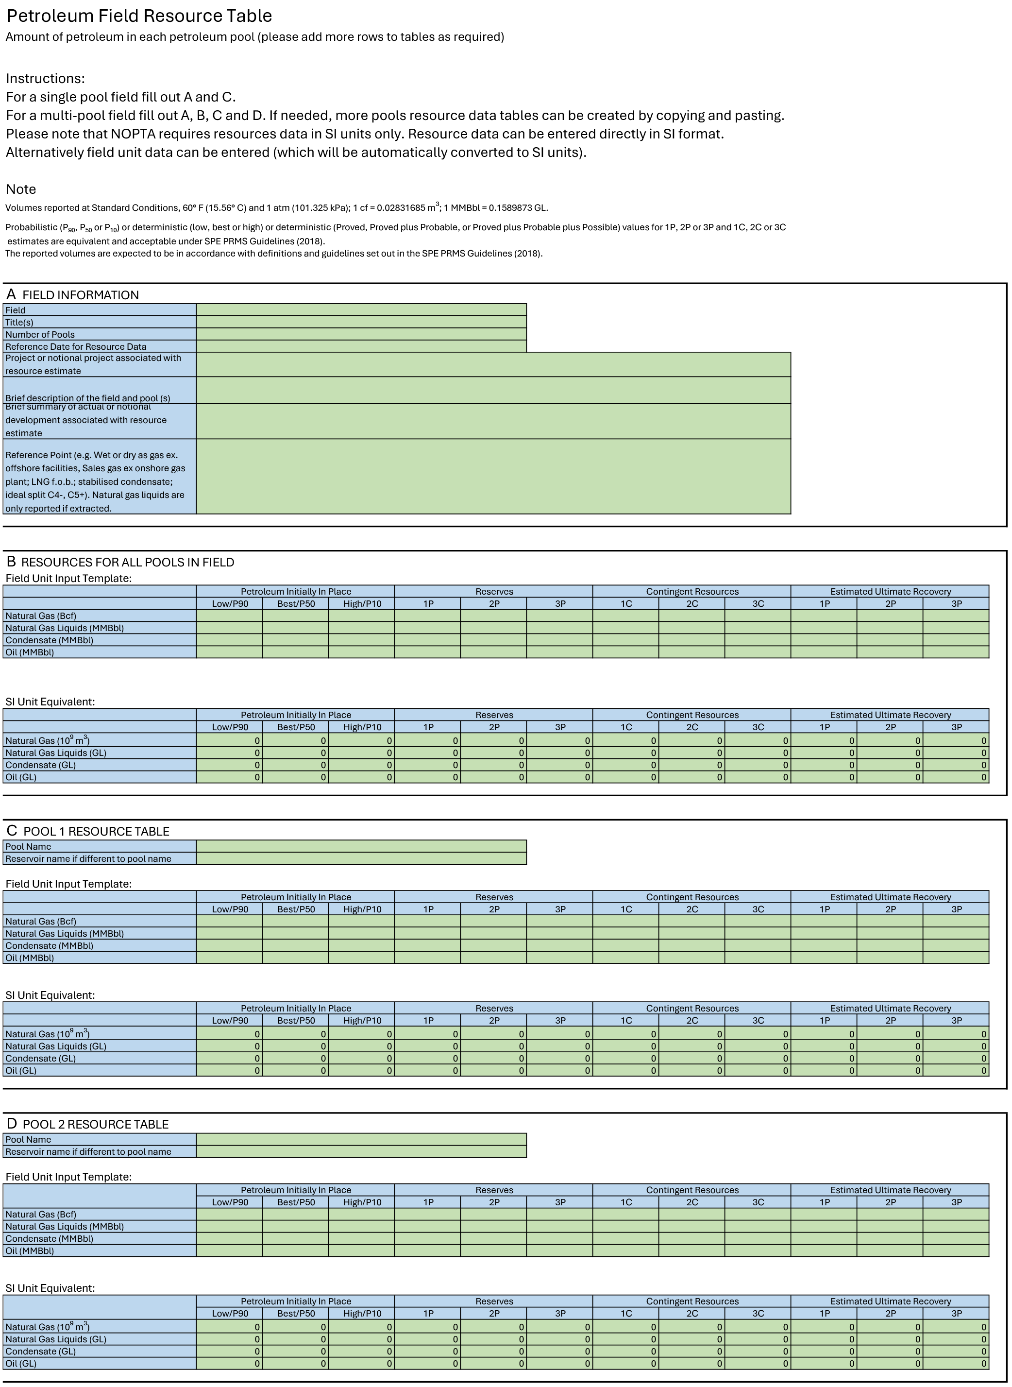

Appendix D. Production / Injection Forecast Template

See FDP Regulatory Submission Requirements Fact Sheet.
Ibid
See FDP Regulatory Submission Requirements Fact Sheet
Ibid

