Field Development Plan – Regulatory Submission Requirements
All fact sheets should be read in conjunction with the Offshore Petroleum and Greenhouse Gas Storage Act 2006 (the OPGGS Act), associated regulations, relevant guidelines and policies (available on NOPTA’s website).

This fact sheet provides information on the submission requirements for Field Development Plans (FDPs) set out in the Offshore Petroleum and Greenhouse Gas Storage (Resource Management and Administration) Regulations 2025 (Cth) (the Regulations). All section references in this fact sheet pertain to the Regulations unless otherwise stated.
Field development planning is one phase of a typical lifecycle of a petroleum resource. Figure 1 illustrates this lifecycle, including key titleholder activities, milestones and regulatory approvals. A FDP is one of the Joint Authority (JA) approvals required to develop petroleum resources in offshore areas (for more information please see the Fact Sheet – Developing a Petroleum Resource).
The key objectives of an FDP are to document and communicate the subsurface development strategy and management plan, including wells and the associated sub-sea and surface facilities and activities.
For more information about the content requirements for an FDP and the Titles Administrator’s assessment processes, refer to the FDP Content Requirements Fact Sheet.

What are the main stages of Field Development Planning?

Early engagement
Prior to submitting a FDP, titleholders are encouraged to:
- engage with the Titles Administrator in the lead up to and following a decision on ‘Concept Select’. Titleholders should engage with the Titles Administrator in relation to key infrastructure decisions and the alternatives considered, prior to entering FEED;
- submit a preliminary FDP (pFDP) to the Titles Administrator; and
- consider any feedback provided by the Titles Administrator in relation to the pFDP.
Undertaking early engagement activities will help ensure that issues or questions are identified. Guidance can then be provided on specific information that may be required for timely consideration and acceptance of an FDP.

Concept Select
Titleholders generally choose a lead development concept before an FDP is submitted. The FDP should reflect a continuation and further refinement of the key aspects of the Concept Select milestone. Decisions made at Concept Select may have a significant impact on the JA’s assessment of whether a particular development concept outlined in an FDP is compatible with optimum long-term recovery of petroleum.
This Concept Select milestone locks-in major resource and facility development decisions, including key surface and subsurface decisions.

Area impacts
As part of the planning process titleholders should consider the area impacts, i.e. how the project may affect surrounding developments in neighbouring title areas throughout its lifecycle. At the project level, this includes the development and management of the subsurface reservoir, as well as consideration of upstream and downstream infrastructure design, optimisation and utilisation.
The FDP should include details of:
- all relevant facilities and operational plans to ensure a complete understanding of the proposed development throughout its life cycle.
- the potential impacts and the benefits that the proposed development may have on other resources and developments in the vicinity.
- the suitability and availability of both existing and proposed area infrastructure and its potential to be used by third parties.

Preliminary FDPs
Titleholders are encouraged to submit a pFDP to the Titles Administrator to ensure clarity of requirements, assessment processes, timeframes and expectations. Submitting a pFDP to the Titles Administrator is voluntary.
The Titles Administrator conducts a gap analysis of pFDPs against the content requirements for an FDP and provides feedback to titleholders on where further work or details may be needed in preparing a final FDP submission.
The JA is not provided with a copy of the gap analysis.
Feedback on a pFDP can reduce assessment timeframes of FDP submissions.
There is no application fee or form for a pFDP submission.
To arrange a time to discuss submission of a pFDP, titleholders should send a request via email to titles@nopta.gov.au.

Regulatory and submission requirements
The regulations set out the requirements for a petroleum production licensee to have an accepted FDP in force for a field in a licence area, and the circumstances for varying an FDP (section 46).
The regulations also set out the related JA approval requirements for petroleum rates of recovery (section 60) and related equipment and procedures (section 66). For further information on these processes, please refer to the Fact Sheet – Rate of recovery & equipment & procedures.

Can recovery be undertaken without an accepted FDP?
Section 57 provides that a production licensee may apply to the Titles Administrator for permission to undertake recovery of petroleum from one or more petroleum pools in the licence area for a period of up to a maximum of three (3) months without having an accepted field development plan in force for a field that includes the pool or pools. Approval under this section is not intended to apply over a prolonged period, or to be used for titleholders to undertake large scale commercial recovery of petroleum.
The application should describe the reasons why short-term recovery operations, such as extended production tests, are required and their anticipated duration. The information must discuss how produced petroleum will be collected, where it will be stored and for how long, as well as any proposed disposal and/or associated flaring and venting. The period can be extended more than once, as long as the total period of all extensions does not exceed 9 months.
An application form, with the submission requirements can be found on NOPTA’s website. The Titles Administrator must consult the JA before deciding on the application.

Requirement to have an accepted FDP
Before petroleum recovery operations can commence, a titleholder must possess:
- a petroleum production licence granted by the JA (Part 2.4 of the Act or Schedule 4 of the Act for Royalty Act titles);
- an FDP accepted by the JA (section 39); and
- a rate of recovery approval (section 60) and equipment and procedures approval (section 66).
A person may apply for acceptance of an FDP if the person is a petroleum production licensee or an applicant for a petroleum production licence (subsection 41(1)).
Once an FDP is accepted, there are a range of scenarios which may see the need for a titleholder to apply for a variation to an FDP (see the FDP Content Requirements Fact Sheet for more information about FDP Assessment).

How to submit an FDP or varied FDP
FDPs or varied FDPs are submitted to the Titles Administrator for a decision by the JA (section 41).
Application forms are available on NOPTA’s website. The forms provide information on how and what to include in the application, including the application fee.
The content requirements for a FDP or varied FDP are outlined in section 45. These are explained in further detail in the FDP content requirements fact sheet.
The applicant may, at any time before the JA makes a decision on FDPs or varied FDPs, amend and resubmit the proposed plan. (subsection 41(5) and section 49).

How FDPs are Assessed
- The Titles Administrator, as technical advisor to the JA, prepares an assessment report containing advice for consideration by the JA. For the Titles Administrator’s assessment processes, refer to the FDP Content Requirements Fact Sheet.
- The Titles Administrator can request the applicant to provide further information about the FDP or varied FDP, or to re-resubmit the FDP or varied FDP with the inclusion of additional, relevant information (sections 42 and 47).
Where further information or resubmission is requested, the applicant will be notified in writing. The notice will specify the time within which the information must be provided, or the FDP or varied FDP resubmitted.
Failure to provide the required information or resubmit the FDP or varied FDP may result in the JA deciding to refuse to consider the application or take any action (or further action) in relation to the application and FDP or varied FDP (subsections 42(4) and 47(4)).
The JA (as the decision-maker) can direct the Titles Administrator to notify the applicant that it requires further information to be included in the FDP to be satisfied that the FDP meets the relevant criteria (sections 43 and 48). As part of this process, the applicant will be provided an opportunity to modify and resubmit the FDP or varied FDP.

JA decision (Sections 43 and 48)
- The JA must accept the FDP or varied FDP, subject to any conditions the JA considers appropriate, if the JA is satisfied that the FDP or varied FDP meets the criteria in section 44.
- The JA must reject the FDP or varied FDP if it is not satisfied as to any of these matters.
- The Titles Administrator will advise the applicant of the outcome as soon as practicable after the JA has made its decision. If a condition is placed on the acceptance, this will be included in the notice of decision.

Significant events
Section 68 requires the titleholder to provide written notice of a significant event in or in relation to the licence area within 7 days after becoming aware of the event. Refer to NOPTA's website for the submission address.

Periodic review and updates
Titleholders must not undertake an activity in a field if the activity is not consistent with the accepted FDP (section 40).
The Titles Administrator encourages titleholders to participate in an annual production and field performance review process which complements reporting and aids in ensuring compliance with regulatory requirements. This is an important process to ensure that petroleum recovery and development operations remain consistent with the strategy described in accepted FDPs.
It is expected that the accepted FDP will need to be varied over time. This could be to reflect proposed new work practices or recovery methods, or where the FDP no longer reflects the titleholder’s plans in relation to field management and development. Mandatory variation requirements are discussed in further detail below.

Requirement to submit an FDP variation
Section 46 sets out the circumstances when a petroleum production licensee must apply for acceptance of a varied FDP.
Applications for a variation to the accepted FDP must be made:
- For a major change, at least 90 days before making the major change (subsection 46(2)).
- Where requested by the JA, within 90 days after written notice from the JA is given to the licensee (subsection 46(4)).
- Following a transfer of licence, within 90 days after the licence transfer has been registered (if the licensee has not given an undertaking to the Titles Administrator). The application must be made by the licensee who is the transferee (subsection 46(6)).
- Following a change in control of the licensee, within 90 days of receipt of the Titles Administrator’s request for a written undertaking (if the licensee has not given that undertaking to the Titles Administrator). The application must be made by the licensee (subsection 46(8)).
A variation of an FDP follows similar application processes as those listed above for an initial FDP submission.
Titleholders should engage early, including via annual field performance review processes, with the Title Administrator on any potential issues that may require a variation to an FDP in accordance with regulatory requirements. Prior to submitting an FDP variation application, titleholders are encouraged to consider using the pFDP variation process outlined above.
An application form is available on NOPTA’s website.
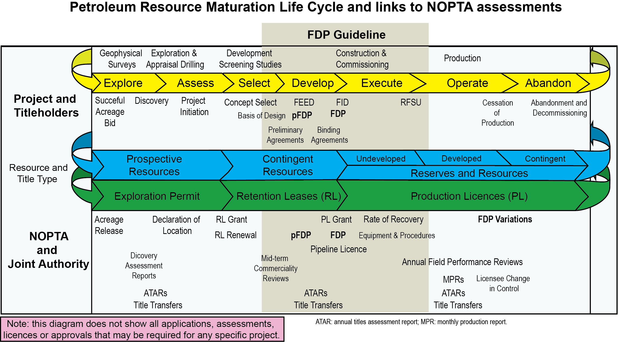
If the JA decides to reject the varied FDP the accepted FDP continues in effect as if the varied FDP had not been submitted (section 53).

FDP Variation as required by the JA
Under section 50, the JA may, by written notice given to the licensee by the Titles Administrator, require a licensee to vary an accepted FDP.
The notice will set out:
- How the JA requires the accepted FDP to be varied;
- The grounds for requiring the variation;
- Steps to follow should the titleholder wish to object to the JA’s requirement to vary the accepted FDP; and
- The timeframe for submitting the varied FDP.
The licensee may object to this notice, in writing, on the basis that the licensee does not agree that the accepted FDP should be varied, or that the accepted FDP should be varied differently to how the JA requires it to be varied. The licensee must provide reasons for the objection. (section 51). Licensees are encouraged to discuss these reasons with the Titles Administrator prior to submitting additional information to facilitate a clear understanding of both the JA’s and titleholder’s requirements.
The JA will decide whether to accept or reject the licensee’s objection. The licensee will be informed of the JA’s decision in writing by the Titles Administrator.

Withdrawal of acceptance of FDP
The JA may withdraw its acceptance of an accepted FDP on the grounds that a licensee has failed to comply with (Section 54):
- A provision of the Act or the regulations;
- The accepted FDP;
- A condition to which the JA’s acceptance of the FDP was subject; or
- A direction given under the Act.
The licensee will be provided with written notice of the intended withdrawal of acceptance and provided an opportunity to make relevant submissions (section 55).

Version history
Version | Date | Comment
1.0 | March 2026 | First Version Created

Figure 1. Field Development Planning life-cycle overview.
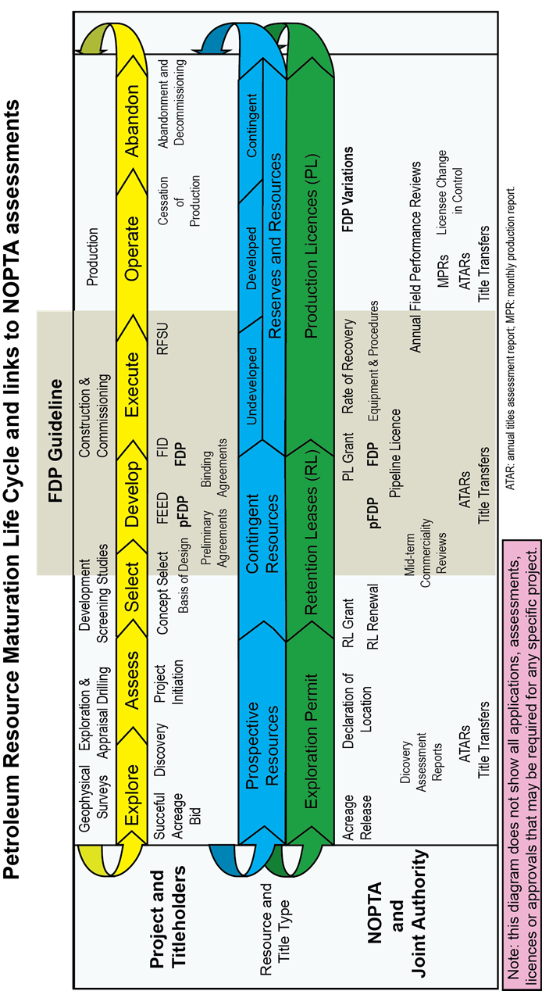

Pursuant to section 160 of the Act, recovery of petroleum in an offshore area without a petroleum production licence or other authorisation under the Act is an offence.
A Royalty Act title is a title that is derived from Petroleum Exploration Permit WA-1-P or WA-28-P and is therefore subject to the Offshore Petroleum (Royalty) Act 2006.
Unless permission has been given by the Titles Administrator to recover without an accepted FDP, as described in this fact sheet
A significant event is defined in Section 67 as including the following: - A change in the understanding of the characteristics of the geology or reservoir that may have a significant impact on the optimum recovery of petroleum from the licence area; - A new or increased risk to the recovery of petroleum within the licence area; - A new or increased risk to the recovery of petroleum outside the licence area caused by the development of pools in the licence area; - A new or increased risk of activities in the licence area causing effects outside the licence area; - Change to the proposed option for development of pools in the licence area, including any tie-in opportunity with nearby licence areas.

