Developing a petroleum resource fact sheet
All fact sheets should be read in conjunction with the Offshore Petroleum and Greenhouse Gas Storage Act 2006 (the OPGGS Act), associated regulations, relevant guidelines and policies (available on NOPTA’s website).

This fact sheet provides information about the processes for applying for a production licence and field development plan (FDP). It must be read in conjunction with the legislation and regulations.

What approvals are required?
Before petroleum recovery operations can commence (outside of exploration and appraisal), you must have:
- a petroleum production licence granted by the Joint Authority
- an FDP accepted by the Joint Authority
- a rate of recovery and equipment and procedures approval from the Joint Authority.
Further information on rate of recovery and equipment and procedures is on NOPTA’s website.
A titleholder should also consider if a pipeline licence and/or an infrastructure licence is required.
Approvals relating to safety, well and facility integrity, and environmental management will also be required from NOPSEMA.

Which legislation applies?
A titleholder may apply for a production licence under Part 2.4 or Schedule 4 of the OPGGS Act. Schedule 4 relates to
the Offshore Petroleum (Royalty) Act 2006 (Royalty Act).
Part 4 of the Offshore Petroleum and Greenhouse Gas (Resource Management and Administration) Regulations 2025 (RMA Regulations) applies to FDPs and rates of recovery.

When do I apply?

Grant of a Production Licence:
- An exploration permit holder with a declared location can apply for a production licence over block(s) within the location at any time up to two years after the location was declared. The two-year application period may be extended for up to a further two years on exceptional technical or force majeure grounds, at the discretion of the Titles Administrator (refer to the Declaration of Location Guideline).
- A retention lease holder can apply for a production licence over block(s) within the lease at any time up to the expiry date of the lease.

Acceptance of FDP:
- A production licence applicant can apply at any time after submitting the licence application.
- A production licence holder can apply at any time.
Development drilling should not begin until the FDP is accepted.
Please allow up to six months for the production licence application or FDP application process. The time taken will depend on a number of factors, including the quality of the submission.

What is the process?
Before a titleholder submits a production licence or FDP application (including an FDP variation), they should discuss timeframes and process with NOPTA.

Step 1 – Preliminary FDP (pFDP) feedback
Titleholders are encouraged to submit a preliminary FDP (pFDP) to the Titles Administrator to ensure clarity around content requirements, assessment processes, timeframes and expectations. Submitting a pFDP to the Titles Administrator is voluntary.
- NOPTA will review the pFDP and provide gap analysis feedback against the RMA Regulations requirements.
- This process generally takes approximately 5 weeks.
- There is no application fee or form for a pFDP submission.
Feedback on a pFDP can reduce assessment timeframes of FDP submissions, as applicants are expected to address relevant matters when preparing the final version of an FDP.

Step 2 – Production Licence application
To be validly made, an application for a production licence must be:
- in the approved form (application forms are available on website at https://www.nopta.gov.au/forms/forms.html)
- accompanied by any information or documents required by the approved form.
- submitted in the approved manner (refer to NOPTA’s website at https://www.nopta.gov.au/forms/index.html); and
- accompanied by the applicable application fee.
For further information on submission requirements and information required to accompany production licence applications refer to the NOPTA Forms Guidance–Petroleum.
NOPTA may request further information from the applicant to support the licence assessment process.
If the application relates to a Royalty Act title, the State will consult with the applicant on the rate of royalty and make a recommendation to the Joint Authority.

Step 3 – FDP application
An FDP application submitted to NOPTA must include:
- A validly executed application form
- Proof of payment of the application fee
- The FDP document (contents as set out below).

What supporting information is required?

Production licence requirements
The supporting information must include evidence that the block(s) contains petroleum and set out details of the applicant’s proposals for work and expenditure in relation to the block(s). For example:
- Block(s) contains petroleum – this should include:
- a summary of the exploration history of the block(s), including discovery well(s) and results
- a summary of the geology of the block(s), including a discussion of stratigraphy and structure
- a summary of appraisal well(s) and results
- a map showing the underlying block(s) constituting the location
- a summary of seismic data covering the block(s) and the outcomes of any processing/reprocessing
- depth structure maps and seismic amplitude images, as appropriate, and
- a discussion of remaining prospectivity.
- Work and expenditure –including:
- the planned timeframes for construction of infrastructure and commencement of production
- a project schedule
- the estimated budget for the project
- the estimated life of the project, and
- the estimated cost of existing and future decommissioning obligations.
- Title background – including an overview of the title history and a summary of the work undertaken to date in the block(s).
- Project overview – including relevant petroleum pool(s)/field(s), drilled and proposed wellhead locations, and project and facility (production & export) details with supporting schematics, as well as progress towards submitting an FDP.
- Stakeholder consultation – including key stakeholders identified, the date(s) they were contacted, any issues they raised, how these will be managed, and any intended future consultation.
Stakeholders identified are expected to be similar to those who would be consulted for an environment plan, including relevant government agencies and other titleholders.
- Technical Advice Available to the Applicants – Provide details of the technical advice that is or will be available to all Applicants.
- Financial Resources Available to the Applicants – Provide details of the financial resources that are or will be available to all Applicants. Information that should be included are copies or links to current annual reports and the most recent financial statements for all Applicants.
- Spatial data – Provide spatial data regarding the pool(s)/field(s) within the block(s) in ESRI or Geodatabase format; and a coordinate listing (latitude, longitude, and datum) of the pool(s)/field(s) in Excel format.

FDP Requirements
Section 45(1) of the RMA Regulations outlines the minimum mandatory content requirements of FDPs and describes the types of information required.
Additionally, The FDP is generally expected to include:
- An executive summary, with an overview of the field and development pathways
- Background information on the licence location, regional context, and details of current and potential future developments
- A reservoir description, which describes all aspects of the subsurface environment including the characteristics of associated fields and petroleum pools
- A description of reservoir development studies and plans for resource recovery, volumetric estimates (consistent with the Society of Petroleum Engineers Petroleum Resource Management System standard definitions), well locations, design, and completions, and production and injection forecasts
- The development concept screening and demonstration that the selected development concept supports optimum long-term recovery of petroleum from the petroleum pools
- A project and facilities overview, including anticipated schedule
- Final cost estimates and expenditure phasing for a commercial development and annual cash flow forecast
- An operational overview, including field and resource recovery management (including project governance arrangements for keeping records)
- A petroleum resource maturation plan, and
- An overview of future planned abandonment and decommissioning.
Section 44(b) of the RMA Regulations also provides that for the Joint Authority to accept an FDP, the FDP must demonstrate that the titleholder will manage the field in a manner that is:
- consistent with good oilfield practice, and
- compatible with optimum long-term recovery of the petroleum.

What other matters should be considered?

Conditions on production licence holders
If the Joint Authority are prepared to offer the grant of a petroleum production licence, the offer will be subject to conditions.
To ensure ongoing exploration and appraisal activities by licensees to maximise hydrocarbon recovery, the following condition will be applied to all production licences:
- The licensee shall continue to appraise and explore the petroleum production licence area to determine whether additional recoverable petroleum exists in the area and exploit such petroleum where commercially viable. The licensee shall provide a report of the status of prospects and leads, and updates regarding the progress of exploitation of petroleum.
Where an applicant for the Production Licence has not made a Final Investment Decision (FID) the following will apply:
- The licensee must provide commerciality reports as part of each annual title assessment report that provides details of progress towards FID against key milestones, progress on the submission and acceptance of an FDP, and any remaining activities required for FID for the licence, until a positive FID is made.

Other conditions may be applied based on the circumstances associated with the application and resource.

Production licence Reporting
Part 3 of the RMA Regulations sets out the requirements for titleholders to submit an Annual Title Assessment Report (ATAR) – refer to the ATAR factsheet for more information. Petroleum Production Licence holders are required to provide specific information to satisfy Section 28 of the RMA Regulations. Some of these include:
- details of activities and expenditure carried out during the 12 month reporting period in relation to exploration, development or management of resources
- technical and financial performance of production from all fields, including forecasts
- details of plans in relation to wells and any potential decommissioning activities
- the status of prospects and leads in the licence area, and updates regarding the progress of developing these resources
- progress towards FID against key milestones, and
- activities conducted to explore for potential greenhouse gas storage formation(s) and injection site(s) (if applicable).

Variation of an FDP
sA titleholder must apply (as per Section 46 of the RMA Regulations) for acceptance of a variation of an FDP if:
- the titleholder intends to make a major change in relation to petroleum recovery,
- on request by the Joint Authority
- there is a new titleholder for the licence, unless that new titleholder gives the Titles Administrator a written undertaking to continue operations in accordance with the accepted FDP.
- there is a change in control of the licensee (within the meaning of section 566B of the OPGGS Act), the Titles Administrator requests the licensee to give a written undertaking that the license will continue operations consistently with the accepted FDP and the licensee does not give that written undertaking within 14 days of the request.
For all of the above, when required, the application for a variation to the accepted FDP must be made within 90 days.
An FDP variation follows the same process and timeframes as the acceptance of an FDP. Titleholders are encouraged to make use of the pFDP gap analysis feedback process offered by NOPTA.
For further information on submission requirements and information required to accompany applications for acceptance of a FDP, refer to the NOPTA Forms Guidance–Petroleum.
Production licence and FDP applications are submitted to titles@nopta.gov.au. NOPTA provides advice to the Joint Authority as the decision-maker. The Joint Authority may apply conditions to a production licence or FDP – see below for more information.

No recovery - Termination of a production licence
Under section 166 of the OPGGS Act the Joint Authority has a discretionary power to terminate life-of-field petroleum production licences if no petroleum recovery operations have been carried on at any time during a continuous period of at least five years (noting this excludes any period where operations were not carried on because of circumstances beyond the licensee’s control).
Generally, “petroleum recovery operations” are considered by NOPTA to include:
- the production of petroleum, as demonstrated through monthly production reporting, and
- all actions taken in preparation for undertaking petroleum recovery. For example, significant investment in capital, drilling wells, and the construction of platforms and facilities.
Where a field has not produced petroleum for an extended period of time, licencees will need to demonstrate that such activities are directly related to enabling the timely restart of production. Activities such as infrastructure inspections, or short-term production of non-commercial volumes of petroleum, are unlikely to be considered as petroleum recovery operations.

Cessation of Production
Please refer to the Cessation of Petroleum Production factsheet on our Forms page for specific information required prior to ceasing production from a petroleum field within a petroleum production licence.
Once petroleum production has ceased, licensees will be expected to provide detailed updates in ATARs, addressing the following:
- the date that petroleum recovery operations were last carried on under the title (the cessation date)
- reasons for non-production and where applicable, activities being undertaken to restart production
- whether there has been any period since the cessation date in which no petroleum recovery operations were carried on because of circumstances beyond the licensee's control, and if so, details of those circumstances
- the future strategy for the title and likelihood of future production
- an overview of the exploration and production history for the title
- if relevant, details of the current status of abandonment activities, i.e. is the field considered fully abandoned with all necessary abandonment approvals in place; and
- detailed project management schedule showing key decommissioning activities to be conducted, including timing of NOPSEMA-related document submissions and approvals.

Greenhouse Gas Storage Formations and Injection Sites with a production licence
Section 161(3) of the OPGGS Act and Part 6 of the RMA Regulations authorise the licensee to explore in the licence area for potential greenhouse gas storage formations and injection sites, and to carry on operations, and execute such works, in the licence area. Licensees should include any such activities in the proposed work program and provide expenditures of these works where applicable.

More information
If you have any specific questions, please contact NOPTA via titles@nopta.gov.au.
Please note: this document is intended as a guide only and should not be relied on as legal advice or regarded as a substitute for legal advice in individual cases.

Version history
Version | Date | Comment
4.0 | 01/01/2026 | Updates to reflect remake of the RMA regulations
3.0 | 2024 | Updates to align with the Future Gas Strategy.
2.0 | 17/02/2023 | Update to layout, format and links.

Field development plan

Production licence
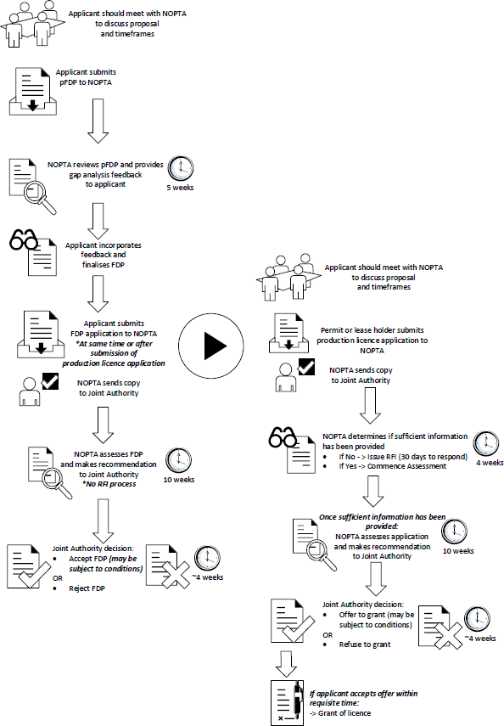

. Major change is defined in Section 6 of the RMA Regulations to mean: - Change to the development strategy or management strategy of the field or a petroleum pool in the field - Significant Change to the development strategy of the field for the development of additional pools in the field - Cessation of production, permanently or for the long term, before the estimated date specified in the FDP - Introduction of new methods for petroleum recovery, such as enhanced recovery and injection of fluids.

