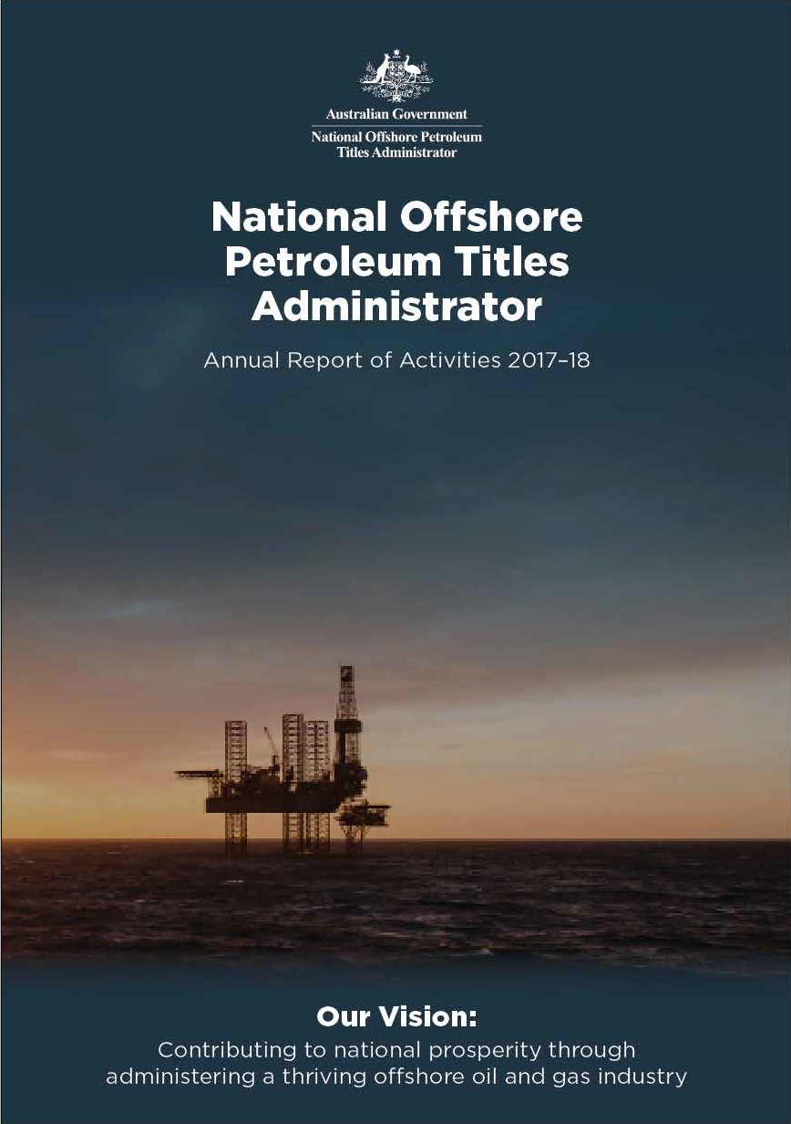

# National Offshore



***Petroleum Titles Administrator***

***2017–18 Annual Report of Activities***

© Commonwealth of Australia 2018

This work is copyright. Apart from any use as permitted under the Copyright Act 1968, no part may be reproduced by any process without prior written permission from the Commonwealth. Requests and inquiries concerning reproduction and rights should be addressed to the Department of Industry, Innovation and Science, GPO Box 9839, Canberra ACT 2601.

ISSN: 2205-8230 (print version) ISSN 2205-8249 (online)

#### For more information about this report please contact:

*Business Manager*

National Offshore Petroleum Titles Administrator Department of Industry, Innovation and Science GPO Box 7871, Perth WA 6850

Phone: (08) 6424 5300

Email: [corporate@nopta.gov.au](mailto:corporate@nopta.gov.au) Web: [www.nopta.gov.au](http://www.nopta.gov.au/)

Members of the International Upstream Forum (Aberdeen, 2017)

# Contents

Titles Administrator’s review 4 Activity at a glance 6 Overview 8 About NOPTA 11 Key achievements 2017–18 13 Titles Administration 14 Decisions of the Joint Authority and the Titles Administrator 16 Data submission and release 17 Cost recovery 18 Cost recovery levy 18 Cost recovery fees 19 Cost effectiveness 20

NOPTA’s financial result 21

Organisational structure 22 Staffing Levels 22

Key work areas 23 Outlook for 2018–19 27

Australian offshore petroleum well activity: 1 July 2017 to 30 June 2018 28

Australian offshore petroleum well activity: 2012 to 30 June 2018 28

Australian offshore petroleum survey activity: 1 July 2017 to 30 June 2018 29

Australian offshore petroleum survey activity: 2012 to 30 June 2018 29

Corporate Plan 2017–2020 30

# Titles Administrator’s review



Reflecting on the past year, it seems to me that in many respects it has been the most profound yet in NOPTA’s journey. Usually

I am firmly focused on what is to come and rarely indulge in looking back, but in the past twelve months the organisational changes, activities undertaken and outcomes delivered have been particularly significant. And, although I am pleased to report on those advances and changes within NOPTA, the one thing that remains constant is the dedication, professionalism and commitment from our people. Without them, none of

this would be possible.

In particular I would like to recognise the retirement of three of our founding senior management group: Terry McKinley, Jenny Lee-Maher and Geoff O’Brien. The contribution our colleagues made to the establishment of NOPTA was instrumental and will leave an enduring impression. Their support, encouragement and

counsel will be missed, but they leave us in very good shape and can be very proud of their legacy at NOPTA. We wish all three a

very happy and long retirement.

Of course, the challenge was to ensure that NOPTA’s capability remained intact and effective after losing a significant cohort of experience and skills. Our succession planning proved equal to the task and the consequent management restructure is now producing the results we anticipated. Indeed, we continue to have a nimble organisation that is tailored for both our business as usual activities and also shorter term, special projects which arise from time to time.

Throughout the year, we have had a number of significant achievements, including the re-evaluation of the commercial viability of ten retention lease areas in offshore Western Australia. Our engagement with the various Joint Venture partners, collectively and individually, as well as with third-parties has resulted in a strategic assessment of key known resources that have the potential to be developed through North West Shelf LNG facilities and infrastructure. There have been several positive outcomes from this work. As the advisor to the Commonwealth-West Australian Joint Authority we have been able to provide a detailed analysis of opportunities to develop new resources over the short to medium term. And, through our close engagement with titleholders, Joint Venture partners and others we have demonstrated

that valuable and positive outcomes can be achieved.

All of this leads me to recognise that as a regulator we occupy a privileged position and have a responsibility beyond our legislative obligations. Certainly, our primary tasks are easy to see, but it is important to acknowledge the contribution that our work makes to the broader public good and to the industry we regulate and administer.

NOPTA’s investment in technology is aimed at streamlining our processes, making it

easier for stakeholders to engage, and supporting our compliance activities. In 2017-18 we further enhanced the integration of our internal databases to better monitor Australia’s offshore petroleum resources; improved our internal processes relating to the National Electronic Approvals Tracking System (NEATS); and refreshed our website. We are planning to do even more.

Another big step for us has been our transition to a cloud based environment for our Information, Communication and Technology (ICT) systems, which will produce substantial productivity improvements and long-term cost savings.

It is also worth noting our relocation of the Melbourne office to co-locate with the National Offshore Petroleum Safety and Environmental Management Authority (NOPSEMA). This has been a long time coming and now completes the last of the remaining establishment activities. The colocation of NOPTA and NOPSEMA provides efficiencies for industry and further facilitates the cooperative way the two agencies operate.

I hope you enjoy our report and that it continues to provide valuable insights to the activities and functions of NOPTA, and also the industry.

# Activity at a glance

### NOPTA financial performance per financial year

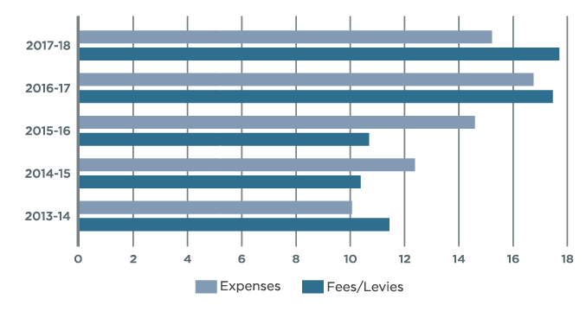

*Applications submitted per financial year*

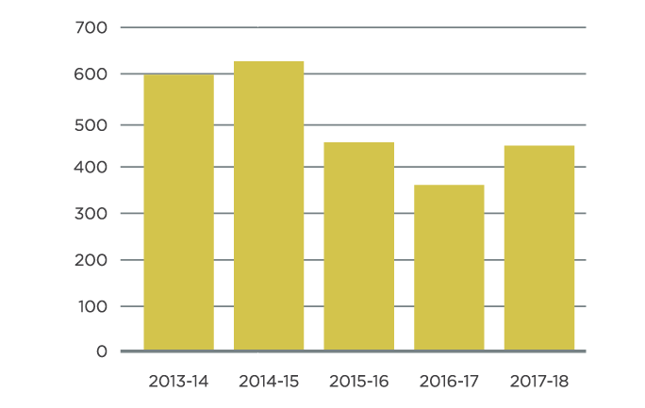

*Well activities completed per financial year*

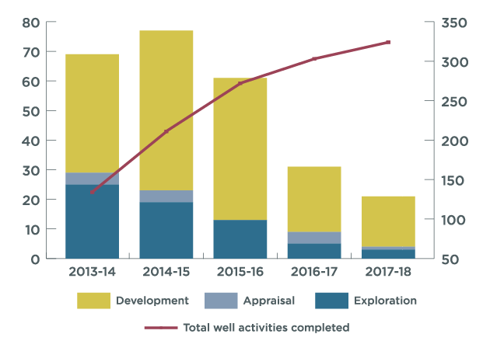

*Surveys completed per financial year*

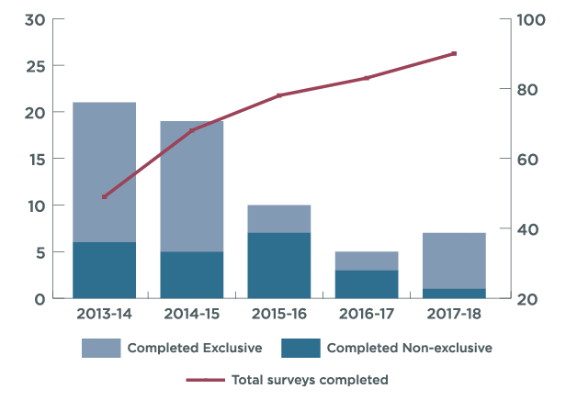

North Rankin Complex: Woodside Energy



# Overview

The aim of this report is to provide stakeholders with information on the activities and key achievements of the National Offshore Petroleum Titles Administrator (NOPTA), headed by a statutory position of Titles Administrator, over the 2017-18 period. This report complements the statutory 2017-18 Annual Report of the Department of Industry, Innovation and Science (the Department).

NOPTA advises on and administers the *Offshore Petroleum and Greenhouse Gas Storage Act 2006* (OPGGS Act) for Australia’s offshore petroleum titles regime, to support the effective regulation of our offshore oil and gas resources consistent with good oil field practice and optimum resource recovery. NOPTA delivers its functions in accordance with the six key performance indicators of the Regulator Performance Framework1.

The following provides an overview of NOPTA’s key activities during 2017-18.

1 See <https://www.cuttingredtape.gov.au/resources/rpf>

#### Supporting efficient regulation

During the reporting period, NOPTA sought to relieve regulatory burden and improve the efficiency and transparency of our administrative and advisory functions. This was achieved through active participation in domestic and international forums, providing input and technical support to legislative amendments led by the Department, and the

commencement of an internal review of our procedures to ensure they remain up-to-date and accord with leading practice.

#### Effective communication

During 2017-18 NOPTA maintained a strong focus on the promotion of effective communication with our stakeholders to support compliance, regulatory feedback and continuous improvement. NOPTA used a variety of mediums to collaborate, communicate, consult and engage with stakeholders, such as: face-to-face meetings,

attending industry conferences and the release of several new and updated guidelines.

In August 2017 NOPTA launched a refreshed website which significantly improves how information is presented and accessed. This was complemented by the release of six short tutorial videos to assist users in navigating and using NEATS, with a focus on highlighting the system’s key features and tips for users. These initiatives are the result of opportunities identified by stakeholders in the NOPTA 2017 Stakeholder Survey and NEATS 2020 project2.

#### Managing regulatory risk

During the reporting period NOPTA took a proactive approach to risk management, with a continued strong emphasis on early engagement with our stakeholders. This included regular engagement with titleholders on work program compliance and data submission expectations, as well as the review and update of our internal risk management framework.

To meet ongoing business requirements and maintain secure, reliable and responsible information technology systems, NOPTA commenced the transition of its information, communication and technology (ICT) systems to a cost-effective cloud based environment.

NOPTA has also continued to use feedback received through the NEATS 2020 project to make incremental improvements to NEATS. This has included improvements to and

upgrading of the internal NEATS application management interface to improve processing efficiencies.

2 See <http://www.nopta.gov.au/publication-and-reports.html>

#### Compliance and monitoring

Over the reporting period NOPTA continued to enhance how compliance and monitoring issues are managed internally to ensure a more coordinated, streamlined and robust decision and advice process. Initiatives in this area have included:

* the introduction of a new internal database system to significantly improve end to end data management and analysis processes relating to petroleum production matters
* continued collaboration with Geoscience Australia to further develop the National Offshore Petroleum Information Management System (NOPIMS) to enable the delivery of an integrated data management system to better manage submissions, monitor compliance, and facilitate open-file release of data
* providing an initial report to the Joint Authority on the re-evaluation of commercial viability of ten offshore petroleum retention leases in the North West Shelf. The results of this review provide for a better understanding of implications relevant to optimal development of gas resources in the region.

Wheatstone LNG first cargo departs for Japan: Chevron Australia

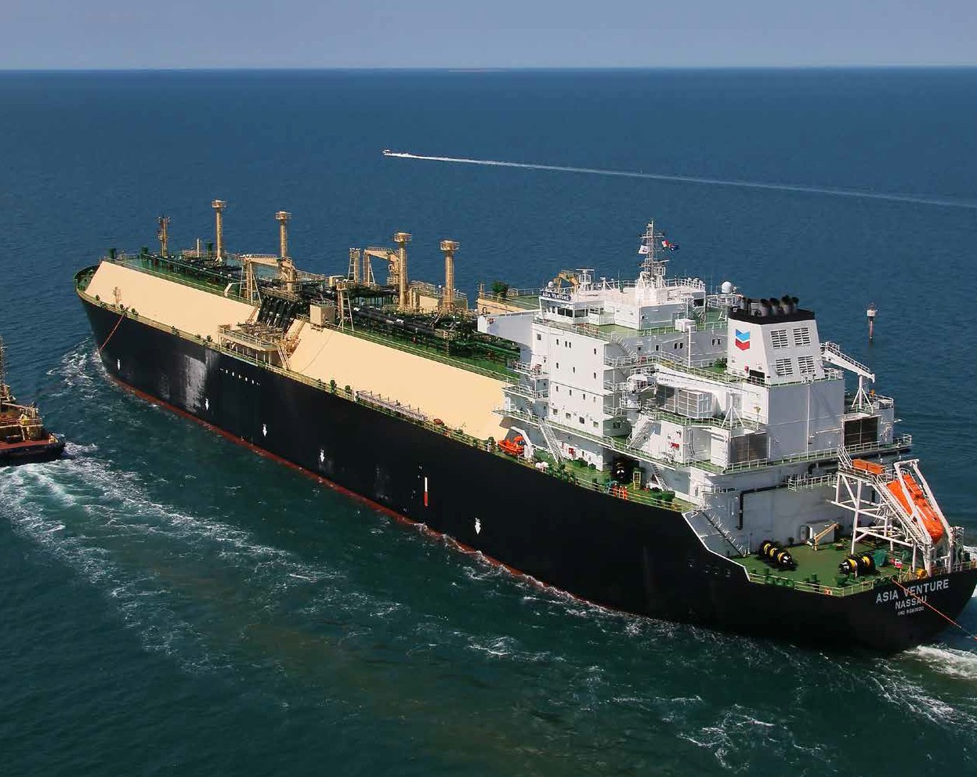

# About NOPTA

NOPTA, also known as the Titles Administrator, is appointed by the Secretary of the [Department of Industry, Innovation and Science](http://www.industry.gov.au/) (the Department) under section 695A of the OPGGS Act. NOPTA was established on 1 January 2012 as part of the Australian Government’s reform program for the Commonwealth offshore oil and gas industry.

The primary purpose of NOPTA is to advise on and administer the OPGGS Act

for Australia’s offshore petroleum titles regime, to support the effective regulation of Australia’s offshore oil and gas resources consistent with

good oil field practice and optimum resource recovery.

On 30 May 2018, the Minister for Resources and Northern Australia, Senator the Hon Matthew Canavan as the responsible Commonwealth Minister under the OPGGS Act, issued a Statement of Expectations (SoE) for NOPTA. NOPTA responded to the SoE with a Statement of Intent on 29 June 20183.

3 See: <http://www.nopta.gov.au/about.html>

Consistent with the OPGGS Act and associated regulations, NOPTA’s functions include:

* advising the responsible Commonwealth Minister (both as a member of the Joint Authority and otherwise) and State and Northern Territory Ministers of the Joint Authority and their delegates
* the day-to-day administration of offshore petroleum titles in Commonwealth waters in accordance with the OPGGS Act and associated regulations
* maintaining a public register of Commonwealth offshore petroleum and greenhouse gas titles
* ensuring petroleum resource management is undertaken in accordance with the principles of good oilfield practice
* implementing effective fi performance monitoring strategies in order to secure optimum petroleum recovery for the benefi of the Australian community
* in partnership with Geoscience Australia and the Western Australian Geological Survey, maintaining the National Offshore Petroleum Data and Core Repository (NOPDCR)
* collecting levies and fees in accordance with Government policy and NOPTA’s approved Cost Recovery Implementation Statement (CRIS)
* maintaining a Special Account consistent with the requirements of the *Public Governance, Performance and Accountability Act 2013* (PGPA Act).

The Joint Authorities are the decision-makers for the granting of the petroleum titles that underpin petroleum exploration and development – exploration permits, retention leases and production licenses. NOPTA provides advice and recommendations in relation to these decisions. All communications to or from the Joint Authority occurs through NOPTA.

NOPTA has the authority to grant short-term titles (petroleum access authority and petroleum special prospecting authority) and is the decision-maker for transfers and dealings in petroleum titles.

# Key achievements 2017–18

In 2017–18 NOPTA delivered key outcomes focused on supporting the effective regulation of Australia’s offshore oil and gas regime, consistent with our obligations under the Regulator Performance Framework. Specifically NOPTA:

* improved its systems and competent capacity to better analyse and manage Australia’s offshore petroleum resources
* received external validation from the Growth Centre Advisory Committee that NOPTA has implemented the Government’s ‘Regulator Performance Framework’ and met all the stipulated key performance indicators
* launched a refreshed website to significantly improve accessibility and transparency. This included the rollout of an interactive map
* improved accessibility to NEATS with the release of six short tutorial videos relating to the NEATS public portal, and new online guidance to the NEATS Industry Portal
* continued the development of the National Offshore Petroleum Information Management System (NOPIMS) with GeoScience Australia and the Western Australian Department of Mines, Industry Regulation and Safety
* provided technical input to the Department’s Offshore South East Australia Future Gas Supply Study
* provided an initial report on the reevaluation of the commercial viability of petroleum production from ten retention lease areas in the North West Shelf and reported to the Joint Authority
* developed and updated the following guidelines in consultation with the Offshore Resources Branch within the Department:

» new Offshore Petroleum: Declaration of a Location Guideline (July 2017)

» revised Transfers and Dealings in Petroleum Titles Guideline (May 2018)

* continued to work with the Offshore Resources Branch and the National Offshore Petroleum Safety and Environmental Management Authority (NOPSEMA) on decommissioning matters under the OPGGS Act, including the following:

» publication of an Offshore Petroleum Decommissioning Guideline (January 2018)

» progressing an interagency protocol for the provision of decommissioning advice to inform title-related decision making

* designed and built a secure, cost-effective cloud based ICT environment
* published a Statement of Intent in response to the Minister’s Statement of Expectations
* established an ‘annual field performance update’ with operators to discuss field performance, insights and planned activities.

Nganhurra FPSO, North Rankin Complex: Woodside Energy



# Titles Administration

NOPTA undertakes various administration and compliance activities relating to offshore titles including:

* + transfers and dealings: applications for the registration of transfers of, and dealings in, petroleum titles
  + petroleum titles applications: grants, renewals, surrenders, expiries and cancellations; title conditions management (credits, suspensions, extensions, variations and exemptions)
  + petroleum discovery: notifications and assessment reports; declaration, variation and revocation of locations
  + petroleum production: applications for acceptance of a field development plan and rate of recovery; approvals of equipment and procedures; monitoring of production
  + infrastructure licence: applications for grant, including proposed location of infrastructure
  + pipeline licence: applications for grant and variation, including proposed location of the pipeline
  + Special Prospecting Authority and Access Authority: applications for grant and variation (including applications for Scientific Investigation Consents)
  + greenhouse gas storage titles: applications for assessment permits; variations, suspensions, extensions and surrender of assessment permits; renewal of assessment permits; declaration of a formation; holding leases; injection licences; search authorities; special authorities; and research consents

During 2017-18, NOPTA received 444 applications (see Figure 1 and Table 1) and processed 3 cancellations (compared to 359 applications and six cancellations in 2016–17).

*Figure 1: 2017–18 Submitted applications*

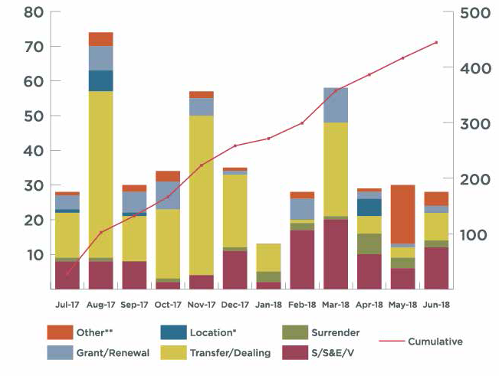

*Table 1: 2017–18 Submitted applications*

|  |  |  |  |  |  |  |  |  |  |  |  |  |
| --- | --- | --- | --- | --- | --- | --- | --- | --- | --- | --- | --- | --- |
| **Application Type** | **Jul 2017** | **Aug 2017** | **Sep 2017** | **Oct 2017** | **Nov 2017** | **Dec 2017** | **Jan 2018** | **Feb 2018** | **Mar 2018** | **Apr 2018** | **May 2018** | **Jun 2018** |
| *S/S&E/V* | 8 | 8 | 8 | 2 | 4 | 11 | 2 | 17 | 20 | 10 | 6 | 12 |
| *Surrender* | 1 | 1 | 0 | 1 | 0 | 1 | 3 | 2 | 1 | 6 | 3 | 2 |
| *Transfer/Dealing* | 13 | 48 | 13 | 20 | 46 | 21 | 8 | 1 | 27 | 5 | 3 | 8 |
| *Location\** | 1 | 6 | 1 | 0 | 0 | 0 | 0 | 0 | 0 | 5 | 0 | 0 |
| *Grant/Renewal* | 4 | 7 | 6 | 8 | 5 | 1 | 0 | 6 | 10 | 2 | 1 | 2 |
| *Other\*\** | 1 | 4 | 2 | 3 | 2 | 1 | 0 | 2 | 0 | 1 | 17 | 4 |
| *Cumulative* | 28 | 102 | 132 | 166 | 223 | 258 | 271 | 299 | 357 | 386 | 416 | 444 |

*\*Inc: Declaration, Location Extension and Revocation*

*\*\*Inc: Credit, Extension Renewal, RoR, FDP Variation, GHG Assessment Permit Renewal and title conditions*

# Decisions of the Joint Authority and the Titles Administrator

In 2017-18 there were 407 decisions (2016-17: 371) made in relation to applications for offshore petroleum titles. NOPTA provided advice to the Joint Authority for decisions on 172 applications and the Titles Administrator made 235 decisions. Table 2 and Figure 2 illustrate the decisions made by the responsible authority and by jurisdiction.

*Table 2: 2017–18 Decisions of the Joint Authority and the Titles Administrator by jurisdiction*

|  |  |  |  |  |  |  |  |  |
| --- | --- | --- | --- | --- | --- | --- | --- | --- |
|  | **Jurisdiction** | | | | | | | |
|  | *WA* | *SA* | *NT* | *VIC* | *AC\** | *NSW* | *QLD* | *TAS\** |
| **JA**  **TA** | 131 | 8 | 6 | 6 | 17 | 0 | 0 | 4 |
| 104 | 2 | 10 | 59 | 11 | 0 | 0 | 49 |
| **Total** | 235 | 10 | 16 | 65 | 28 | 0 | 0 | 53 |

*\*AC = Ashmore Cartier. JA comprises only the Commonwealth Minister*

*Tasmania has opted out of JA arrangements and the Commonwealth Minister is the decision-maker*

*Figure 2: 2017–18 Decisions of the Joint Authority and the Titles Administrator (aggregate)*

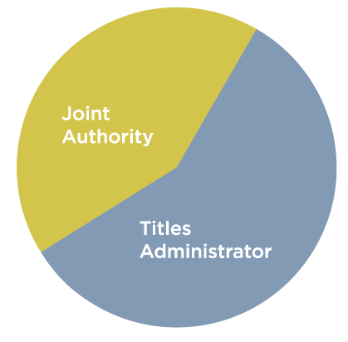

# Data submission and release

The Titles Administrator has responsibility for the submission and release of documentary information and petroleum mining samples (petroleum data), in accordance with Part

7 and Part 8 of the *Offshore Petroleum and Greenhouse Gas Storage (Resource Management and Administration) Regulations 2011* (RMA Regulations).

In 2017-18, 512 items relating to new wells and 291 items relating to new and reprocessed surveys were submitted to NOPTA. Public release included data from 120 well activities and 71 surveys (including reprocessed surveys).

*Figure 3: Submission items received July 2017 to June 2018*

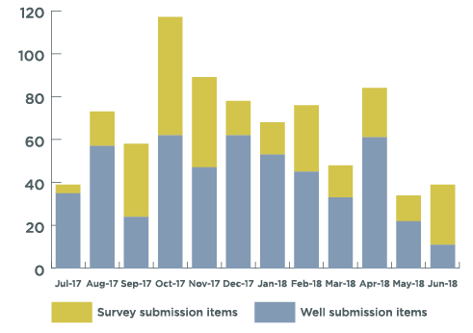

*Figure 4: Data released July 2017 to June 2018*

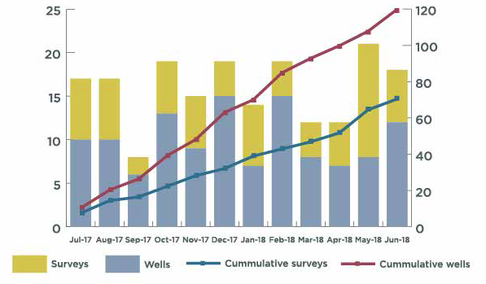

# Cost recovery

NOPTA operates on a full cost-recovery basis from industry levies and fees in accordance with the Australian Government Cost Recovery Policy and the requirements of the PGPA Act.

NOPTA’s cost recovery charges comprise an annual levy imposed on different types of titles (permits, leases and licences) and fees charged on applications made to the Titles

Administrator relating to offshore petroleum titles. The NOPTA ‘Schedule of Fees’ sets out the fees and levies that apply from 1 July 20164.

#### Cost recovery levy

An Annual Titles Administration Levy is payable in accordance with the *Offshore Petroleum and Greenhouse Gas Storage (Regulatory Fees) Regulations 2004* upon the grant of a title and annually thereafter within 30 days of the anniversary of the title. Where a title is in force for less than twelve months, the levy is calculated for the remaining period of the title.

The levy makes up the majority of NOPTA’s revenue (approximately 85 per cent in 2017-18). It provides a stable revenue stream to enable NOPTA to meet its ongoing activities including industry-wide monitoring, data management, compliance and enforcement.

There were 417 titles in force during 2017-18 that contributed to the annual levy total of $15.1 million, as shown in Table 3.

*Table 3: Annual Titles Administration Levy 2017-18*

|  |  |  |  |  |  |
| --- | --- | --- | --- | --- | --- |
| **Title Type** | **No. of Titles** | **No. of Blocks** | **Length Km** | **Levy Rate** | **Levy Amount** |
| *Exploration Permit* | 140 | NA | NA | $10,000/title | $1,400,000 |
| *Part Year Exploration Permit* | 1 | NA | NA | $10,000/title | $2,520 |
| *Part Year Exploration Permit Renewal* | 6 | NA | NA | $10,000/title | $23,836 |
| *Greenhouse Gas Assessment Permit* | 4 | NA | NA | $10,000/title | $40,000 |
| *Infrastructure Licence* | 3 | NA | NA | $25,000/title | $75,000 |
| *Pipeline Licence* | 75 | NA | 4131 | $100/km | $413,100 |
| *Production Licence* | 90 | 300 | NA | $20,000/block | $6,000,000 |
| *Retention Lease* | 91 | 354 | NA | $20,000/block | $7,080,000 |
| *Part Year Retention Lease Renewal* | 7 | 41 | NA | $20,000/block | $80,877 |
| *Annual Levy* | 417 |  |  |  | $15,115,333 |

4 See <http://www.nopta.gov.au/cost-recovery-and-fees.html>

#### Cost recovery fees

Application fees are payable in accordance with the RMA Regulations at the time that an application is submitted for approval to enable titleholders to undertake certain regulated activities. Revenue from fees fluctuates from year to year as it is dependent on the timing and number of applications lodged.

Each application attracts a flat fee of $7,500. Not all application types currently attract a fee. NOPTA received 342 applications in 2017-18 that attracted a fee, generating revenue of

$2.6 million, or approximately 15 per cent of NOPTA’s total income, as shown in the Table

4.

*Table 4: Application Fees 2017-18*

|  |  |  |
| --- | --- | --- |
| **Application Type** | **No. of Applications** | **Fee Amount** |
| *Work-bid Petroleum Exploration Permit* | 13 | $97,500 |
| *Renewal of Petroleum Exploration Permit* | 9 | $67,500 |
| *Petroleum Retention Lease* | 8 | $60,000 |
| *Renewal of Petroleum Retention Lease* | 5 | $37,500 |
| *Renewal of Petroleum Production Licence* | 5 | $37,500 |
| *Petroleum Pipeline Licence* | 1 | $7,500 |
| *Variation of Pipeline Licence* | 7 | $52,500 |
| *Petroleum Special Prospecting Authority* | 6 | $45,000 |
| *Transfer* | 38 | $285,000 |
| *Dealing* | 141 | $1,057,500 |
| *Petroleum Access Authority* | 5 | $39,420 |
| *Suspension and extension; variation; exemption (per title)* | 68 | $510,000 |
| *Declaration of Location* | 2 | $15,000 |
| *Surrender* | 21 | $157,500 |
| *Variation Field Development Plan* | 3 | $22,500 |
| *Rate of Recovery* | 9 | $67,500 |
| *Renewal of Greenhouse Gas Assessment Permit* | 1 | $7,500 |
| *Application Fees* | 342 | $2,566,920 |

#### Cost effectiveness

NOPTA is committed to maintaining its low-cost delivery of services. Some of the cost saving measures include:

* use of fixed-term contracts as opposed to full-time staff employment where

appropriate to cater for fluctuations in industry activity

* use of part-time and flexible working arrangements
* use of non-ongoing employees before determining that a role will continue as ongoing
* use of fixed-term secondments within Government
* competitive tenders
* maintaining salaries at acceptable levels and within Department of Finance guidelines.

From 1 September 2017 NOPTA has absorbed the surcharge for credit card payments previously passed on to titleholders to simplify processes and reduce regulatory burden.

While NOPTA is structurally a branch within the Department, its functions are legislated under the OPGGS Act. This provides a clear separation from the Department and enables easy identification of the costs recovered from industry.

The Department provides the governance structure, access to corporate support and systems, and pays workers’ compensation and other insurances as well as charges directly attributable to NOPTA. In 2017-18 the Department recouped $524,984 for these operational costs, which represented approximately 3.25 per cent of NOPTA’s total expenditure.

# NOPTA’s financial result

NOPTA operates a Special Account under the *Public Governance, Performance and Accountability Act*. The balance of the Special Account was $5.2 million at 30 June 2018, of which $1.9 million was available to meet our business as usual expenditure, after taking into consideration some major commitments.

Table 5 outlines NOPTA’s financial performance for 2017-18 compared to 2016-17.

NOPTA reduced its accumulated deficit from $3.3 to $1.6 million in 2017-18. Our total operating expenditure since our establishment in 2012 was $82 million, which included $6 million in amortisation and depreciation. We continue to work towards reducing the deficit over the next three years (Table 6).

*Table 5: NOPTA’s 2017-18 financial result compared to 2016-17*

|  |  |  |
| --- | --- | --- |
| **INCOME STATEMENT** | **2017-18 $’000** | **2016-17 $’000** |
| **Revenue - Cost Recovery** | | |
| *Levies* | 15,115 | 15,190 |
| *Application Fees* | 2,567 | 2,255 |
| *Other* | 18 | 8 |
| *Total Revenue* | 17,700 | 17,453 |
| *Expenses* |  |  |
| *Employee Benefits* | 6,597 | 7,803 |
| *Suppliers* | 3,866 | 3,024 |
| *NOPDCR\** | 1,902 | 2,702 |
| *Systems including NEATS maintenance* | 1,936 | 1,990 |
| *Depreciation and Amortisation* | 1,245 | 1,227 |
| *Total Expenses* | 15,546 | 16,746 |
| *Surplus / (deficit)* | 2,154 | 707 |

*\* 2016-17 financial year included NOPDIP payments*

*Table 6: Summary of financial performance and estimates*

|  |  |  |  |  |  |  |  |  |  |  |
| --- | --- | --- | --- | --- | --- | --- | --- | --- | --- | --- |
|  | **2011-12**  **Actual**  **$’000** | **2012-13**  **Actual**  **$’000** | **2013-14**  **Actual**  **$’000** | **2014-15**  **Actual**  **$’000** | **2015-16**  **Actual**  **$’000** | **2016-17**  **Actual**  **$’000** | **2017-18**  **Actual**  **$’000** | **2018-19**  **Estimate**  **$’000** | **2019-20**  **Estimate**  **$’000** | **2020-21**  **Estimate**  **$’000** |
| *Expenses* | 4,046 | 8,003 | 10,067 | 12,405 | 14,591 | 16,746 | 15,546 | 16,794 | 16,794 | 16,794 |
| *Revenue* | 2,848 | 9,737 | 11,438 | 10,377 | 10,687 | 17,453 | 17,700 | 18,000 | 18,000 | 18,000 |
| *Balance* | -1,198 | 1,734 | 1,371 | -2,028 | -3,904 | 707 | 2,154 | 1,206 | 1,206 | 1,206 |
| *Cumulative Balance* | -1,198 | 536 | 1,907 | -121 | -4,025 | -3,318 | -1,164 | 42 | 1,248 | 2,454 |

# Organisational structure

To ensure the regulatory regime continues to be administered in an efficient and effective manner it is essential that NOPTA maintains a competent and technically proficient capacity.

During 2017-18 NOPTA further embedded its organisational structure. Approval was received for filling acting and vacant positions on an ongoing basis, with an outcome of five promotions. Two teams, formerly within the Business Support Unit, were created; Information Communication Technology (ICT) and the Geospatial and Databases.

Engagement with Learning and Development activities continued with all staff participating in some form of ongoing learning activity. A strategic learning and development plan was implemented and all staff attended a communication workshop and customised training to improve writing skills. Oneonone interview training skills was offered to all staff.

A HSE Plan was developed to highlight health, safety and wellbeing activities and events. Staff volunteer to organise events during the year.

#### Staffing Levels

NOPTA’s staffing level (including contractors), was maintained at 55 for the financial year. Staff turnover remained low and included the retirement of three senior managers.

*Figure 5: NOPTA’s organisational structure at 1 July 2018*

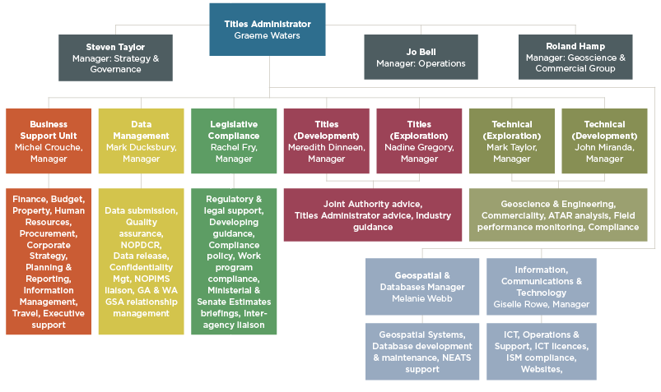

# Key work areas

NOPTA is made up of the following nine teams, spread across both the Perth and Melbourne office locations:

* Titles Exploration
* Titles Development
* Technical Exploration
* Technical Development
* Data Management
* Legislative Compliance
* Business Support
* Geospatial and Databases
* ICT Services

A brief overview of the key functions of each team is provided below.

#### Titles Team (Titles Exploration and Titles Development)

The Titles Teams (exploration and development) have three core functions:

1. to provide guidance to industry on matters pertaining to compliance with the offshore petroleum and greenhouse gas storage regulatory framework
2. to act as the point of contact between industry and the Joint Authority and/or Titles Administrator on offshore petroleum and greenhouse gas storage titles applications
3. to undertake day to day administration of offshore petroleum and greenhouse gas storage titles in accordance with the OPGGS Act and associated regulations.

These functions involve:

* maintaining a publicly available register of offshore petroleum and greenhouse gas titles
* working with the other teams within NOPTA to provide information, application assessments, analysis, reports and advice to the Joint Authority and/or the Titles Administrator
* implementing offshore petroleum and greenhouse gas title related decisions.

#### Technical Team

**(Technical Exploration and Technical Development)**

The technical teams (exploration and development) are responsible for providing geotechnical, engineering and commercial advice across the entire petroleum title lifecycle, from initial permit award, through exploration and discovery, to development and

production for all titles in offshore Australia. The five core functions of the teams are:



* 1. geoscience and engineering assessment of offshore petroleum exploration and development applications
  2. monitoring field performance and providing advice on resource management issues and the optimal long term recovery of Australia’s offshore petroleum resources
  3. providing guidance on matters pertaining to offshore petroleum exploration and development within the regulatory framework
  4. conducting commercial and financial assessments associated with applications and reporting received by NOPTA.
  5. development and application of production, hydrocarbon resource and field information databases in support of the above activities

#### Data Management

The Data Management Team is responsible for managing the submission and release of offshore petroleum data in compliance with the RMA Regulations. Key aspects of this role include:

* + managing the submission of data made under the RMA Regulations
  + developing systems and business processes to improve consistency and usability of offshore petroleum data
  + managing the National Offshore Petroleum Data and Core Repository relationship
  + developing reporting standards for data submissions, including activity reports
* recommending the release of well, survey and petroleum mining sample data
* improving the comprehensiveness and quality of the Commonwealth data collection.

#### Legislative Compliance

The Legislative Compliance Team has a range of legal, compliance and advisory functions. These include:

* providing legal and regulatory support across NOPTA. This includes responding to requests for internal legal advice, managing requests for external legal advice, and assisting to implement the outcomes of advice
* developing and contributing to internal and external guidance for staff, titleholders, and other stakeholders. This includes guidelines and factsheets published on NOPTA’s website
* maintaining a register to track compliance items across NOPTA and overseeing the escalation of compliance issues
* managing NOPTA’s relationship with the Department in relation to offshore petroleum and greenhouse gas policy and legislative matters. This includes coordinating NOPTA’s input into legislative amendments and policy reviews that relate to NOPTA’s functions under the OPGGS Act
* maintaining NOPTA policies such as the compliance and enforcement policy and NOPTA’s delegation policy.

#### Business Support Unit (BSU)

The BSU undertakes administrative and executive functions to enable NOPTA to meet its statutory obligations and to facilitate a safe and supportive workplace. The functions within the BSU include:

* Human Resources
* Health, Safety and Wellbeing
* Cost Recovery (CRIS)
* Finance
* Procurement
* Information Management
* Property
* Corporate Planning & Reporting

#### Geospatial and Databases (GDT)

The Geospatial and Databases Team is responsible for providing geospatial information service, database and NEATS development and support within NOPTA and to external stakeholders. The key functions with the Geospatial and Database team include:

* provide spatial support to NOPTA staff and external stakeholders
* maintain NOPTA’s corporate spatial information and systems
* provide NEATS support and maintenance
* manage the Application Support services provided by external providers
* provide guidance and facilitate the development and administration of internal databases.

#### Information Communication and Technology (ICT)

The ICT team’s function is to serve the business by managing NOPTA’s IT environment with a focus on enhancing existing services, improving service processes and delivering contemporary technology that meets NOPTA’s requirements. Key functions include:

* implementing NOPTA’s ICT strategy
* managing ICT contracts and services provided by external providers
* facilitating the development and administration of NOPTA’s business tools
* ensuring compliance with appropriate standards and managing the currency of policies and procedures
* transitioning NOPTA’s aging IT environment to more efficient and innovative cloud infrastructure.

# Outlook for 2018–19

NOPTA’s forward work program will be guided by industry activity and associated applications as well as any new Government policy initiatives. This flexibility and open approach is consistent with the objectives of the Regulator Performance Framework. NOPTA’s key work areas for 2018–19 include:

* Continue to strengthen relationships with key stakeholders, including NOPSEMA, the Department’s Offshore Resources Branch, delegates of the Joint Authority, Geoscience Australia and industry.
* Continue to provide input into the Department’s review of offshore petroleum decommissioning under the OPGGS Act framework.
* Further development of the offshore historical production, resource and field databases to support analysis, assessment and reporting, as necessary.
* Continue to develop NOPIMS by incorporating additional documentary information and improving search functions to aid data discovery.
* Finalise improvements of internal processes relating to NEATS.
* Continue to review and update NOPTA’s internal processes and procedures.
* Review and update NOPTA’s application forms and associated website guidance material.
* Finalise the implementation of cloud services and decommission redundant IT infrastructure.

###### Australian offshore petroleum well activity: 1 July 2017 to 30 June 2018

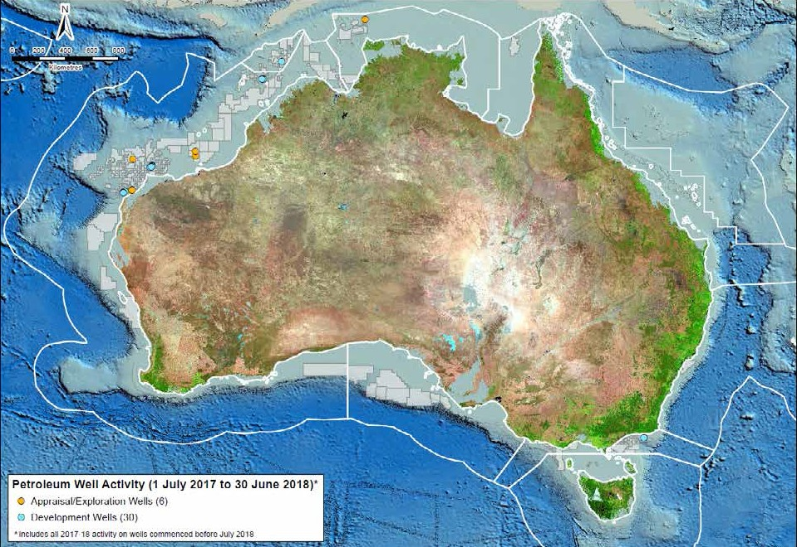

***Australian offshore petroleum well activity: 2012 to 30 June 2018***

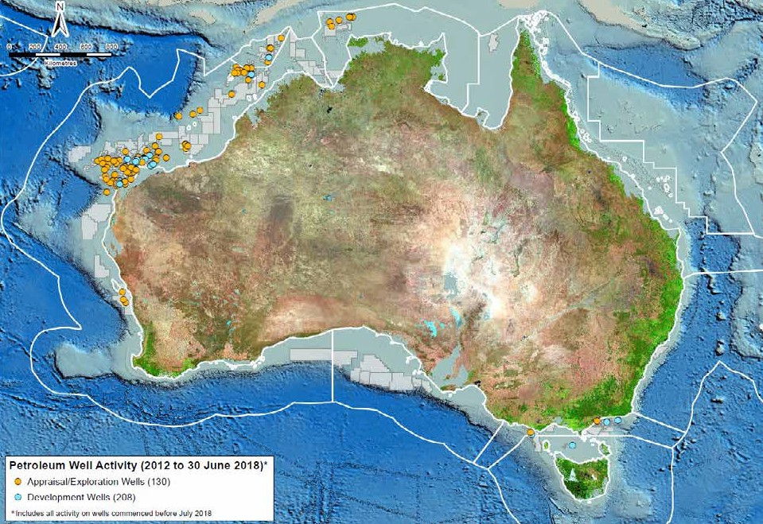

***Australian offshore petroleum survey activity: 1 July 2017 to 30 June 2018***

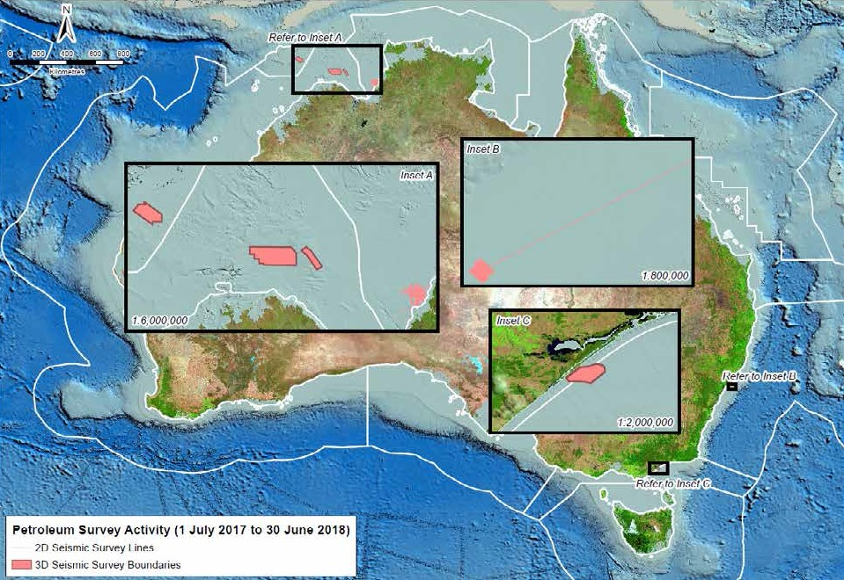

***Australian offshore petroleum survey activity: 2012 to 30 June 2018***

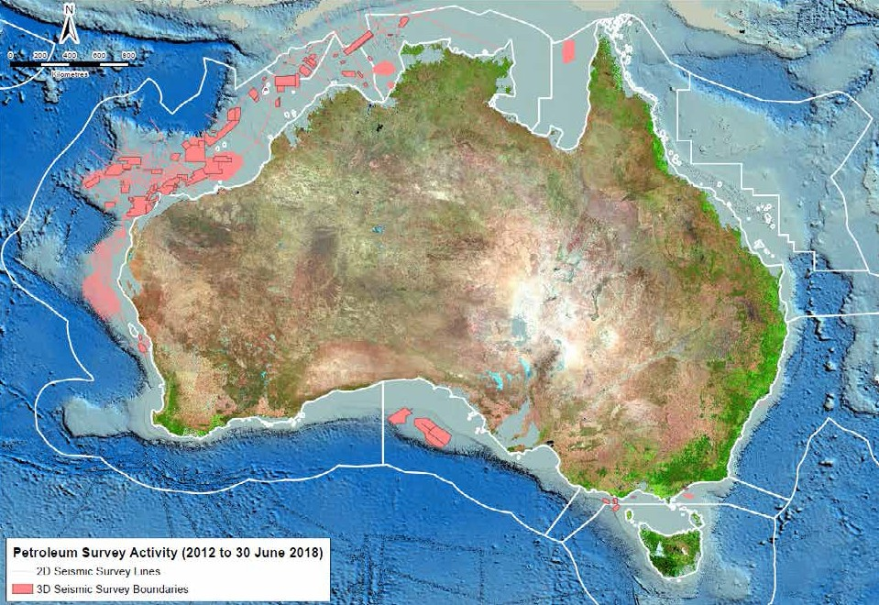

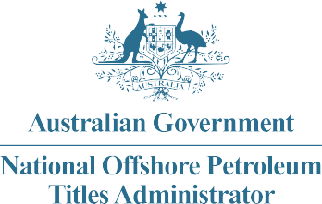

**NOPTA Corporate Plan 2017– 2020**

**Our Vision** Contributing to national prosperity through administering a thriving offshore oil and gas industry.

**Our Purpose** To advise on and administer the Offshore Petroleum and Greenhouse Gas Storage Act 2006 for Australia’s offshore petroleum titles regime to support the effective regulation of our offshore oil and gas resources consistent with good oil field practice and optimum recovery.

**Our Culture** We value mutual respect, openness and inclusiveness. We are responsive, consultative, accountable and transparent.

Key Performance Indicators

**(Regulator Performance Framework)**

##### **KPI 1** NOPTA does not unnecessarily impede the efficient operation of Titleholders.

**KPI 2** Communication with Titleholders is clear, targeted and effective.

**KPI 3** Actions undertaken by NOPTA are proportionate to the regulatory risk being managed.

**KPI 4** Compliance and monitoring approaches are streamlined and coordinated.

**KPI 5** NOPTA is open and transparent in its dealings with Titleholders.

**KPI 6** NOPTA actively contributes to the continuous improvement of regulatory frameworks.

|  |  |  |  |
| --- | --- | --- | --- |
| **Our functions** | **Our objectives** | **How we will deliver** | **Our indicators of success** |
| **Assist and advise the Joint Authority and the responsible Commonwealth Minister** | * Contribute to the efficient decision making of the Joint Authority (JA) and responsible Commonwealth Minister. * Maintain and promote open and transparent stakeholder engagement. | * Provide sound advice and recommendations to the JA and responsible Commonwealth Minister, as set out in the JA protocol. * Identify and provide options to streamline and reduce regulatory burden, where appropriate. * Take a risk based approach to engagement, compliance and enforcement, allowing for proportionate responses. * Ensure guidelines and factsheets are up to date and relevant through timely and effective review and consultation. * Risk-based compliance and enforcement policy is regularly reviewed. * Contribute effectively to resource management initiatives. * Field performance monitoring strategies to secure optimum recovery. * Clear, targeted and effective stakeholder engagement. | * Effective management of offshore oil and gas resources in Australia. * Advice to the JA and the responsible Commonwealth Minister is timely, accurate and consistent. * Assessment timeframes set by the JA protocol are met. * Positive feedback from the JA, industry and other stakeholders as measured through stakeholder surveys and other feedback mechansisms. * Guidance information provided to industry is accurate, complete and readily accessible on the NOPTA website, incorporating stakeholder feedback. * Reduction in stakeholder enquiries and non-compliance. |
| **Manage and complete Titles Administrator statutory decisions and authorisations** | * Deliver efficient and consistent Titles Administrator decisions and authorisations. * Maintain and promote open and transparent stakeholder engagement. | * Clear, targeted and effective stakeholder engagement. * Ensure timely decisions and authorisations. | * Decisions and authorisations are timely, consistent, defensible and readily accessible. * Positive feedback from industry and other stakeholders as measured through stakeholder surveys and other feedback mechansisms. |
| **Keep a register of titles** | * Maintain a publicly available titles register and approvals tracking system for applications. | * Maintain and improve the National Electronic Approvals Tracking System (NEATS). * Upload historical title registers in NEATS for all active titles. * Enhance the tracking process and system for applications and key regulatory submissions. | * The titles register is publicly available, and up to date. * Tracking system for regulatory submissions implemented. |
| **Manage data and reporting submissions** | * Streamline data and reporting submissions. * Improve data quality and data integration. * Complete consolidation of offshore data collection. * Facilitate ease of access to open file data. | * Manage the National Offshore Petroleum Data and Core Repository. * Coordinate with Geoscience Australia and States and Territory representatives to finalise data integration and quality control processes. * Maintain timely authorisations to release well, survey and petroleum mining sample data. * Implement systems for enhanced delivery of data, including further enhancements to the National Offshore Petroleum Information Management System (NOPIMS). | * Submission non-compliance is minimised. * Data consolidation and integration program implemented. * NOPIMS is implemented. |
| **Engage, consult and cooperate with stakeholders** | * Continue to strengthen our relationships with key stakeholders including   NOPSEMA, the department’s Offshore Resources  Branch, delegates of the JA, Geoscience Australia and industry.   * Maintain and promote open and transparent stakeholder engagement. | * Work with NOPSEMA and the Offshore Resources Branch to identify options to simplify and streamline legislation, guidelines and processes for industry. * Contribute to applicable national and international fora. * Contribute advice and technical expertise to intra and interdepartmental meetings and taskforces. * Engage with APPEA and other industry groups. * Communication is clear, targeted and effective. | * Positive feedback from agencies, industry and other stakeholders as measured through stakeholder surveys and other feedback mechansisms. * Timely and responsive delivery of ongoing Geographic Information System services to NOPSEMA. * Developing and maintaining networks through attending national and international fora. * Active participation in policy and legislative discussions. * A monthly dashboard is published providing application and data statistics. |
| **Provide corporate support to facilitate delivery of legislated functions** | * Maintain a competent capacity. * Maintain strong financial management and risk management systems, processes and culture. * Ensure all NOPTA staff are appropriately trained in   corporate systems, processes and *Public Governance Accountability Act 2013* (the PGPA) requirements relative to their role.   * Maintain secure, reliable and responsive information technology systems. | * Recruit and retain skilled professionals. * Encourage individuals’ professional learning and development. * Facilitate an annual NOPTA planning and training workshop. * Maintain and improve staff work-life balance. * Provide a safe and supportive workplace with flexible work options. * Provide a reliable and stable ICT service to support NOPTA functions. | * NOPTA is fully cost recovered and maintains its Cost Recovery Impact Statement in line with the Australian Government Charging Framework. * Manage NOPTA’s Special Account in accordance with the PGPA and Commonwealth Procurement Rules. * Risk management integrated into financial and corporate decision making processes. * Flexible working arrangements implemented. * Increased efficiency and effectiveness through the use of collaborative work platforms. * ICT systems and services are robust, flexible, solutions oriented and relevant to business requirements. |

