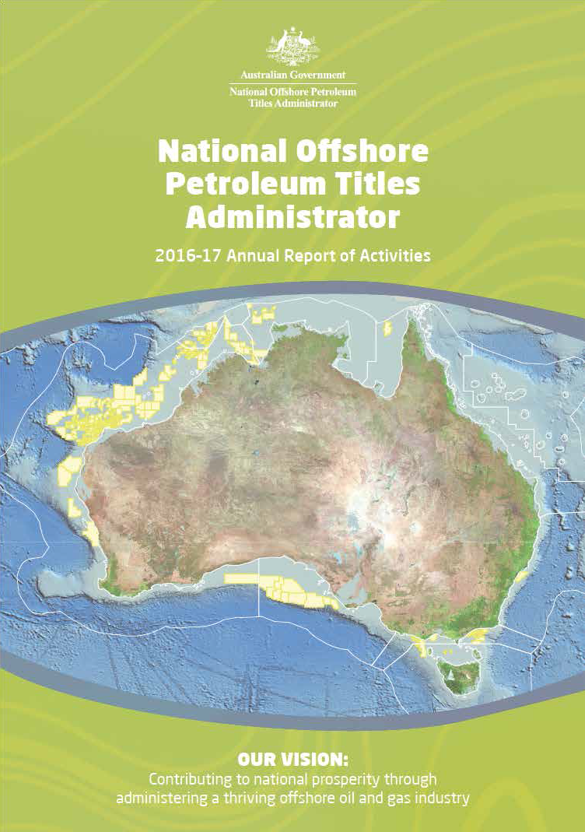

# National Offshore Petroleum Titles Administrator

**2016–17 Annual Report of Activities**

© Commonwealth of Australia 2017

This work is copyright. Apart from any use as permitted under the Copyright Act 1968, no part may be reproduced by any process without prior written permission from the Commonwealth. Requests and inquiries concerning reproduction and rights should be addressed to the Department of Industry, Innovation and Science, GPO Box 9839, Canberra ACT 2601.

ISSN: 2205-8230 (print version) ISSN 2205-8249 (online)

For more information about this report please contact:

Business Manager

National Offshore Petroleum Titles Administrator Department of Industry, Innovation and Science

GPO Box 7871

Perth WA 6850

Phone: (08) 6424 5300

Email: [corporate@nopta.gov.au](mailto:corporate@nopta.gov.au) Web: [www.nopta.gov.au](http://www.nopta.gov.au/)

*Cover image: Map produced by NOPTA showing Australian offshore titles in force at 30 June 2017 Photo (this page): Opening launch of the newly expanded Perth Core Library (Nov 2016)*

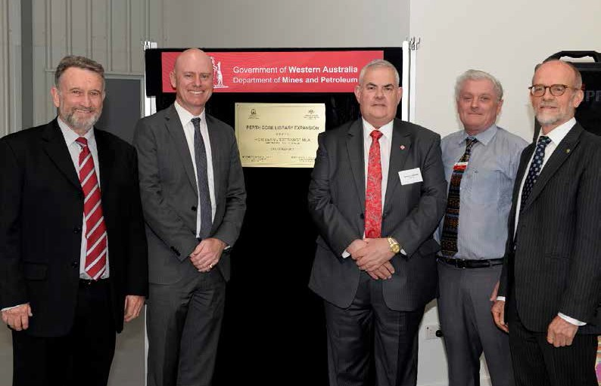



*Prelude FLNG as it leaves SHI Shipyard, Geoje South Korea. Image courtesy of Shell*

# Contents

Titles Administrator’s Review 2 Overview 3 About NOPTA 5 Key Achievements 2016–17 6 Titles Administration 7 *Figure 1: 2016–17 Submitted applications 8*

*Table 1: 2016–17 Submitted applications 8* Decisions of the Joint Authority and the Titles Administrator 9 *Table 2: 2016–17 Decisions of the Joint Authority and the Titles Administrator by jurisdiction 9 Figure 2: 2016–17 Decisions of the Joint Authority and the Titles Administrator (aggregate) 9* Data submission and release 10 *Figure 3: Submission items received July 2016 to June 2017 10*

*Figure 4: Data released July 2016 to June 2017 10* National Offshore Data and Core Repository 11 Cost recovery 12 *Table 3: Annual Titles Administration Levy 2016 –17 12*

*Table 4: Application Fees 2016–17 13* NOPTA’s Financial Result 15 *Table 5: NOPTA’s 2016–17 financial result compared to 2015–16 15 Table 6: Summary of financial performance and estimates 15 Table 7: NOPTA’s financial performance since its establishment 16* Organisational Structure 17 *Figure 5: NOPTA’s organisational structure at 1 July 2017 17* Key Work Areas 18 Outlook for 2017–18 21

Australian Offshore Petroleum Well Activity: 2012 to 30 June 2017 22

Australian Offshore Petroleum Survey Activity: 2012 to 30 June 2017 23

Corporate Plan 2017–2020 24

# Titles Administrator’s Review



January 2017 marked the 5th anniversary of the reforms to Australia’s Commonwealth offshore petroleum regulatory and administration arrangements. As an integral component in that regulatory regime, the National Offshore Petroleum Titles Administrator (NOPTA), has become firmly established in

delivering high-quality advice to industry and governments and continues to strive for continuous improvement.

Our performance, when measured against the Government’s Regulator Performance Framework is most encouraging, as are the results of our stakeholder feedback. I am also pleased to report that we have completed the implementation of all recommendations arising from the 2015 operational review of NOPTA.

A strong focus for us over the past year has been the implementation of the new National Offshore Petroleum

Information Management System (NOPIMS) to provide industry with a wider range of data. Our collaboration with Geoscience Australia and Western Australia’s Geological Survey continues to provide better, easier access and more reliable data.

On reflection, 2016–17 has been a year of consolidation in our processes and developing, or putting in place, a range of initiatives to improve the delivery of our advice and increasing the availability of information. Shortly, we will be launching a revised web site that seeks to significantly improve the user experience through the way we present information.

Over the coming year I will be seeking further opportunities to relieve burden for industry in resource and data management regulations and invite stakeholders to contribute ideas that may advance the reform agenda.

Yours sincerely, Graeme A Waters

National Offshore Petroleum Titles Administrator

# Overview

The aim of this report is to provide stakeholders with information on the activities and key achievements of the National Offshore Petroleum Titles Administrator (NOPTA), headed by a statutory position of Titles Administrator, over the 2016–17 period.

This report complements the statutory 2016–17 Annual Report of the Department of Innovation, Industry and Science (the Department).

NOPTA advises on and administers the *Offshore Petroleum and Greenhouse Gas Storage Act 2006* (OPGGS Act) for Australia’s offshore petroleum titles regime to support the effective regulation of our offshore oil and gas resources consistent with good oil field practice and optimum recovery of petroleum. NOPTA’s recently updated 2017–2020 Corporate Plan (available at [www.nopta.gov.au](http://www.nopta.gov.au/)) outlines how NOPTA delivers its functions with reference to the six key performance indicators of the Regulator Performance Framework1.

The following provides an overview of NOPTA’s key activities during 2016–17.

##### NOPTA 2016–17 Stakeholder Survey

In 2017 NOPTA engaged KPMG to undertake a survey of key stakeholders to assess NOPTA’s performance and level of stakeholder satisfaction and to identify areas for improvement. Stakeholders who responded reported high overall levels of satisfaction with NOPTA, its staff and processes2. This is consistent with the overall results of the 2015 and 2016 stakeholder surveys. NOPTA thanks all stakeholders for their valuable contribution to this process and encourages future participation to help support NOPTA’s continuous improvement.

##### Industry Guidance

NOPTA continues to consult and work collaboratively with a range of stakeholders to improve the level of guidance for industry. During 2016–17, this has taken the form of factsheets, guidelines and application forms for titleholders.

##### Resource Management

Monitoring production of Australia’s offshore oil and gas resources is fundamental to ensuring developments are consistent with the principles of good oil-field practice and optimal long-term recovery of hydrocarbons. During 2016–17, NOPTA continued its performance assessments of fields and its monitoring of compliance with approved field development plans and production rates. NOPTA also commenced annual performance reviews of all fields, including meetings with titleholders.

In 2017 NOPTA initiated the re-evaluation of commercial viability of petroleum production from ten retention leases in the North West Shelf region in accordance with section 136(5) of the OPGGS Act. The re-evaluation process will consider the potential for resources to be developed through the North West Shelf gas facility.

1. See <https://www.cuttingredtape.gov.au/resources/rpf>)
2. KPMG Stakeholder Survey Report 17 May 2017 <http://www.nopta.gov.au/media/stakeholder-survey/index.html>

##### NEATS 2020: Pre-planning and Scoping

Following a competitive procurement process, NOPTA engaged KPMG in 2016 to conduct a pre-planning and scoping project for the next development phase for the National Electronic Application Tracking System (NEATS)—referred to as NEATS 20203. This project was initiated following the 2015 Operational Review of NOPTA4 which recommended that NOPTA continue to develop NEATS. Feedback from the 2016 NOPTA Stakeholder Survey was also taken into account as part of this process.

The key outcome from the project is that there is no immediate need for any major investment to further develop NEATS. However, KPMG did report some high level requirements identified by stakeholders for enhancing NEATS in the longer-term. Consistent with KPMG’s findings, NOPTA’s current focus is to develop user guides to assist titleholders, and undertake awareness sessions to help the industry to better

understand and use NEATS. Any further development of NEATS will need to show clear benefits to industry.

##### Information, Communication and Technology (ICT) Governance

In 2016 NOPTA engaged Protiviti to assess ICT governance and project management and to document the responsibility and accountability for key ICT functions. The recommendations include the delegation of some responsibilities and a more balanced distribution of responsibilities. These recommendations are currently being implemented to maintain a secure, reliable and responsive ICT service to support NOPTA and industry needs.

1. NEATS 2020: Pre-Planning and Scoping—Summary Report <http://www.nopta.gov.au/media/neats2020/index.html>
2. NOPTA Operational Review 2015 [www.nopta.gov.au/media/operational-review/index.html](http://www.nopta.gov.au/media/operational-review/index.html)

*The Wheatstone drilling campaign is complete, with all nine development well flowbacks successful. Image courtesy of Chevron*

# About NOPTA

NOPTA, also known as the Titles Administrator, is appointed by the Secretary of the [Department of Industry, Innovation and Science](http://www.industry.gov.au/) (the Department) under section 695A of the *Offshore Petroleum and Greenhouse Gas Storage Act 2006* (OPGGS Act).

NOPTA is responsible for the day-to-day administration of all petroleum and greenhouse gas titles in Commonwealth waters in Australia and is the first point of contact for matters relating to offshore titles administration. NOPTA operates on a full cost recovery basis, funded by the petroleum industry.

NOPTA’s key functions in Commonwealth waters are to:

» provide information, assessments, analysis, reports, advice and recommendations to members of the Joint Authorities and the ‘responsible Commonwealth Minister’ under the OPGGS Act and associated regulations

» facilitate life of title administration, including but not limited to Joint Authority consideration of changes to permit conditions, and approval and registration of transfers and dealings associated with offshore petroleum titles

» manage the collection, management and release of data

» keep the registers of petroleum and greenhouse gas storage titles.

The Joint Authorities are the decision-maker for the granting of the petroleum titles that underpin petroleum exploration and development—exploration permits, retention leases and production licenses. NOPTA provides advice and recommendations in relation

to these decisions. All communications to or from the Joint Authority occurs through NOPTA.

NOPTA has the authority to grant short-term titles (petroleum access authority and petroleum special prospecting authority) and approves certain commercial arrangements known as transfers and dealings.

# Key Achievements 2016–17

In 2016–17 NOPTA delivered key outcomes focused on improving operational support for the industry and delivering on its obligations under the Regulator Performance Framework (RPF). Specifically NOPTA:

» published its inaugural self-assessment against the RPF. NOPTA self-assessed that it has implemented the RPF and met its six KPIs effectively which was externally validated by the Growth Centre Advisory Committee

» published the 2017–2020 NOPTA Corporate Plan which maintains a strong focus on the six KPIs of the RPF

» conducted its annual stakeholder survey to assess client satisfaction with NOPTA’s performance in key areas

» completed a review of NEATS to identify industry’s expectations for the next development phase for NEATS (known as the NEATS 2020 project)

» assisted Geoscience Australia in the development and implementation of the National Offshore Petroleum Information Management System (NOPIMS) to provide improved access to a wider range of petroleum data to industry stakeholders

» developed an internal risk register to complement the broader divisional and departmental risk plans. NOPTA identified 19 key risks in the people, process and technological categories; none of these risks are rated as ‘high’, and the majority of risks are medium in severity and adequately controlled

» developed internal databases to capture, aggregate and analyse data to improve the monitoring of Australia’s offshore petroleum resources, as well as titleholder compliance to fulfil any conditions or expectations placed on their title by the Joint Authority

» consulted with industry on the management of petroleum production data and tendered for a software system to manage the collation and analysis of this data— this will improve NOPTA’s capability to efficiently manage, aggregate and report on petroleum production from offshore Australia

» developed an internal ICT strategy in May 2017 to articulate priorities to 31 December 2019, taking into account outcomes arising from the NEATS 2020 report

» developed and updated a range of new and existing guidelines, factsheets and application forms for titleholders. In conjunction with the Offshore Resources Branch of the Department, specific achievements over this period include the publication of:

* the updated ‘Grant and Administration of Retention Lease and Related Matters Guideline’
* the updated ‘Offshore Petroleum Special Prospecting Authority, Access Authority and Scientific Investigations Consents Guideline’
* the updated ‘Offshore Petroleum Declaration of a Location Guideline’

» continued to enhance its relationship with NOPSEMA to simplify and streamline regulatory processes for industry, including the provision of web-based geographic information system services to NOPSEMA.

# Titles Administration

NOPTA undertakes various administration and compliance activities relating to offshore titles including:

» Transfers and Dealings: applications for the registration of transfers of, and dealings in, petroleum titles

» Petroleum Titles Applications: grants, renewals, surrenders, expiries and cancellations; title conditions management (credits, suspensions, extensions, variations and exemptions)

» Petroleum Discovery: notifications and assessment reports; declaration, variation and revocation of locations

» Petroleum Production: applications for acceptance of a field development plan and rate of recovery; approvals of equipment and procedures; monitoring of production

» Infrastructure Licence: applications for grant, including proposed location of infrastructure

» Pipeline Licence: applications for grant and variation, including proposed location of the pipeline

» Special Prospecting Authority and Access Authority: applications for grant and variation (including applications for Scientific Investigation Consents)

» Greenhouse Gas Storage Titles: applications for assessment permits; variations, suspensions, extensions and surrender of assessment permits; renewal of assessment permits; declaration of a formation; holding leases; injection licences; search authorities; special authorities; and research consents

During 2016–17, NOPTA received 359 applications and processed six cancellations (compared to 451 applications and three cancellations in 2015–16), as outlined in Figure 1 and Table 1 below.

Figure 1: 2016–17 Submitted applications

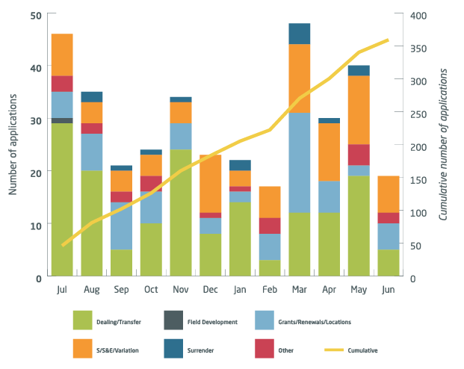

Table 1: 2016–17 Submitted applications

|  |  |  |  |  |  |  |  |  |  |  |  |  |
| --- | --- | --- | --- | --- | --- | --- | --- | --- | --- | --- | --- | --- |
| **Application Type** | **Jul** | **Aug** | **Sep** | **Oct** | **Nov** | **Dec** | **Jan** | **Feb** | **Mar** | **Apr** | **May** | **Jun** |
| **Dealing/Transfer** | 29 | 20 | 5 | 10 | 24 | 8 | 14 | 3 | 12 | 12 | 19 | 5 |
| **Field Development** | 1 |  |  |  |  |  |  |  |  |  |  |  |
| **Grants/Renewals/Locations** | 5 | 7 | 9 | 6 | 5 | 3 | 2 | 5 | 19 | 6 | 2 | 5 |
| **Other** | 3 | 2 | 2 | 3 |  | 1 | 1 | 3 |  |  | 4 | 2 |
| **S/S&E/Variation** | 8 | 4 | 4 | 4 | 4 | 11 | 3 | 6 | 13 | 11 | 13 | 7 |
| **Surrender** |  | 2 | 1 | 1 | 1 |  | 2 |  | 4 | 1 | 2 |  |
| **Monthly Total** | 46 | 35 | 21 | 24 | 34 | 23 | 22 | 17 | 48 | 30 | 40 | 19 |
| **Cumulative** | **46** | **81** | **102** | **126** | **160** | **183** | **205** | **222** | **270** | **300** | **340** | **359** |

# Decisions of the Joint Authority and the Titles Administrator

In 2016–17 there were 371 decisions (2015–16: 478) made in relation to applications for offshore petroleum titles. NOPTA provided advice to the Joint Authority for decisions on 167 applications and the Titles Administrator made 204 decisions. Table 2 and Figure 2 illustrate the decisions made by the responsible authority and by jurisdiction.

Table 2: 2016–17 Decisions of the Joint Authority and the Titles Administrator by jurisdiction

|  |  |  |  |  |  |  |  |  |
| --- | --- | --- | --- | --- | --- | --- | --- | --- |
| **Jurisdiction** | | | | | | | | |
| **Decision Maker** | **WA** | **SA** | **NT** | **VIC** | **AC \*** | **NSW** | **QLD** | **TAS \*** |
| **Joint Authority** | 129 | 5 | 4 | 20 | 7 | 0 | 0 | 2 |
| **Titles Administrator** | 162 | 8 | 5 | 23 | 5 | 0 | 0 | 1 |
| **Total** | **291** | **13** | **9** | **43** | **12** | **0** | **0** | **3** |

*\*AC = Ashmore Cartier. JA comprises only the Commonwealth Minister, Tasmania has opted out of JA arrangements and the Commonwealth Minister is the decision maker*

Figure 2: 2016–17 Decisions of the Joint Authority and the Titles Administrator (aggregate)

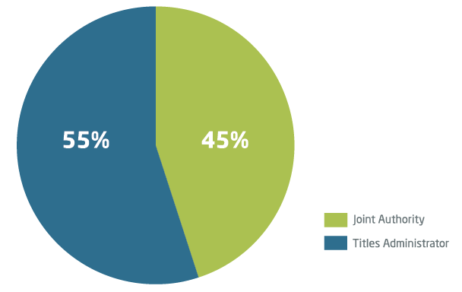

# Data submission and release

The Titles Administrator has responsibility for the submission and release of documentary information and petroleum mining samples (petroleum data), in accordance with Part 7 and Part 8 of the *Offshore Petroleum and Greenhouse Gas Storage (Resource Management and Administration) Regulations 2011* (RMA Regulations).

During the period 619 items relating to new wells and 320 items relating to new and reprocessed surveys were submitted to NOPTA (Figure 3). With time lags between activity completion and regulated data submission dates, the level of current submissions reflects the level of industry activity between one and three years ago.

Figure 3: Submission items received July 2016 to June 2017

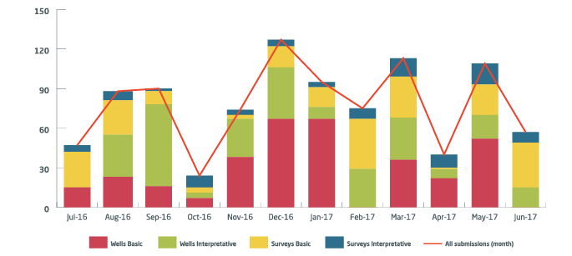

During the same period, data from 160 well activities and 143 surveys (including reprocessed surveys) were released for public use (Figure 4).

Figure 4: Data released July 2016 to June 2017

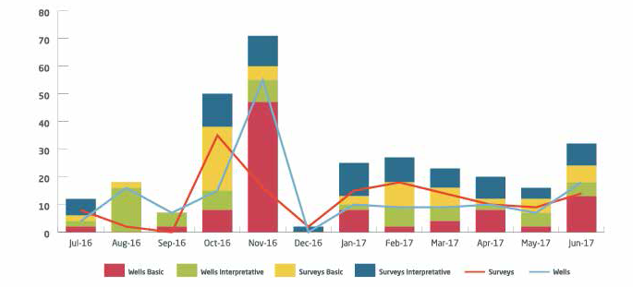

# National Offshore Data and Core Repository

NOPTA, in collaboration with Geoscience Australia and the Department of Mines and Petroleum (Geological Survey of Western Australia), operates the National Offshore Petroleum Data and Core Repository (NOPDCR) through which petroleum mining samples and digital data are archived, maintained and made available once the relevant confidentiality periods expire and the Titles Administrator has authorised release.

With reduced volumes of current submissions, considerable focus has been given to improving the completeness and quality of data made publicly available; and improving discovery and delivery of this information.

The co-developed National Offshore Petroleum Information Management System, (NOPIMS) has recently undergone a major redevelopment to increase compatibility with different internet browsers and systems, making it easier to find and access petroleum data. No registration is required to view and download seismic and well related information, and new features include predictive search boxes, a more intuitive interface, and a map that can be accessed on all platforms including tablets and mobiles.

The National Offshore Data Integration Project (NOPDIP) has completed processing of over 900 boxes of hard-copy records previously held by the Northern Territory Designated Authority. This data will progressively become available through NOPIMS. With processing of hard-copy records from Western Australia and Victoria to occur in subsequent years, this will significantly increase the range and volume of information available from the Commonwealth petroleum data collection.

To request well and survey data from repository holdings please contact [ausgeodata@](mailto:ausgeodata@ga.gov.au) [ga.gov.au](mailto:ausgeodata@ga.gov.au).

To request to view and sample physical assets such as core, cuttings and fluids please contact [ausgeosamples@ga.gov.au](mailto:ausgeosamples@ga.gov.au).

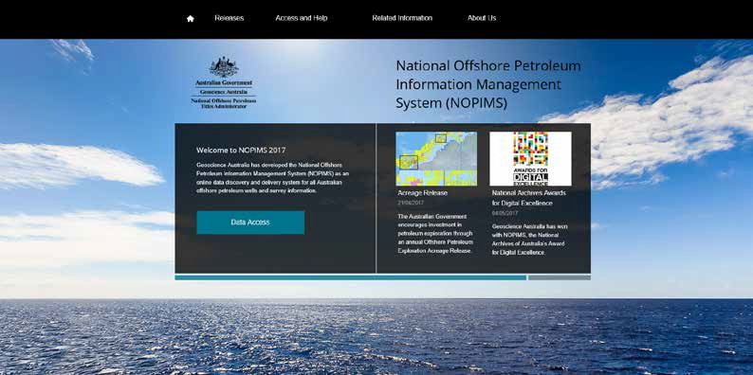

[www.ga.gov.au/nopims](http://www.ga.gov.au/nopims)

# Cost recovery

NOPTA’s cost recovery charges include an annual levy imposed on different types of titles (permits, leases and licences) and fees charged on applications made to the Titles Administrator relating to offshore petroleum titles.

##### Cost recovery levy

An Annual Titles Administration Levy is imposed on holders of titles (permits, leases and licences). The levy is payable in accordance with the *Offshore Petroleum and Greenhouse Gas Storage (Regulatory Fees) Regulations 2004* upon the grant of a title and annually thereafter within 30 days of the anniversary of the title. Where a title is in force for less than twelve months, the levy is calculated for the remaining period of the title.

The levy makes up the majority of NOPTA’s revenue (approximately 87 per cent in 2016–17) providing a stable revenue stream that is dependent upon the current number and type of titles in force. It is used to fund activities where it is not possible or practical to attribute costs to a specific entity (e.g. industry-wide monitoring, data management, compliance and enforcement). This means there is a degree of cross-subsidy between titleholders, although this is minimal.

There were 427 titles in force during 2016–17 that contributed to the annual levy total of

$15.19 million, as shown in Table 3.

Table 3: Annual Titles Administration Levy 2016 –17

|  |  |  |  |  |  |
| --- | --- | --- | --- | --- | --- |
| **Title type** | **No. of Titles** | **No. of blocks** | **Length Km** | **Levy Rate** | **Levy Amount** |
| Exploration Permit | 156 | NA | NA | $10,000/title | $1,560,000 |
| Exploration Permit Renewal | 8 | NA | NA | $10,000/title | $26,712 |
| Greenhouse Gas Assessment Permit | 4 | NA | NA | $10,000/title | $40,000 |
| Infrastructure Licence | 3 | NA | NA | $25,000/title | $75,000 |
| Pipeline Licence | 73 | NA | 4,027 | $100/km | $402,700 |
| Production Licence | 93 | 310 | NA | $20,000/block | $6,200,000 |
| Production Licence Renewal | 2 | 5 | NA | $20,000/block | $35,342 |
| Retention Lease | 84 | 341 | NA | $20,000/block | $6,760,000 |
| Retention Lease Renewal | 3 | 11 | NA | $20,000/block | $56,767 |
| Part Year Retention Lease | 1 | 3 | NA | $20,000/block | $33,698 |
| Annual Levy | 427 |  |  |  | $15,190,220 |

##### Cost recovery fees

Application fees are payable in accordance with the RMA Regulations at the time that an application is submitted for approval to enable titleholders to undertake certain regulated activities. Revenue from fees fluctuates from year to year as it is dependent on the timing and number of applications lodged.

A flat fee structure of $7,500 per application was introduced on 1 July 2016, following a comprehensive review of activities and rates in consultation with stakeholders.

NOPTA received 307 applications in 2016–17 and generated revenue of $2.25 million, or approximately 13 per cent of NOPTA’s total income, as shown in the Table 4.

Table 4: Application Fees 2016–17

|  |  |  |
| --- | --- | --- |
| **Application type (charged at a flat fee of $7,500 per application)** | **No. of Applications** | **Fee Amount** |
| Work-bid Petroleum Exploration Permit | 16 | $120,000 |
| Cash-bid Petroleum Exploration Permit | 2 | $15,000 |
| Renewal of Petroleum Exploration Permit | 9 | $67,500 |
| Petroleum Retention Lease | 7 | $52,500 |
| Renewal of Petroleum Retention Lease | 14 | $105,000 |
| Petroleum Production Licence | 1 | $7,500 |
| Renewal of Petroleum Production Licence | 4 | $30,000 |
| Petroleum Pipeline Licence | 1 | $7,500 |
| Variation of Pipeline Licence | 3 | $22,500 |
| Petroleum Special Prospecting Authority | 3 | $22,500 |
| Transfer | 36 | $270,000 |
| 1 | $7,180 |
| Dealing | 94 | $705,000 |
| 10 | $29,500 |
| Petroleum Access Authority | 7 | $52,500 |
| Suspension and Extension; Variation; Exemption (per title) | 64 | $480,000 |
| Suspension and Extension; Variation; Exemption (per title) | 1 | $5,340 |
| Declaration of Location | 8 | $60,000 |
| Surrender | 15 | $112,500 |
| Acceptance of a Field Development Plan | 1 | $7,500 |
| Variation Field Development Plan | 1 | $7,500 |
| Rate of Recovery | 9 | $67,500 |
| Application Fees | 307 | $2,254,520 |

##### Cost Effectiveness

NOPTA is committed to maintaining low-cost delivery through continuous process and systems improvement in consultation with industry. Since its establishment NOPTA has maintained a low-cost delivery of its legislated functions to the industry.

From 1 September 2017 the surcharge for credit card payments made through NEATS will be abolished in an effort to simplify processes and reduce regulatory burden.

While NOPTA is structurally a branch within the Department, NOPTA does not undertake activities other than the functions legislated under the OPGGS Act. This allows for easy identification of the costs attributable to cost recovered activities.

The Department provides the governance structure under the *Public Governance, Performance and Accountability Act 2013*, access to corporate support and systems, and pays for NOPTA related workers compensation and other insurances as well as charges associated with software, licences and devices, and office fit-outs used by NOPTA staff. In 2016–17 the Department recouped $608,343 for these operational costs, or approximately 3.7 per cent of NOPTA’s total expenditure.

Some of the cost saving measures undertaken by NOPTA include:

» use of fixed-term contracts as opposed to full-time staff employment where appropriate to cater for fluctuations in industry activity

» use of part-time working arrangements

» use of non-ongoing employees before determining that a role will continue as ongoing

» use of fixed-term secondments within Government

» competitive tenders

» maintaining salary at acceptable levels and within Department of Finance guidelines.

# NOPTA’s Financial Result

NOPTA had an operational cash balance of $4.48 million available at 30 June 2017. Table 5 outlines NOPTA’s financial performance for 2016–17 compared to 2015–16.

NOPTA currently has an accumulated deficit of $3.32 million over total operating expenditure of $65.86 million, which includes $4.68 million in amortisation and depreciation costs. The accumulated deficit will be reduced over the next three years (Table 6).

Table 7 illustrates NOPTA’s financial performance since its establishment.

Table 5: NOPTA’s 2016–17 financial result compared to 2015–16

|  |  |  |
| --- | --- | --- |
| **INCOME STATEMENT** | **2016–17**  **$’000** | **2015–16**  **$’000** |
| **Revenue—Cost Recovery** | | |
| *Levies* | 15,190 | 9,140 |
| *Application Fees* | 2,255 | 1,650 |
| *Other* | 8 | (103) |
| *Total Revenue* | 17,453 | 10,687 |
| **Expenses** | | |
| *Employee Benefits* | 7,803 | 6,369 |
| *Suppliers* | 3,024 | 3,907 |
| *NOPDCR & NOPDIP (paid to Geoscience Australia)* | 2,702 | 1,969 |
| *Systems including NEATS maintenance* | 1,990 | 1,699 |
| *Depreciation and amortisation* | 1,227 | 647 |
| **Total Expenses** | 16,746 | 14,591 |
| **Surplus / (defi** | 707 | (3,904) |

Table 6: Summary of financial performance and estimates

|  |  |  |  |  |  |  |  |  |  |
| --- | --- | --- | --- | --- | --- | --- | --- | --- | --- |
|  | **2011-12**  **Actual**  **$000** | **2012-13**  **Actual**  **$000** | **2013-14**  **Actual**  **$000** | **2014-15**  **Actual**  **$000** | **2015–16**  **Actual**  **$000** | **2016–17**  **Actual**  **$000** | **2017-18**  **Estimate**  **$000** | **2018-19**  **Estimate**  **$000** | **2019-20**  **Estimate**  **$000** |
| **Expenses** | 4,046 | 8,003 | 10,067 | 12,405 | 14,591 | 16,746 | 15,000 | 15,300 | 15,300 |
| **Revenue** | 2,848 | 9,737 | 11,438 | 10,377 | 10,687 | 17,453 | 16,080 | 16,080 | 16,080 |
| **Balance** | -1,198 | 1,734 | 1,371 | -2,028 | -3,904 | 707 | 1,080 | 780 | 780 |
| **Cumulative Balance** | -1,198 | 536 | 1,907 | -121 | -4,025 | -3,318 | -2,238 | -1,458 | -678 |

Table 7: NOPTA’s financial performance since its establishment

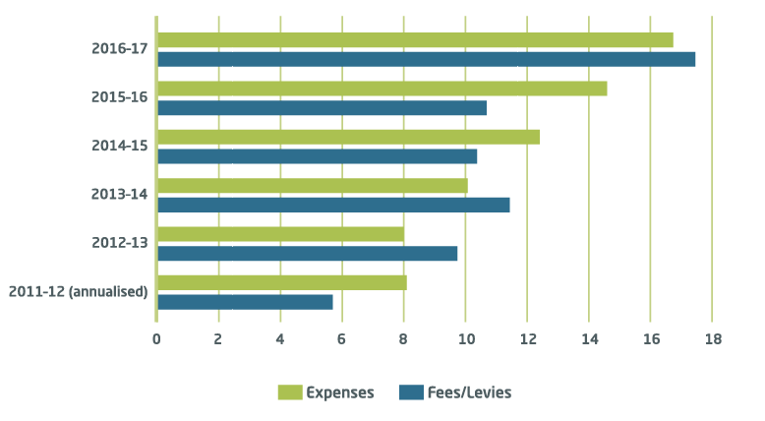

# Organisational Structure

During the reporting year NOPTA implemented a revised organisational structure. The organisational structure aims to enhance collaboration and communication and to facilitate the succession planning for key personnel. Two streams, Exploration and Development, have been embedded within the Titles and Technical teams.

##### Staffing Levels

The staffing level, including contractors, increased from 51 at the beginning of the financial year to 55 at 30 June 2017. Staff turn-over remained low and engagement with Learning and Development activities continued with all staff participating in some form of ongoing learning activity. A Strategic Staff Development Strategy was developed

to assist with the implementation of the revised organisational structure and provides guidance for ongoing staff development.

Figure 5: NOPTA organisational structure agreed on 30 June 2017 to be implemented in 2017–18

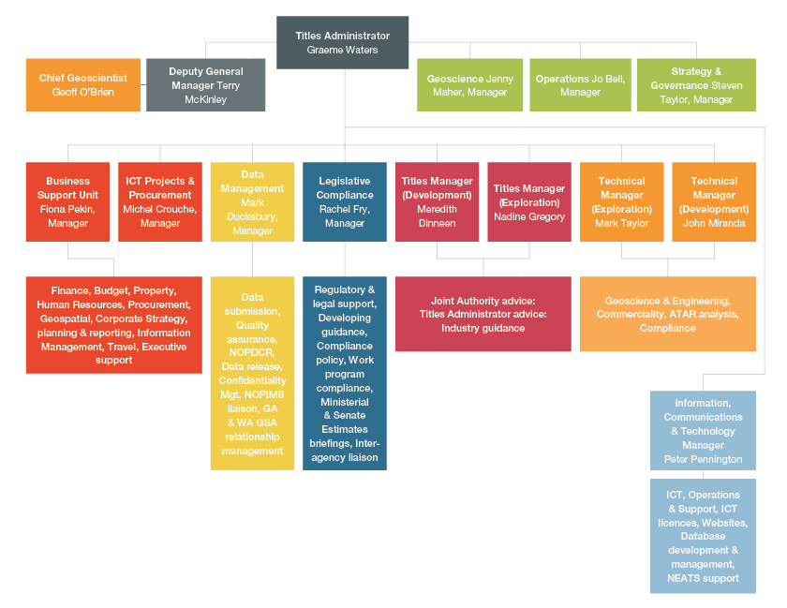

# Key Work Areas

NOPTA is made up of the following five teams, spread across both the Perth and Melbourne office locations:

» Titles Team (Exploration and Development)

» Technical Team (Exploration and Development)

» Data Management Team

» Legislative Compliance Team

» Business Support Unit (BSU), including ICT Services

A brief overview of the key functions of each team is provided below.

##### Titles Team

The Titles Team has three core functions:

1. to provide guidance to industry on matters pertaining to compliance with the offshore petroleum and greenhouse gas storage regulatory framework
2. to act as the point of contact between industry and the Joint Authority and/or Titles Administrator on offshore petroleum and greenhouse gas storage titles applications
3. to undertake day to day administration of offshore petroleum and greenhouse gas storage titles in accordance with the OPGGS Act and associated regulations.

These functions involve:

» maintaining a publicly available register of offshore petroleum and greenhouse gas titles

» working with the other teams within NOPTA to provide information, application assessments, analysis, reports and advice to the Joint Authority and/or the Titles Administrator

» Implementing offshore petroleum and greenhouse gas title related decisions.

##### Technical Team

The Technical Team is responsible for providing geotechnical, engineering and commercial advice across the entire petroleum title lifecycle, from initial permit award, through exploration and discovery, to development and production for all titles in offshore Australia. The four core functions of the team are:

1. geoscience and engineering assessment of offshore petroleum exploration and development applications
2. monitoring field performance and providing advice on resource management issues and the optimal long term recovery of Australia’s offshore petroleum resources
3. providing guidance on matters pertaining to offshore petroleum exploration and development within the regulatory framework
4. conducting commercial and financial assessments associated with applications and reporting received by NOPTA.

*Sunset from Prelude FLNG facility. Image courtesy of Shell*

##### Data Management

The Data Management Team is responsible for managing the submission and release of offshore petroleum data in compliance with the RMA Regulations. Key aspects of this role include:

» managing the submission of data made under the RMA Regulations

» developing systems and business processes to improve consistency and usability of offshore petroleum data

» managing the National Offshore Petroleum Data and Core Repository relationship

» developing reporting standards for data submissions, including activity reports

» recommending the release of well, survey and petroleum mining sample data

» improving the comprehensiveness and quality of the Commonwealth data collection.

##### Legislative Compliance

The Legislative Compliance Team has numerous functions including:

*Regulatory and legal support*

» providing legal and regulatory support across NOPTA. This includes responding to requests for internal legal advice, managing requests for external legal advice and assisting to implement the outcomes of advice

» developing and contributing to internal and external guidance for staff and other stakeholders, including titleholders. This includes factsheets, guidelines, information on website pages and internal guidance notes.

*Compliance*

» compliance activities are devolved across NOPTA—the team is an escalation point for issues relating to work program compliance. The team also manages the compliance register which tracks compliance issues across NOPTA.

*Policy and Legislation*

» managing NOPTA’s relationship with the wider Department in relation to offshore petroleum and greenhouse gas policy and legislative matters. This includes coordinating NOPTA’s input/comments into legislative amendments, consultation papers and reviews

» creating and maintaining NOPTA policies including the compliance and enforcement policy and NOPTA’s delegation policy.

##### Business Support Unit (BSU)

The BSU undertakes administrative and executive functions to enable NOTPA to meet its statutory obligations and to facilitate a safe and supportive workplace. The functions within the BSU include:

» Human Resources

» Cost Recovery (CRIS)

» Finance

» Procurement

» Records Management

» Property

» Corporate Planning & Reporting

» Geospatial Systems

The BSU also has responsibility for ICT within NOPTA, performing three core functions:

» implementing NOPTA’s ICT strategy

» managing ICT contracts and services provided by external providers

» facilitating the development and administration of NOPTA’s business tools.

Outlook for 2017–18

NOPTA’s forward work program will be guided by industry activity and associated applications and any new policy initiatives. This flexible and open approach is consistent with the objectives of the Regulator Performance Framework. NOPTA’s key work areas for 2017–18 include:

» implementing improvement opportunities identified from the 2017 stakeholder survey report

» upgrading ICT infrastructure with the aim of improving connectivity between us and our stakeholders

» providing a report to the Joint Authority for consideration in early 2018 reflecting outcomes relating to the NOPTA initiated re-evaluation of commercial viability of petroleum production from ten retention lease areas in the North West Shelf

» reviewing the RMA Regulations in relation to data submission and release

» further developing NOPIMS to deliver an integrated data management system to better manage submissions, monitor compliance, and facilitate open-file release of data

» continuing to strengthen our relationships with key stakeholders, including NOPSEMA, the Department’s Offshore Resources Branch, delegates of the Joint Authority, Geoscience Australia and industry

» abolishing the surcharge for credit card payments made through NEATS from 1 September 2017 to simplify processes and reduce regulatory burden

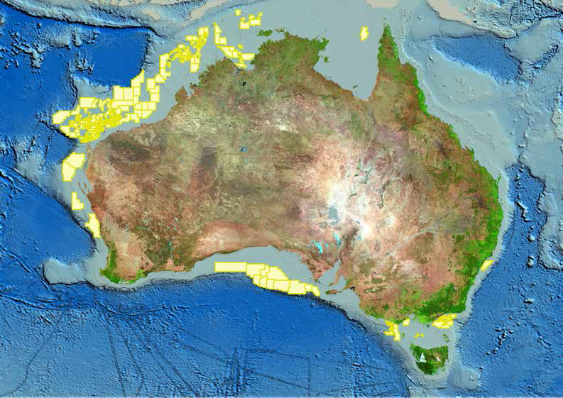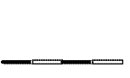

**Petroleum Well Activity (2012 to 30 June 2017)**

!( Appraisal/Exploration Wells

!( Development Wells

±

0 200 400

(! (! (!!(!(!(!((!(!(!

!(

!(

600 800

(!(!(!

Kilometres

(!((!(!(!(!(!(!(

(!

!(!(!(!(!!(!(!(!(!(!(!(!(!((!(!(!(!(!!((!!(!(!(!!(!(!(!((!!((!((!(!((!!!

!

( !(

!(

!( !(!(

!(

(! (!(! !(!(!(!(!(!(

!(!(!!(!(!(!(!(((!(!(!(!(!(!(!(!(!!(!(!(!(!((!(!(!(!(!!!((!((!(!!(!(!(!(!(!(!(!(!(!(!(!(!(!(!(!(!(!(!(!(!(!(!(!(!(!(!(!(!(!!(!!(!((!(!(!(!(!(!((!(!(!(!!((!(!!((!!(!((!(!!(!(!(!(!(!(!((!(!(!(!(!(!!(!(!(!(

!(!(!(!(!(!(!(

!(!(

((!(!(!

!( (!!(!!((!(!(!!(!(!(!(!(!(!(!((!(! (!(!(!(!(!(!(!((!(!(!(!(!(

!(!( !(!( !(!(!(

(!(!((!(!

!

(!(!(!!((!((!!(!(!(!(!(!(!((!(!(!(!(!(!(!(!(!(!(!(!(!(!(!(!(!(!((!!!(!(!(!(!(!(!(!(!(!(!(!(!(!((!(!(!(!(!(!((!(!!(!(!!(!(!

(

!(!(

!(

!(!(

!( !(!(!(!(!(!(

!(!(!(!(!(!(

!(!(

## Australian Offshore Petroleum Well Activity: 2012 to 30 June 2017

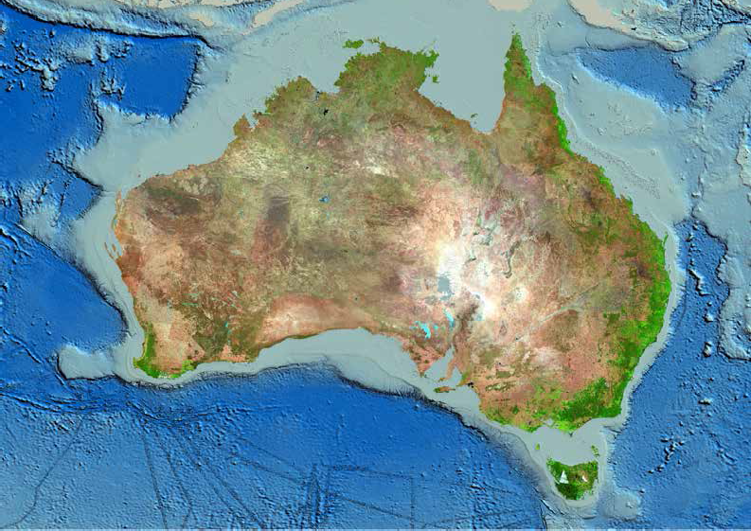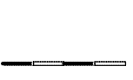

**Petroleum Survey Activity (2012 to 30 June 2017)**

2D Seismic Survey Lines

3D Seismic Survey Boundaries

±

0 200 400 600 800

Kilometres

Australian Offshore Petroleum Survey Activity: 2012 to 30 June 2017

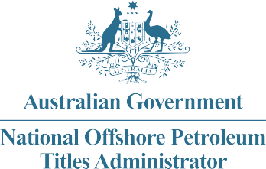

**NOPTA Corporate Plan**

2017– 2020

### Our Vision Contributing to national prosperity through administering a thriving offshore oil and gas industry.

Our Purpose To advise on and administer the Offshore Petroleum and Greenhouse Gas Storage Act 2006 for Australia’s offshore petroleum titles regime to support the effective regulation of our offshore oil and gas resources consistent with good oil field practice and optimum recovery.

Our Culture We value mutual respect, openness and inclusiveness. We are responsive, consultative, accountable and transparent.

Key Performance Indicators

*(Regulator Performance Framework)*

#### **KPI 1** NOPTA does not unnecessarily impede the efficient operation of Titleholders.

**KPI 2** Communication with Titleholders is clear, targeted and effective.

**KPI 3** Actions undertaken by NOPTA are proportionate to the regulatory risk being managed.

**KPI 4** Compliance and monitoring approaches are streamlined and coordinated.

**KPI 5** NOPTA is open and transparent in its dealings with Titleholders.

**KPI 6** NOPTA actively contributes to the continuous improvement of regulatory frameworks.

|  |  |  |  |
| --- | --- | --- | --- |
| **Our functions** | **Our objectives** | **How we will deliver** | **Our indicators of success** |
| Assist and advise the Joint Authority and the responsible Commonwealth Minister | » Contribute to the efficient decision making of the Joint Authority (JA) and responsible Commonwealth Minister.  » Maintain and promote open and transparent stakeholder engagement. | » Provide sound advice and recommendations to the JA and responsible Commonwealth Minister, as set out in the JA protocol.  » Identify and provide options to streamline and reduce regulatory burden, where appropriate.  » Take a risk based approach to engagement, compliance and enforcement, allowing for proportionate responses.  » Ensure guidelines and factsheets are up to date and relevant through timely and effective review and consultation.  » Risk-based compliance and enforcement policy is regularly reviewed.  » Contribute effectively to resource management initiatives.  » Field performance monitoring strategies to secure optimum recovery.  » Clear, targeted and effective stakeholder engagement. | » Effective management of offshore oil and gas resources in Australia.  » Advice to the JA and the responsible Commonwealth Minister is timely, accurate and consistent.  » Assessment timeframes set by the JA protocol are met.  » Positive feedback from the JA, industry and other stakeholders as measured through stakeholder surveys and other feedback mechanisms.  » Guidance information provided to industry is accurate, complete and readily accessible on the NOPTA website, incorporating stakeholder feedback.  » Reduction in stakeholder enquiries and non-compliance. |
| Manage and complete Titles Administrator statutory decisions and authorisations | » Deliver efficient and consistent Titles Administrator decisions and authorisations.  » Maintain and promote open and transparent stakeholder engagement. | » Clear, targeted and effective stakeholder engagement.  » Ensure timely decisions and authorisations. | » Decisions and authorisations are timely, consistent, defensible and readily accessible.  » Positive feedback from industry and other stakeholders as measured through stakeholder surveys and other feedback mechanisms. |
| Keep a register of titles | » Maintain a publicly available titles register and approvals tracking system for applications. | » Maintain and improve the National Electronic Approvals Tracking System (NEATS).  » Upload historical title registers in NEATS for all active titles.  » Enhance the tracking process and system for applications and key regulatory submissions. | » The titles register is publicly available, and up to date.  » Tracking system for regulatory submissions implemented. |
| Manage data and reporting submissions | » Streamline data and reporting submissions.  » Improve data quality and data integration.  » Complete consolidation of offshore data collection.  » Facilitate ease of access to open file data. | » Manage the National Offshore Petroleum Data and Core Repository.  » Coordinate with Geoscience Australia and States and Territory representatives to finalise data integration and quality control processes.  » Maintain timely authorisations to release well, survey and petroleum mining sample data.  » Implement systems for enhanced delivery of data, including further enhancements to the National Offshore Petroleum Information Management System (NOPIMS). | » Submission non-compliance is minimised.  » Data consolidation and integration program implemented.  » NOPIMS is implemented. |
| Engage, consult and cooperate with stakeholders | » Continue to strengthen our relationships with key stakeholders including  NOPSEMA, the department’s Offshore Resources Branch, delegates of the JA, Geoscience Australia and industry.  » Maintain and promote open and transparent stakeholder engagement. | » Work with NOPSEMA and the Offshore Resources Branch to identify options to simplify and streamline legislation, guidelines and processes for industry.  » Contribute to applicable national and international fora.  » Contribute advice and technical expertise to intra and interdepartmental meetings and taskforces.  » Engage with APPEA and other industry groups.  » Communication is clear, targeted and effective. | » Positive feedback from agencies, industry and other stakeholders as measured through stakeholder surveys and other feedback mechanisms.  » Timely and responsive delivery of ongoing Geographic Information System services to NOPSEMA.  » Developing and maintaining networks through attending national and international fora.  » Active participation in policy and legislative discussions.  » A monthly dashboard is published providing application and data statistics. |
| Provide corporate support to facilitate delivery of legislated functions | » Maintain a competent capacity.  » Maintain strong financial management and risk management systems, processes and culture.  » Ensure all NOPTA staff are appropriately trained in corporate systems, processes and *Public Governance Accountability Act 2013* (the PGPA) requirements relative to their role.  » Maintain secure, reliable and responsive information technology systems. | » Recruit and retain skilled professionals.  » Encourage individuals’ professional learning and development.  » Facilitate an annual NOPTA planning and training workshop.  » Maintain and improve staff work-life balance.  » Provide a safe and supportive workplace with flexible work options.  » Provide a reliable and stable ICT service to support NOPTA functions. | » NOPTA is fully cost recovered and maintains its Cost Recovery Impact Statement in line with the Australian Government Charging Framework.  » Manage NOPTA’s Special Account in accordance with the PGPA and Commonwealth Procurement Rules.  » Risk management integrated into financial and corporate decision making processes.  » Flexible working arrangements implemented.  » Increased efficiency and effectiveness through the use of collaborative work platforms.  » ICT systems and services are robust, flexible, solutions oriented and relevant to business requirements. |

