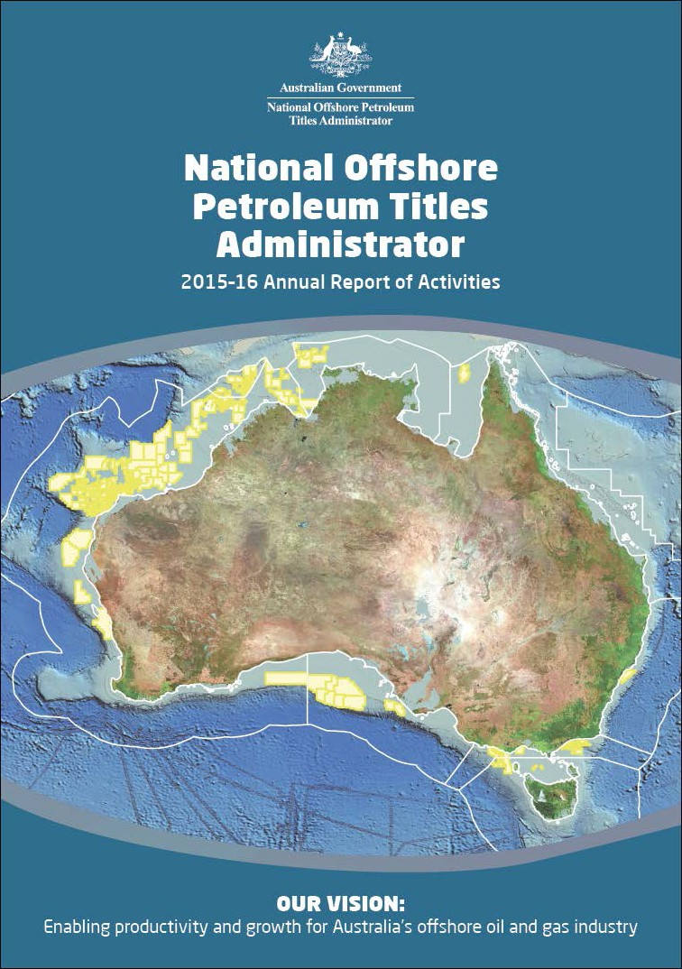

**National Offshore Petroleum Titles Administrator**

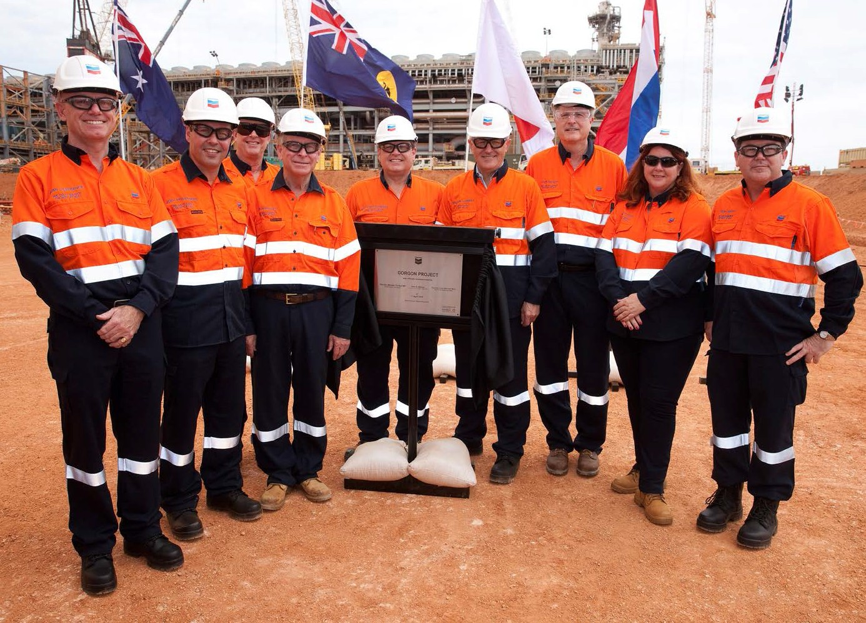

2015–16 Annual Report of Activities

© Commonwealth of Australia 2016

This work is copyright. Apart from any use as permitted under the Copyright Act 1968, no part may be reproduced by any process without prior written permission from the Commonwealth. Requests and inquiries concerning reproduction and rights should be addressed to the Department of Industry, Innovation and Science, GPO Box 9839, Canberra ACT 2601.

ISSN: 2205-8230 (print version) ISSN: 2205-8249 (online)

For more information about this report please contact:

Business Manager

National Offshore Petroleum Titles Administrator Department of Industry, Innovation and Science

GPO Box 7871

Perth WA 6850

Phone: (08) 6424 5300

Email: corporate @nopta.gov.au Web: [www.nopta.gov.au](http://www.nopta.gov.au/)

*Cover image: Map produced by NOPTA showing Australian offshore titles in force at 30 June 2016*

# Contents

Titles Administrator’s Review 2 Overview 3

Key Achievements 2015–16 4 Cost Effectiveness 5 Key Outputs 6 *Figure 1: 2015–16 Submitted applications* 7 Decisions of the Joint Authority and the Titles Administrator 8 *Figure 2: 2015–16 Decisions of the Joint Authority and the Titles Administrator* 8 Data submission and release 8 *Figure 3: Submission items received July 2015 to June 2016* 9

*Figure 4: Outstanding submission items July 2015 to June 2016* 9 National Offshore Petroleum Data and Core Repository (NOPDCR) 10 Cost recovery 12 *Table 1: Annual Titles Administration Levy 2015 –16* 12

*Table 2: Application Fees 2014–15* 13 NOPTA’s Financial Result 14 *Figure 5: NOPTA Finances $M* 14 *Table 3: Summary of financial performance and estimates* 15 *Table 4: NOPTA’s 2015-16 financial result compared to 2014-15* 15 Corporate Plan 16 Organisational Structure 18 *Figure 6: NOPTA’s organisational structure at 30 June 2016* 18 Key Work Areas 19 Outlook for 2016–17 22

*Photo (left): Official commemoration of the Gorgon Project attended (from left to right) by Sean L’Estrange MLA, Minister for Mines & Petroleum and Small Business, The Hon Josh Frydenburg MP, former Minister for Energy, Resources & Northern Territory, Ambassador John Berry, US Ambassador to Australia, The Hon Colin Barnett MLA, Premier of Western Australia, Roy Krzywosinski, Chevron Australia Managing Director, The Hon Malcolm Turnbull MP, Prime Minister, John S Watson, Chevron CEO and Chairman, Melissa Price MP, Member for Durack and Senator Dean Smith, Patron Senator for Durack.*

# Titles Administrator’s Review



It is my great pleasure to present NOPTA’s annual report of activities for the 2015-16 financial year. This is our second report and builds on last year’s inaugural.

January 2016 marked the fourth anniversary of NOPTA’s establishment and the implementation of the regulatory reforms recommended by the Productivity Commission.

This financial year also marked the introduction of reporting for the Government’s Regulatory Performance Framework (RPF) as part of ‘cutting the red tape’ policy for Commonwealth regulatory bodies.

NOPTA has committed to integrating the RPF into its planning, operations and reporting and adopted the Key Performance Indicators in our Corporate Plan. Similarly, NOPTA has steadfastly maintained its commitment to relieving regulatory burden.

We recently concluded our second stakeholder feedback survey and appreciate that even in a difficult operating environment for many companies, NOPTA continues to enjoy the overwhelming support of industry. It is important that companies provide feedback on NOPTA’s performance so that NOPTA can effectively deliver high quality regulatory outcomes.

NOPTA maintains its commitment to continuous improvement, with a culture that embraces innovation, efficiency and stakeholder engagement.

Last year I reported our plans to expand the functionality of the NEATS portal, implement a broader range of web-based services and enhance our competent capacity in reservoir engineering, geophysics and field performance monitoring. I am pleased to now report that we have made significant progress in all of these endeavors and will continue to engage with our stakeholders on development plans.

We have also commenced implementation of the recommendations arising from the Operational Review of NOPTA and I am pleased to report that all have been progressed and some completed, including publishing of the Joint Authority protocol. The majority of recommendations will be implemented by the end of 2016.

We received positive feedback and encouragement from our first activities report and trust that you find this sequel to be a good read too.

Yours sincerely,

Graeme A Waters

National Offshore Petroleum Titles Administrator

# Overview

The purpose of this report is to provide key stakeholders with information specific to the activities of the National Offshore Petroleum Titles Administrator (NOPTA), headed by a statutory position of Titles Administrator.

NOPTA was established as a branch of Resources Division of the Department of Industry, Innovation and Science (the Department) on 1 January 2012, to be the national offshore petroleum regulator responsible for providing advice and information to the responsible Commonwealth Minister and the relevant State and Northern Territory Ministers, collectively named the Joint Authority (JA). NOPTA’s advice is independent to the decisions of the JA.

The Titles Administrator is also separately responsible for making some decisions relating to offshore petroleum titles, and administering titles and related well and survey digital reports and data.

NOPTA’s vision is to enable productivity and growth for Australia’s offshore oil and gas industry. It undertakes a range of regulatory functions with a focus on timeliness, accuracy, transparency and consistency. NOPTA’s Corporate Plan 2015–2017 provides information on how NOPTA delivers its objectives and its indicators of success. The Corporate Plan is available on NOPTA’s website at [www.nopta.gov.au](http://www.nopta.gov.au/) and is included in this report.

An important aspect of NOPTA’s operation is to consult stakeholders to continue to simplify and streamline processes for industry. As part of its obligations under the Australian Government’s Regulator Performance Framework1, NOPTA again engaged KPMG to undertake a survey of

key stakeholders during 2015–16, to provide an assessment of NOPTA’s performance, level of stakeholder satisfaction and identify areas for improvement.

The key findings of the survey as reported by KPMG were as follows:

*“Overall in 2016 respondents indicated a very high level of satisfaction with NOPTA’s staff, particularly their technical competence, approachability, responsiveness and professionalism, which were similar to the levels of satisfaction recorded in 2015. NOPTA as an organisation was favourably viewed on the characteristics measured, particularly*

*in terms of collaboration and consultation in its approach and its public accountability. It also rated well on its responsiveness to business needs and commitment to continuous improvement. Most respondents also considered NOPTA to be open and transparent in dealings, and that it engaged stakeholders to streamline, clarify or improve reporting requirements.”*

The *KPMG Stakeholder Survey Report*2 is available on NOPTA’s website.

1. https:/[/www.cuttingredtape.go](http://www.cuttingredtape.gov.au/resources/rpf)v[.au/resources/rpf](http://www.cuttingredtape.gov.au/resources/rpf)
2. KPMG Stakeholder Survey Report 27 May 2016; <http://www.nopta.gov.au/media/stakeholder-survey/index.html>

# Key Achievements 2015–16



*First shipment of LNG from the*

*Gorgon Project departing Barrow Island. Image courtesy of Chevron Australia Pty Ltd*

In 2015–16, NOPTA:

* + hosted International Upstream Forum 7 in Melbourne, which was attended by delegates representing 11 countries; the event was highly successful in forging strong links with overseas jurisdictions
  + completed its annual stakeholder survey in May 2016, which indicated a very high level of satisfaction with NOPTA’s staff, particularly their technical competence, approachability, responsiveness and professionalism
  + completed a comprehensive review of its cost recovery arrangements in consultation with titleholders and stakeholders; the updated Cost Recovery Implementation Statement came into force from 1 July 2016
  + published its inaugural annual report of activities for 2014–15
  + established the National Offshore Petroleum Data Integration Project (the NOPDIP Project) with Geoscience Australia to replace state-based manual systems with a comprehensive digitised holding of offshore petroleum data
  + continued to build competent capacity in resource management
  + continued to enhance its relationship with the National Offshore Petroleum Safety and Environment Management Authority (NOPSEMA) to simplify and streamline processes for industry, including providing web-based services to NOPSEMA
  + published the operating protocols for offshore petroleum Joint Authorities and supporting institutions on the NOPTA website to enhance the level of transparency for industry and stakeholders in relation to application processing and decision-making time frames, and continued to publish monthly reports of performance statistics.

Teams within NOPTA have also worked together to improve the level of guidance for industry on matters pertaining to compliance with the offshore petroleum and greenhouse gas storage regulatory framework. This has taken the form of factsheets, guidelines, information on website pages and internal guidance notes. In particular NOPTA dedicated time to establish a set of guidance presentations on the legislative framework; and in partnership with the Offshore Resources Branch assisted with the proposed re-write of the Declaration of a Location Guideline; reviewed the Special Prospecting Authority Guideline; established the Greenhouse Gas Declaration of a Formation Guideline; and developed a Greenhouse Gas Search Authority, Special Authority and Research Consent factsheet.

During 2015-16, NOPTA also completed a review and update of NOPTA’s application forms. The review was aimed at simplifying the forms, making them more user friendly and provided more guidance to applicants. The review also considered feedback provided by indus[try in the NOPTA](http://www.nopta.gov.au/media/stakeholder-survey/index.html) [Annual Stakeholder Surve](http://www.nopta.gov.au/media/stakeholder-survey/index.html)y.

In collaboration with Geoscience Australia (GA), NOPTA continued the development of the National Offshore Petroleum Information Management System (the NOPIMS) during the year to improve data availability. The Commonwealth also contributed $1.2 million to the improvement of facilities at the WA Department of Mines and Petroleum (WADMP) Core Store in Carlisle, Western Australia. Due to expanded compliance activities, NOPTA has also seen the level of outstanding data submissions from offshore titleholders reduce to negligible levels.

As part of the implementation of the RPF NOPTA has prepared its inaugural self-assessment, which will be published later in 2016. The self-assessment will provide further detail of NOPTA’s performance, and future improvement against the six key performance indicators. NOPTA has rated well against all areas.

# Cost Effectiveness

NOPTA is committed to maintaining low cost delivery through continuous process and systems improvement in consultation with industry.

NOPTA’s cost recovery structure has been designed to reduce unnecessary administrative burden. From 1 July 2016 the annual administration levy has been aligned to reflect the level of effort required to regulate and administer the different types of titles. A standard fee of $7,500 now applies to applications submitted to NOPTA and assists in relieving regulatory burden through a clear and more simplified fee structure.

During 2015-2016 industry stakeholders were consulted on the proposed changes to NOPTA’s cost recovery arrangements. Consultation with affected stakeholders included feedback that NOPTA has improved efficiency, provides timely and considered information and that the proposed cost increase was not significant, indicating NOPTA has reduced administrative and regulatory burden on titleholders, which is another indicator of cost effectiveness.

Since its establishment NOPTA has maintained a low cost delivery of its legislated functions to the industry. An assessment of NOPTA’s structure, resources and skills found that NOPTA’s

staffing level was significantly below that of previous arrangements by 44 per cent. In addition, benchmarking between NOPTA and similar overseas bodies also found that NOPTA is the smallest in terms of establishment size.

It should be noted that NOPTA is structurally a branch within the Resources Division of the Department of Industry, Innovation and Science, however, it does not undertake activities other than the functions legislated under the *Offshore Petroleum and Greenhouse Gas Storage*

*Act 2006* (Cth) (OPGGSA), which allows for easy identification of the costs attributable to cost recovered activities. The Department provides the governance structure under the *Public Governance, Performance and Accountability Act 2013* (Cth), access to corporate support and systems, and pays for NOPTA related workers compensation and other insurances as well as charges associated with software, licences and devices, and office fit outs used by NOPTA staff. In 2015-16 the Department recouped $558,474 for these operational costs, or approximately 3.8 per cent of NOPTA’s total expenditure.

Some of the cost saving measures undertaken by NOPTA include:

* + Relinquishment of office space in Perth at a saving of $600,000.
  + Use of fixed term contracts as opposed to full time staff employment where appropriate to cater for fluctuations in industry activity (2015-16: 8 contractors).
  + Use of part-time working arrangements.
  + Use of non-ongoing employees before determining that a role will continue as ongoing.
  + Use of fixed term secondments within Government (2015-16: 1 to NOPTA and 2 from NOPTA).
  + Competitive tenders, including the establishment of a deed of standing offer for technical advice.
  + Maintaining salary at acceptable levels and within Department of Finance guidelines, in comparison to other regulators’ rates that are significantly higher (up to 50 per cent) for positions at similar levels.
  + Identifying opportunities to streamline and share services to reduce costs, including the provision of geographic information systems to NOPSEMA at no additional cost to industry and no cost is recovered from NOPSEMA (estimated annual cost of $30,000 to 40,000 and initial set up cost of $50,000).

# Key Outputs

NOPTA undertakes various assessments and compliance activities relating to the following key outputs:

* + Acreage Release (Petroleum Exploration Permit): Annual release (three rounds per release) of petroleum exploration acreage through a competitive bidding/tender process.
  + Petroleum Exploration Permit: Applications for grant, renewal, credits, surrenders, expiries and cancellations.
  + Suspension and Extension; Variation; Exemption: Applications for suspension, suspension and extension, variation, and exemption relating to conditions of a permit, lease or licence (including work program conditions).
  + Declaration of a Location: Applications to declare a location following the discovery of petroleum and nominate a block or blocks as a location.
  + Retention Lease: Applications for grant or renewal.
  + Production Licence: Applications for grant and renewal.
  + Field Development Plan: Application for acceptance of the Field Development Plan.
  + Infrastructure Licence: Applications for grant, including proposed location of infrastructure.
  + Pipeline Licence: Applications for grant and variation, including proposed location of the pipeline.
  + Special Prospecting Authority and Access Authority: Applications for grant and variation. Applications for scientific investigation consents.
  + Transfers and Dealings: Applications for the registration of transfers of, and dealings in, petroleum titles.
  + Greenhouse Gas Storage Applications: Applications for assessment permits; variation, suspension, extension and surrender of assessment permits; renewal of assessment permits; declaration of a formation; holding leases; injection licences; search authorities; special authorities; and research consents.

NOPTA received 451 applications and processed 3 cancellations in 2015–16 (2014–15 total: 625), as outlined in figure 1 below.

Figure 1: 2015–16 Submitted applications

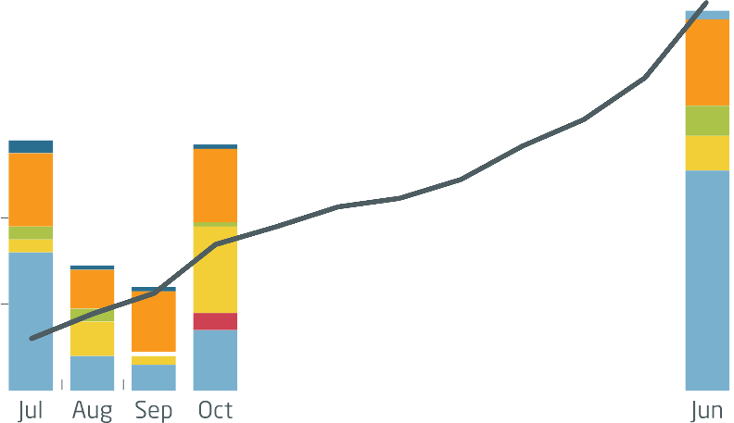

   



|  |  |  |  |  |  |  |  |  |  |  |  |  |
| --- | --- | --- | --- | --- | --- | --- | --- | --- | --- | --- | --- | --- |
| **Application Type** | **Jul** | **Aug** | **Sep** | **Oct** | **Nov** | **Dec** | **Jan** | **Feb** | **Mar** | **Apr** | **May** | **Jun** |
| Dealing/Transfer | 32 | 8 | 6 | 14 | 9 | 1 |  | 7 | 13 | 6 | 35 | 51 |
| Field Development | 4 | | | |  | 1 |  |  | 6 |  | 1 | |
| Grants/Renewals/Locations | 3 | 8 | 2 | 20 | 2 | 4 | 4 | 1 | 9 | 15 | 6 | 8 |
| Other | 3 | 3 | 1 | 1 | 1 | 1 | 3 |  | 1 | 2 | 2 | 7 |
| S/S&E/Variation | 17 | 9 | 14 | 17 | 9 | 14 | 3 | 12 | 9 | 7 | 2 | 20 |
| Surrender | 3 | 1 | 1 | 1 |  | 2 |  | 2 | 1 | 1 | 3 | 2 |
| Monthly Total | 58 | 29 | 24 | 57 | 21 | 23 | 10 | 22 | 39 | 31 | 49 | 88 |
| **Cumulative** | **58** | **87** | **111** | **168** | **189** | **212** | **222** | **244** | **283** | **314** | **363** | **451** |

# Decisions of the Joint Authority and the Titles Administrator

In 2015–16 there were 478 decisions (2014–15: 573) made with regard to applications for offshore petroleum titles. NOPTA provided advice to the Joint Authority for decisions on 254 applications and the Titles Administrator made 224 decisions. The following illustrates the decisions made by the responsible authority and by jurisdiction.

Figure 2: 2015–16 Decisions of the Joint Authority and the Titles Administrator

|  |  |  |  |  |  |  |  |  |  |  |  |  |
| --- | --- | --- | --- | --- | --- | --- | --- | --- | --- | --- | --- | --- |
| **Jurisdiction** | | | | | | | | | | | | |
| Decision Maker | WA | SA |  | NT |  | Vic | AC* | NSW |  | QLD |  | Tas* |
| Joint Authority  Titles Administrator | 192 |  | 7 |  | 9 | 11 | 22 |  | 2 |  | 1 | 10 |
| 158 | 0 | | 7 | | 32 | 23 | 0 | | 0 | | 4 |
| Totals | 350 | 7 | | 16 | | 43 | 45 | 2 | | 1 | | 14 |

*\*AC = Ashmore Cartier. JA comprises only the Commonwealth Minister, Tasmania has opted out of JA arrangements and the Commonwealth Minister is the decision maker*

# Data submission and release



NOPTA actively engages with stakeholders to define submission expectations and more efficiently manage the receipt of regulated data items. During 2015-16 NOPTA continued to meet with titleholders, contractors and service providers on data management related issues; provided regular updates of expected and outstanding submissions to titleholders; and worked closely with partners on data completeness and quality initiatives.

NOPTA continues to consult with stakeholders on potential improvements to the data submission guidelines. This ongoing consultation seeks to ensure the information is up to date, is responsive to technological developments, removes inconsistencies and enables flexibility in meeting the requirements. A revised set of submission guidelines is expected to be finalised during 2016-17.

On an international level NOPTA is an active contributor to Professional Petroleum Data Management Association (PPDM) initiatives through membership of the Regulatory Standards Committee; and engages with Energistics (an international energy standards development organization) on a range of data transfer and streamlining initiatives.

Despite a recorded downturn in drilling and surveying activity, the level of reports received remained steady, in major part due to enhanced data compliance activity and time lags between activity completion and the due dates for regulatory submission.

Figure 3: Submission items received July 2015 to June 2016

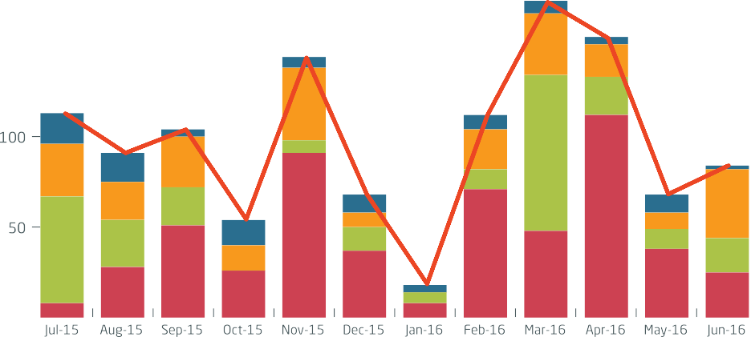

NOPTA processed data from 129 well activities and 146 survey activities during 2015-16. Of these 73 per cent were received on time. As a result, the level of outstanding submissions and the time these were outstanding was kept to a very low level.

Figure 4: Outstanding submission items July 2015 to June 2016

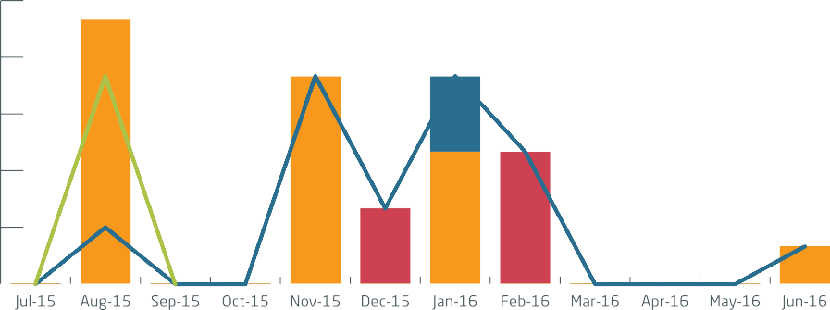

  

One of NOPTA’s other key functions is the quality control and release of data for public consumption. During the same period, NOPTA released data from 238 well and survey activities (noting that each activity has a requirement for multiple submissions).

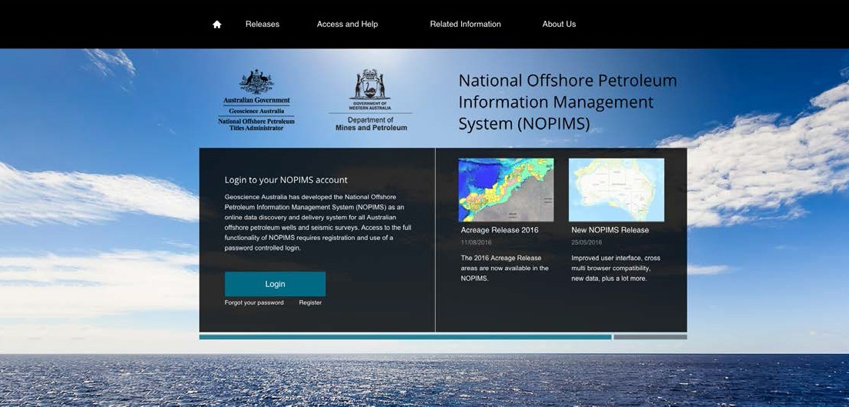

# National Offshore Petroleum Data and Core Repository (NOPDCR)

As reported last year, NOPTA has established the NOPDCR in conjunction with GA and the Geological Survey of Western Australia, a branch of WADMP.

One of the significant improvements delivered by the NOPDCR is in the enhanced handling and storage of petroleum mining samples. In further support of this deliverable, the Commonwealth has contributed $1.2 million to the expansion and refurbishment of the WADMP Core Store in Carlisle, Western Australia. A feature of this redevelopment is the roofing of an outdoor area, which now provides greatly enhanced viewing, sampling and analytical facilities at these premises. Redevelopment of the Carlisle facility is expected to be completed by the end of the 2016 calendar year.

The NOPDCR arrangement has also allowed a more streamlined approach to data compliance and quality control. Processes now ensure that new data is submitted on time, complete and undergoes appropriate quality checks prior to release. Initiatives are also in place to ensure that legacy data (submitted prior to NOPTA’s establishment in 2012) is improved; and that gaps in the Commonwealth data collection are addressed wherever possible.

Following the establishment of the new system in 2014-15, work has continued on the development of the NOPIMS. The NOPIMS initiative was further promoted and populated during 2015-16 and now includes an enhanced range of publically available wells and survey related reports and data. Integration of the digital data collection into NOPIMS continues and is now approximately 95 per cent complete.

A project to integrate remaining hard copy holdings into the NOPIMS was also commenced in 2015-16 under joint NOPTA and GA management (the NOPDIP Project). Its aim is to ensure the remaining hard copy legacy data collections of the former State and Territory Authorities are quality checked, digitised and made available. Given the volume of materials involved, this activity is projected to continue until 2019.



*Goodwyn A Platform, North West Shelf Project.*

*Image courtesy of Woodside Energy Ltd*

NOPTA is also assessing the feasibility of delivering updates to wells and survey metadata through web services. This initiative seeks to ensure a ‘single source of truth’ for stakeholders and will streamline population of external databases, including NOPIMS and state-based data discovery and delivery systems.

In addition, NOPTA, GA and WADMP are each independently engaging with the Commonwealth Government Resources Data Initiative (RDI)3 with the aim of improving the discoverability and availability of environmental, water, mining and oil and gas data.

1. The RDI includes industry and government stakeholders such as the States and Territories, the Offshore Resources Branch and other Commonwealth departments (including the Department of the Prime Minister and Cabinet and the Department of Environment)

# Cost recovery

NOPTA’s cost recovery charges include an annual levy imposed on different types of titles (permits, leases and licences) and fees charged on applications made to the Titles Administrator relating to offshore petroleum titles. After stakeholder consultation and a robust review process by the Department of Finance NOPTA’s charges were changed through legislative amendment on 1 July 20164.

### Cost recovery levy

An Annual Titles Administration Levy is imposed on holders of titles (permits, leases and licences). The levy is payable in accordance with the *Offshore Petroleum and Greenhouse Gas Storage (Regulatory Fees) Regulations 2004 (Cth)* upon the grant of a title and annually

thereafter within 30 days of the anniversary of the title. Where a title is in force for less than twelve months, the levy is calculated for the remaining period of the title.

The levy makes up the majority of NOPTA’s revenue, approximately 85 per cent in 2015–16, providing a stable revenue stream that is dependent upon the current number and type of titles in force. It is used to fund activities where it is not possible or practical to attribute their costs to a specific entity (e.g. industry wide monitoring, data management, compliance and enforcement). This means there is a degree of cross-subsidy between Titleholders, however this is minimal. The recalibration of the levy structure in consultation with industry in July 2016 and the introduction of new application fees has further reduced the degree of cross-subsidy.

The focus of NOPTA’s activities in relation to titles is assessing the technical and financial ability of applicants to carry out title related activities. Technical assessments of field development plans are more closely aligned to the number of blocks, whereas for pipeline licences, the complexity of assessments varies depending on the length of the pipeline and the number of titles that the pipeline crosses.

There were 421 titles in force during 2015–16 that attracted the annual levy of $9.14 million, as shown in the table below.

Table 1: Annual Titles Administration Levy 2015 –16

|  |  |  |  |  |  |
| --- | --- | --- | --- | --- | --- |
| **Title type** | **No. of Titles** | **No. of blocks** | **Length Km** | **Levy Rate** | **Levy Amount** |
| Exploration Permit | 171 | NA | NA | $9,781/title | $1,672,551 |
| Infrastructure Licence | 3 | NA | NA | $22,500/title | $67,500 |
| Pipeline Licence | 72 | NA | 3,977 | $52/km | $206,804 |
| Production Licence | 94 | 309 | NA | $15,500/block | $4,789,500 |
| Retention Lease | 81 | 310 | NA | $7,755/block | $2,404,050 |
| Annual Levy | 421 |  |  |  | $9,140,405 |

1. Cost Recovery Implementation Statement, Offshore Petroleum and Greenhouse Gas Storage Titles Administration, 2016-17

### Cost recovery fees

Application fees are payable in accordance with the *Offshore Petroleum and Greenhouse Gas Storage (Resource Management and Administration) Regulations 2011 (Cth)* at the time that an application is submitted for approval to enable Titleholders to undertake certain regulated activities. Revenue from fees fluctuates from year to year as they are dependent on the timing, type and number of applications lodged by Titleholders.

NOPTA received 451 applications in 2015-16, of which 354 attracted a statutory fee and generated revenue of $1.65 million, or approximately 15 per cent of NOPTA’s total income, as shown in the table below.

Table 2: Application Fees 2014–15

|  |  |  |  |
| --- | --- | --- | --- |
| **Application type** | **No. of Applications** | **Fee** | **Fee Amount** |
| Work-bid petroleum exploration permit  Renewal of petroleum exploration permit | 15 | $8,183 | $122,745 |
| 7 | $2,090 | $14,630 |
| Petroleum retention lease | 13 | $2,090 | $27,170 |
| Renewal of petroleum retention lease  Petroleum production licence | 8 | $2,090 | $16,720 |
| 1 | $2,090 | $2,090 |
| Cash-bid petroleum exploration permit | 4 | $2,090 | $8,360 |
| Pipeline Licence | 1 | $5,220 | $5,220 |
| Variation of pipeline licence | 1 | $1,050 | $1,050 |
| Petroleum special prospecting authority  Petroleum access authority | 9 | $5,580 | $50,220 |
| 9 | $5,580 | $50,220 |
| Suspension and extension; variation; exemption (per title) | 105 | $5,340 | $560,700 |
| Declaration of location  Transfer | 18 | $7,596 | $136,728 |
| 41 | $7,180 | $294,380 |
| Dealing | 122 | $2,950 | $359,900 |
| Application Fees | 354 |  | $1,650,133 |

Following a comprehensive review of activities and rates, a flat fee structure of $7,500 per application was established on 1 July 2016, due to the fact that similar effort was required to assess the different types of applications. This represents the average cost of assessing each application type submitted to NOPTA. There may be some variation within each fee item, however as the same, few numbers of Titleholders submit these applications, the outcome is the same for them, with lower regulatory burden through a single fee. In addition a number of new application fees were introduced in July 2016 to reduce the level of cross-subsidy with levies. Fees have been determined on the estimated cost, based on management estimates of the level of effort required. The fee rates were calculated by dividing the estimated cost to be recovered for each type of application, by the estimated number of applications. Applying a flat rate across all applications submitted to NOPTA provides a transparent, simple and consistent approach for all Titleholders.

# NOPTA’s Financial Result

NOPTA had an operational cash balance of $1.57 million available at 30 June 2016, representing 10.7 per cent of the 2016-17 expenditure budget of $14.619 million as published in the CRIS5. NOPTA aims to retain a cash reserve of 10 per cent of its annual budget as a financially responsible measure. This will enable NOPTA to continue to meet its ongoing monthly expenses, asset replacements and potential unplanned expenditure.

NOPTA currently has an accumulated deficit of $4.025 million over total operating expenditure of $49.1 million, this includes $3.45 million in amortisation and depreciation costs. A new CRIS was implemented on 1 July 2016 which will reduce this deficit over the next four years, see Table 3.

Figure 5 illustrates NOPTA’s financial performance since its establishment.

Figure 5: NOPTA Finances $M



 

1. Cost Recovery Implementation Statement, Offshore Petroleum and Greenhouse Gas Storage Titles Administration, 2016-17

Table 3: Summary of financial performance and estimates

|  |  |  |  |  |  |  |  |  |  |
| --- | --- | --- | --- | --- | --- | --- | --- | --- | --- |
|  | **2011-12**  **Actual**  **$000** | **2012-13**  **Actual**  **$000** | **2013-14**  **Actual**  **$000** | **2014-15**  **Actual**  **$000** | **2015-16**  **Actual**  **$000** | **2016-17**  **Estimate**  **$000** | **2017-18**  **Estimate**  **$000** | **2018-19**  **Estimate**  **$000** | **2019-20**  **Estimate**  **$000** |
| Expenses | 4,046 | 8,003 | 10,067 | 12,405 | 14,591 | 14,619 | 15,000 | 15,300 | 15,300 |
| Revenue | 2,848 | 9,737 | 11,438 | 10,377 | 10,687 | 16,080 | 16,080 | 16,080 | 16,080 |
| Balance | -1,198 | 1,734 | 1,371 | -2,028 | -3,904 | 1,461 | 1,080 | 780 | 780 |
| Cumulative Balance | -1,198 | 536 | 1,907 | -121 | -4,025 | -2,564 | -1,484 | -704 | 76 |

Table 4: NOPTA’s 2015-16 financial result compared to 2014-15

|  |  |  |
| --- | --- | --- |
| **INCOME STATEMENT6 2015-16**  **$’000** | | **2014-15**  **$’000** |
| Revenue – Cost Recovery | | |
| Levies | 9,140 | 8,541 |
| Application Fees | 1,650 | 1,759 |
| Other7 | (102) | 76 |
| Total Revenue | 10,689 | 10,377 |
| Expenses | | |
| Employee Benefits | 6,369 | 4,906 |
| Suppliers | 3,907 | 2,710 |
| NOPDCR | 1,969 | 1,792 |
| Systems including NEATS maintenance | 1,699 | 1,252 |
| Depreciation and amortisation | 647 | 1,745 |
| Total Expenses | 14,591 | 12,405 |
| Surplus / (deficit) | (3,902) | (2,027) |

There are a number of factors driving the increase in NOPTA’s expenses. These include increased specialist resources (staff and consultants) required for resource management and stewardship. Specialist resources are required to complete NOPTA’s establishment to the approved level. This also relates to the Government’s response to Recommendation 6 of NOPTA’s Ministerial Review8, that NOPTA enhances its capability and capacity to more effectively contribute to the management of Australia’s offshore resources.

In addition, NOPTA costs for workers compensation, property/public liability insurances, business software licences, office equipment, depreciation for fit-outs occupied by NOPTA and corporate support/governance, had not been previously recouped. This has now been rectified in 2015-16 with an estimated annual cost of $600,000. No retrospective adjustment was made to prior periods.

1. Excludes $1.2 million for expenditure related to implementation funding that is not cost recovered. Variances between Table 3 and Table 4 due to rounding
2. Late payment penalties and adjustments made to revenue received in previous financial years
3. 2015 Operational Review of the National Offshore Petroleum Titles Administrator, Report for the Minister for Industry and Science, September 2015

Corporate Plan 2015–2017

## Our Vision

Enabling productivity and growth for Australia’s offshore oil and gas industry.

## Our Purpose

The effective stewardship of Australia’s offshore oil and gas resources to ensure the optimum long-term recovery of hydrocarbons.

## Our Culture

In NOPTA, our commitment to each other is based on mutual respect, openness and inclusiveness. We invite participation.

We work together and lead with enthusiasm and purpose to make a difference.

Key Performance Indicators

*(Regulator Performance Framework)*

**KPI 1** NOPTA does not unnecessarily impede the efficient operation of titleholders.

**KPI 2** Communication with titleholders is clear, targeted and effective.

**KPI 3** Actions undertaken by NOPTA are proportionate to the regulatory risk being managed.

**KPI 4** Compliance and monitoring approaches are streamlined and coordinated.

**KPI 5** NOPTA is open and transparent in its dealings with titleholders.

**KPI 6** NOPTA actively contributes to the continuous improvement of regulatory frameworks.

##### 

**Our Key Achievements 2012-2014**

* Completed transition from former regulatory regimes.
* Established the National Offshore Petroleum Data and Core repository (NOPDCR).
* Developed the National Electronic Approvals Tracking System (NEATS).
* Achieved full cost recovery for the establishment of NOPTA, NOPDCR and NEATS.
* Implemented ICT network (NOPTANet).
* Developed fact sheets for titleholders.
* Developed electronic document and records management system.
* Established resource management project.
* Established new cost recovery arrangements.

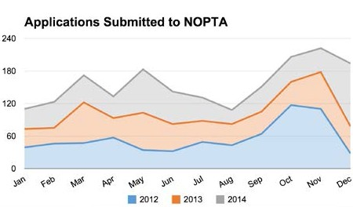

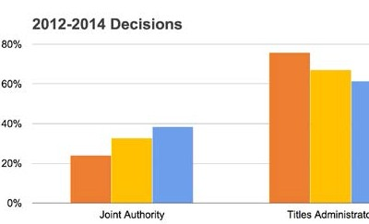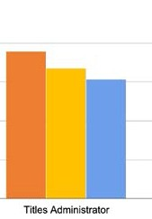

**Our Key Risks**

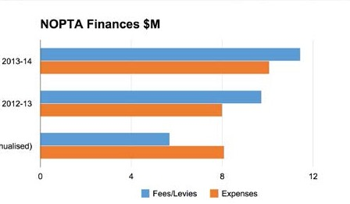

* Recruitment and retention of experienced professionals up to our approved staffing level, in a competitive environment.
* Maintaining financial capacity within NOPTA to effectively respond to changes in work priorities.
* Maintenance of adequate information management systems that support streamlined, efficient workflows.
* Maintaining high profile delivery of legislated functions to titleholders whilst operating within a large, multifaceted Department.

**Our Functions Our objectives How we will deliver Our indicators of success**

**Assist and Advise the Joint Authority and the Responsible** **Commonwealth Minister**

**Incorporating Titles Administrator’s Delegated and Statutory Decisions and Authorisations**

* Contribute to the efficient decision making of the Joint Authority (JA) and responsible Commonwealth Minister.
* Deliver efficient, consistent and timely Titles Administrator decisions.
* Promote stakeholder engagement.
* Reduce regulatory burden.
* Provide reliable advice and recommendations to the JA and responsible Commonwealth Minister.
* Conduct robust reviews and assessments including analysing development options, economic modelling and barriers to commercialisation.
* Maintain open and transparent relationship with titleholders.
* Maintain timely authorisations to release well, survey and petroleum mining sample data.
* Participate at national and international regulatory forums.
* Implement compliance program.
* Review guidelines and other public material (factsheets) through appropriate internal and external consultation.
* Improved management of hydrocarbon resources in offshore Australia.
* Advice to the JAs and the Responsible Commonwealth Minister is timely, accurate and consistent.
* Assessment timeframes set by the JA protocol are met.
* Decisions and authorisations are timely, consistent, defensible and readily accessible.
* Positive feedback from JAs, industry and other stakeholders (Annual NOPTA survey).
* Clear, targeted and effective stakeholder engagement.
* Enhanced recognition of NOPTA as an effective regulator.
* Risk-based compliance program documented.
* Reduction of overall non-compliance.
* Industry feedback is incorporated into guidance material.
* Guidance information provided to industry is accurate, complete and readily accessible including information on the NOPTA website.

**Keeping Register of Titles**

* Maintain a publicly available titles register and approvals tracking system for applications.
* Maintain and improve the National Electronic Approvals Tracking System (NEATS).
* Upload historical title registers in NEATS for all active titles.
* Establish a tracking process and system for key regulatory submissions.
* The titles register is publicly available, and up to date.
* Tracking system for regulatory submissions implemented.

**Data and Information Management**

* Improve data quality and data integration.
* Complete consolidation of offshore data collection.
* Implement resources and reserves reporting standards.
* Streamline data submissions and access processes.
* Facilitate ease of access to open file data.
* Manage the National Offshore Petroleum Data and Core repository (NOPDCR).
* Coordinate with Geoscience Australia and States and Territory representatives to finalise data integration and quality control processes.
* Develop reporting standards in consultation with stakeholders.
* Maintain central point for company contacts.
* Implement systems for enhanced delivery of data.
* Data consolidation and integration program implemented.
* Reporting standards for resources and reserves and other data submissions implemented and monitored.
* National Offshore Petroleum Information Management System (NOPIMS) implemented.

**Cooperate with NOPSEMA and other Agencies**

* Enhance relationship with NOSPEMA, other agencies and the Department’s Offshore Resources Branch.
* Streamline and reduce regulatory burden.
* Contribute to improvements in the timely exploitation of Australia’s offshore hydrocarbon resources.
* Work with NOPSEMA to simplify and streamline processes for industry.
* Provide input and technical support to various Departmental and interdepartmental committees/taskforces and related agencies.
* Provide input and technical support to the policy area of the Offshore Resources Branch.
* Participate in intra and interdepartmental forums and quarterly meetings with NOPSEMA and the Offshore Resources Branch.
* Provide high quality input for resource management projects.
* Undertake comprehensive assessments of the hydrocarbon resource systems (and attendant infrastructure).
* Geographic Information System (GIS) services delivered to NOPSEMA.
* Opportunities to streamline and share services and information with NOPSEMA identified and put into action.
* Co-operative approach to proposed legislative amendments.
* Positive feedback from agencies, industry and other stakeholders (Annual NOPTA survey).
* NOPTA advice on all aspects of hydrocarbon resources is accurate, timely and valued by stakeholders.

**Provide Corporate Support to Facilitate Delivery of Legislated Functions**



* Maintain a competent capacity.
* Maintain a strong financial management and risk management culture.
* Maintain secure, reliable and responsive information technology systems.
* Recruit and retain skilled professionals.
* Encourage individuals’ professional development.
* Facilitate annual NOPTA planning and training workshop.
* Maintain and improve staff work-life balance.
* Provide a safe and supportive workplace with flexible work options.
* Implement automated workflows, information management and integrated communications systems.
* Implement a quality management system.
* NOPTA is fully cost recovered.
* Staff performance rated as effective or above.
* Risk management integrated into financial and corporate decision making processes.
* Flexible working arrangements implemented.
* Unplanned leave events are reduced.
* Increased efficiency through the use of collaborative work platforms.

# Organisational Structure

Figure 6: NOPTA’s organisational structure at 30 June 2016

**Titles Administrator**

Graeme Waters

**Deputy General Manager**

**Melbourne Office Manager**

Terry McKinley

**Executive Assistant**

Paula Blair

**Principal Geoscientist**

Geoff O’Brien

**Business**

**Support Unit** Fiona Pekin, Manager

**Commercial**

**Titles Team**

Jo Bell, Manager

**& Operations**

**Support Team** Steven Taylor, Manager

**Legislative Geoscience**

**Data Management**

**Compliance Engineering Team**

Mark Ducksbury,

**Team** Rachel Fry, Jenny-Lee Maher, Manager

Manager (Actg) Manager

**HR &**

**Coordination Leader**

**Asst Manager,**

**Titles (4)**

**Commercial & Legal Compliance Technical Asst Manager (1)**

**Analytics (4) (4) Specialists (10)**

**Senior Finance**

**Coordinator**

**Senior Titles**

**Administration Officer (4)**

**Geospatial**

**Systems (2)**

**Data specialists**

**(4)**

**ICT, Database**

**Titles**

**& Records**

**Administration**

**Management &**

**Officer (1)**

**NEATS (4)**

NOPTA had a successful year in terms of staffing. In 2015-16 staff turn-over remained low and there was high staff engagement regarding Learning and Development with 100 per cent of staff participating in some form of ongoing learning activity.

During the year NOPTA increased its capacity particularly in the commercial and geoscientific areas after being successful in gaining approval to recruit and fill a number of vacancies. This included an increase in specialist resources required for improved resource management and stewardship, which relates to recommendations resulting from NOPTA’s Ministerial Review9. The legislative compliance team was also established to ensure continued compliance with and to meet obligations under the RPF.

The Department of Industry, Innovation and Science Enterprise Agreement 2016 took effect on 6 April 2016. The three year agreement applies to all non-Senior Executive Service employees in NOPTA.

The staffing level, including contractors, increased from 47 at the beginning of the financial year to 51 at 30 June 2016.

1. 2015 Operational Review of the National Offshore Petroleum Titles Administrator, Report for the Minister for Industry and Science, September 2015

# Key Work Areas

### Titles

The titles team has three core functions:

1. To provide guidance to industry on matters pertaining to compliance with the offshore petroleum and greenhouse gas storage regulatory framework.
2. To act as the point of contact between industry and the Joint Authority and/or Titles Administrator on offshore petroleum and greenhouse gas storage titles applications.
3. To undertake day to day administration of offshore petroleum and greenhouse gas storage titles in accordance with the Act and Regulations.

These functions involve:

* + maintaining a publicly available register of offshore petroleum and greenhouse gas titles;
  + working with the other teams within NOPTA to provide information, application assessments, analysis, reports and advice to the Joint Authority and/or the Titles Administrator; and
  + implementing offshore petroleum and greenhouse gas title related decisions.

### Geoscience and Engineering

The geoscience & engineering team (GET) provides the technical expertise to all teams within NOPTA, supporting the optimum management of the offshore petroleum resources. The two core roles of GET are:

* Titles Administration Support  
  The team supports the titles administration process through the provision of geoscience and engineering assessments and advice, including application assessments, input into compliance matters and reports to the Titles Administrator and the Joint Authority.
* Resource Stewardship  
  Monitoring production of Australia’s offshore oil and gas resources is fundamental to ensuring developments are consistent with the principles of good oil-field practice and optimal long-term recovery of hydrocarbons. Capability in this function has increased over the last twelve months and the team has commenced performance assessments of fields and monitoring of compliance with the approved Field Development Plan and production rate.

### Data Management

The data management team is responsible for managing the submission and release of offshore petroleum data in compliance with the Resource Management Administration (RMA) Regulations.

Key aspects of this role include:

* + managing the submission of data made under the OPPGSA (RMA) Regulations;
  + developing systems and business processes to improve consistency and usability of offshore petroleum data;
  + managing the National Offshore Petroleum Data and Core Repository (NOPDCR) relationship;
  + developing reporting standards for data submissions, including activity reports;
  + recommending the release of well, survey and petroleum mining sample data; and
  + improving the comprehensiveness and quality of the Commonwealth data collection.

### Legislative Compliance

The legislative compliance team has three core functions:

* + Regulatory and Legal Support  
    The team provides legal and regulatory support across NOPTA. This includes developing and contributing to internal and external guidance (in the form of factsheets, guidelines, information on website pages and internal guidance notes) for staff and other stakeholders, including titleholders. The team also responds and manages requests for legal advice on issues.
  + Compliance Policy and Enforcement  
    Compliance activities within NOPTA are devolved across all teams. Legislative compliance is responsible for establishing and implementing a compliance policy across the organisation that ensures a consistent approach to the escalation and resolution of issues of non-compliance as they are identified. The team also manages the compliance register which tracks compliance issues across NOPTA.
  + Policy and Legislation  
    The team manages NOPTA’s relationship with the wider department and other stakeholders in relation to policy, legislative and reporting matters, utilising NOPTA experience and expertise in administering the offshore petroleum and greenhouse gas legislation. This includes coordinating NOPTA’s input/comments into legislative amendments, consultation papers, regulatory reform and reviews.
  + Legislative compliance has coordinated the implementation of the regulator performance framework and the completion of the inaugural self-assessment.

### Commercial and Operations Support Team

The commercial and operation support team provides a range of advice and support services to the teams within NOPTA and are responsible for producing a range of reporting and data services for internal management, reporting to the Joint Authority and for external consumption.

The three key functions of the commercial and operations support team are:

* Commercial, Economic and Financial Analysis

The team provides advice on commercial, economic and financial matters that impact upon the assessment of applications and the fulfilment of NOPTA’s regulatory functions. This function includes undertaking assessments of commercial viability in relation to Retention Leases, input into the assessment of optimal recovery of petroleum, and assessment of the financial capacity of applicants when becoming titleholders or applying for new acreage.

* Geospatial Services

The Geographic Information Systems (GIS) group maintains the corporate spatial datasets to reflect the ongoing activities undertaken by the titleholders. Key areas of activity include the provision of input to NOPTA’s application processes, and the delivery of an online flexible tool to access and view spatial data for all NOPTA staff. GIS also provide spatial data and maps

for Commonwealth offshore petroleum and greenhouse gas titles and activities through the NOPTA public website. In addition, GIS provides spatial services for NOPSEMA and aims to engage with industry and other government departments on sharing spatial data.

* Analytical Services

The team is responsible for the collection of data received through the Annual Title Assessment reports received by NOPTA for the purpose of assessing titleholder compliance and enabling the dissemination of relevant information to users in other NOPTA teams. Data collected across NOPTA is collated and analysed to provide regular reporting to management and the Joint Authority on NOPTA’s performance.

### Business Support Unit

The business support unit (BSU) undertakes the necessary administrative and executive functions to enable NOPTA to meet its statutory obligations under the *Public Governance, Performance & Accountability Act 2013 (Cth)* and to facilitate a safe and supportive workplace.

The BSU also has responsibility for Information and Communications Technology (ICT) within NOPTA performing three core functions:

* implementing NOPTA’s ICT strategy
* managing ICT contracts and services provided by external providers
* facilitating the development and administration of NOPTA’s business tools.

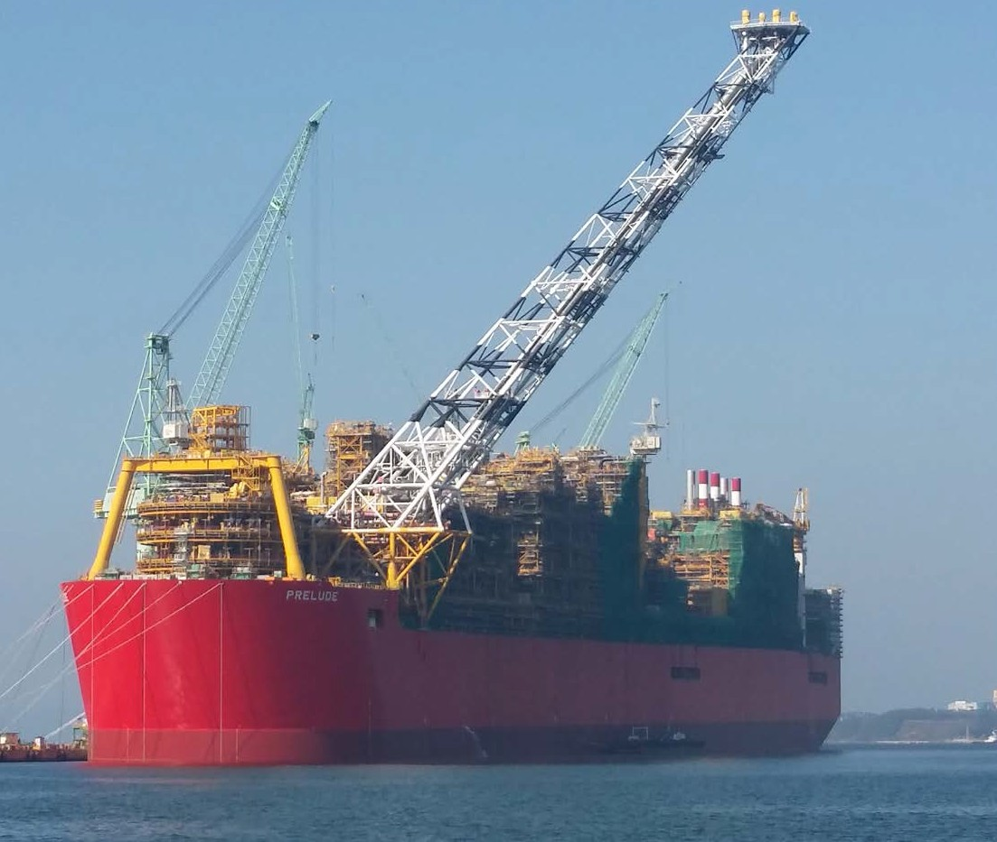

# Outlook for 2016–17

NOPTA’s key work areas for 2016–17 include:

* implement improvement opportunities identified from the 2016 stakeholder survey report;
* work with the Department as required to implement actions from the Offshore Petroleum Resource Management review;
* continue auditing performance of producing fields and compliance with approved Field Development Plan and production rates;
* continue data improvement initiatives and improve the availability and discoverability of petroleum data through the NOPIMS, in collaboration with Geoscience Australia;
* investigate enhancements of NEATS to meet industry calls for transparency of application tracking, greater automation, industry and Joint Authority portals, and facilitate payment by industry;
* ICT change management to reflect development in NEATS, workflows and increased business requirements;
* continue to implement recommendations of the Ministerial review;
* publish the results of NOPTA’s first self-assessment against the Regulator’s Performance Framework.



Prelude floating liquefied natural gas (FLNG) – images courtesy of Shell Australia

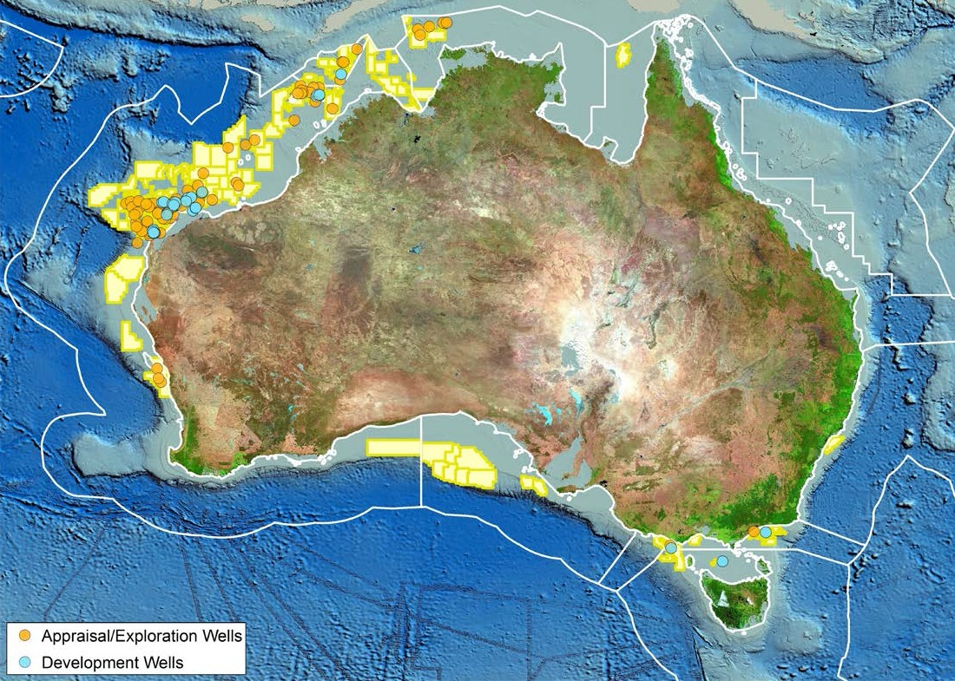

#### Australian Offshore Petroleum Well Activity: 2012 to 30 June 2016

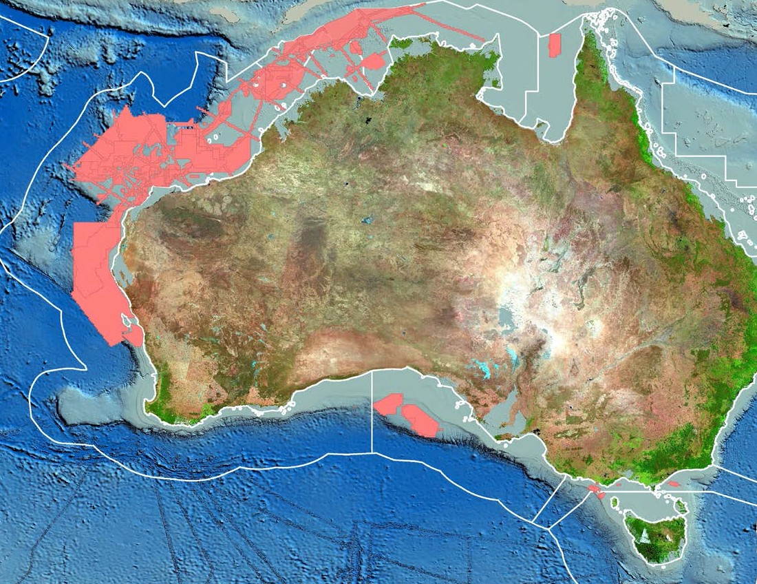

*Australian Offshore Petroleum Survey Activity: 2012 to 30 June 2016*